Week beginning: 6th July

Weekly timetable

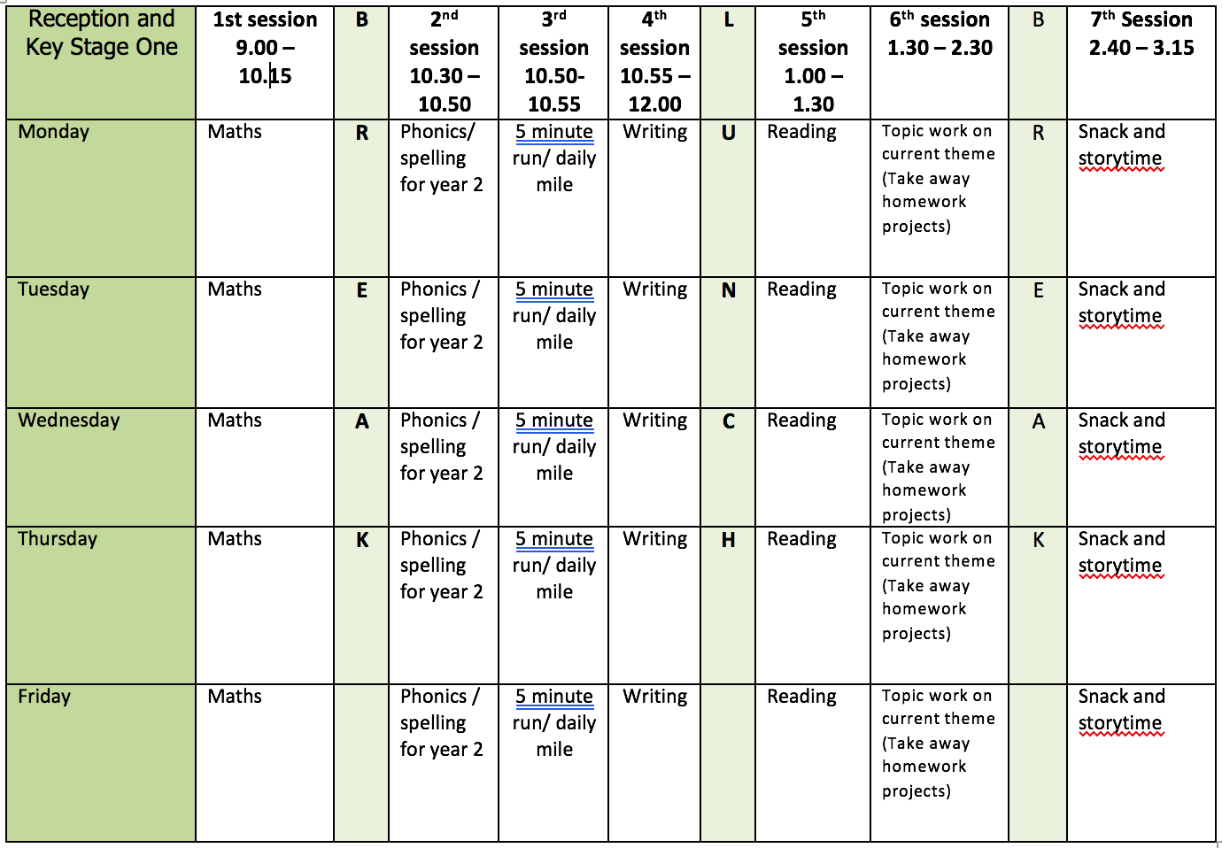

Mental health and well being

Belly Hike

Often, we only look for the bigger things in life and miss the small and just as wonderful creatures that are there all the time. So why not take a Belly Hike when you go to the park or are playing in the garden. Lie on your belly…and look through the grass at the wonders that can lie within the blades, ants, dew drops, seeds, spiders, and beetles…
When you feel you have looked at everything within your reach, gently turn yourself around and do the same exercise again…did you find more there than the first time... what was different? Or maybe just the same? By taking time to focus on a smaller patch of life and give it our full attention we are being mindful and respectful. This will help calm our nervous system, and our brains, and can improve our mood.

English

This week we will be using the book ‘Somebody Swallowed Stanley’ by Sarah Roberts as a stimulus for our writing. You can listen to the story here: https://www.youtube.com/results?search_query=somebody+swallowed+stanley

Monday: Watch and listen to the story. Provide pictures of animals who could have swallowed Stanley e.g. whale, seagull, turtle etc. Chose an animal and annotate picture to describe what it looks like.
Tuesday: Recap words and phrases to describe chosen animals yesterday and explain that we need these ideas to write a riddle. Discuss what a riddle is and model writing one. Children to write a riddle of their chosen animal.
Wednesday: Recap toolkit for a diary (first person, time words, date, thoughts, and feelings). Using time words retell the story in character as Stanley – draw pictures and add key words. At each point think about how Stanley might feel or what he is thinking.
Thursday: Using plan from yesterday write a diary in role as Stan.
Friday: What can you do with a plastic bag? How can it be recycled and reused? Create a list!

Reading

Monday: Fluency and expression: reading out loud to develop reading fluency and expression. Continue this daily throughout the week with a range of different books.
Tuesday: Word Recognition: practice reading the tricky words from the year 1 list.
Wednesday: Make a list of all the settings in the books you have read in a text you have read this week. Which is your favourite? Write a sentence to explain why.
Thursday: Draw a picture of your favourite character in a book you have read this week. Describe what the character.
Friday: Think of the character you drew yesterday. Write 3 questions you might ask if you met them.

Phonics

Children need to do a combination of reading and writing from the word lists. I have also included some alien/nonsense words. If possible ask your child to write a sentence containing a word with that days sound in. You can make the sentence as silly as you like!

Use the week use phonic play to recap sounds. Here are some of the resources the children enjoy most in the classroom:

You can access phonics play here: https://www.phonicsplay.co.uk/ and enter the login details provided on the homepage.

https://www.phonicsplay.co.uk/resources/phase/2/dragons-den (select phase 5 sounds)

https://www.phonicsplay.co.uk/resources/phase/2/picnic-on-pluto (select phase 5 sounds)

https://www.phonicsplay.co.uk/resources/phase/2/flashcards-speed-trials (select phase 5a)

https://www.phonicsplay.co.uk/resources/phase/2/tricky-word-trucks (select any phase)

Video Links

Recapping set 2 sounds - https://www.youtube.com/watch?v=p7hRbrpq5Bo
Recapping set 3 sounds - https://www.youtube.com/watch?v=zMSvBplxgfo
Parent help video - https://www.youtube.com/watch?v=dftlTCNWlMQ

Maths

Monday: White Rose lesson one – recognising half
Tuesday: White Rose lesson two – finding half of shapes and sets of objects
Wednesday: White Rose lesson three – recognising quarters
Thursday: White Rose lesson four – finding a quarter of shapes and sets of objects
Friday: Fraction challenges

The White Rose lesson resources are downloadable from the ‘Y1 home learning’ page along with video links to support each lesson.

Topic work

Monday
Jellyfish in a bottle - Plastic bags in the ocean mimic jellyfish and jellyfish are one of the food sources of lots of our large ocean predators. In this simple science experiment, you can show easily that this is true and help you to understand a little more about the effect that our human impact is having on the planet. Although lots of ocean predators will eat jellyfish, the Leatherback Sea Turtle eats only jellyfish, they have adapted to eat them. These ocean creatures as endangered animals were washed up dead on beaches around the world and inside their stomachs were large quantities of plastic bags. So many that the sea turtles own stomachs had foiled them into thinking they were full and they were dying from starvation as they couldn’t eat any real jellyfish.

Instructions here to make the jellyfish in a bottle. https://rainydaymum.co.uk/plastic-bag-jellyfish/
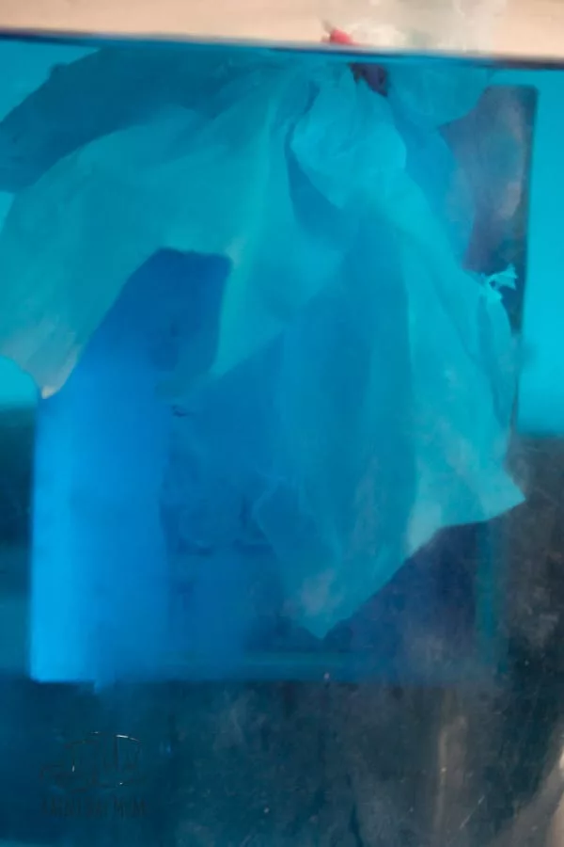

Tuesday: Water Polluntion Clean Up Activity - https://jdaniel4smom.com/2017/01/water-pollution-experiments-kids.html
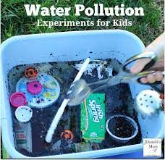
Video to aid discussion on water pollution - https://www.youtube.com/watch?v=Om42Lppkd9w

Wednesday and Thursday: Create a jellyfish from recycled materials.
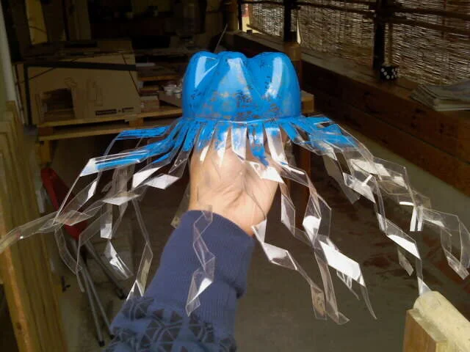
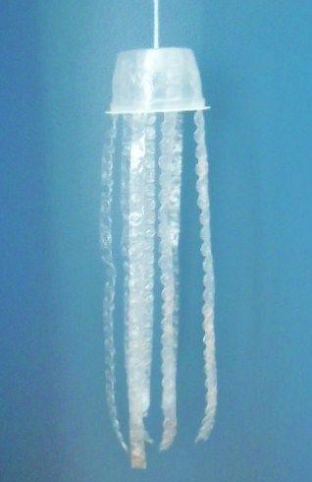
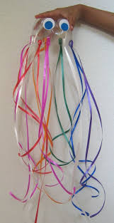
Here are some ideas and video links to help you:

https://www.youtube.com/watch?v=6Aa9g32MpjE
https://www.instructables.com/id/plastic-bottle-jellyfish/

Friday: What can you do with a plastic bag? How can you reuse it? What can you turn it into? Could you make a kite?

PE

Try a new physical activity and learn a new skill. Could be hula hooping on one arm, skipping whilst crossing the rope, taking a penalty blindfolded etc.

