Y1 Summer Term Takeaway Homework
Choose one task and bring your work into school for sharing on Wednesday 21st May 2025.
Choose a different task and bring your work into school for sharing on Wednesday 16th July 2025.
Science -  Create a seasons tree  What happens to a tree in a year?  Can you add extra details around your tree that represent each season? (think about activities, weather clothes and plants)  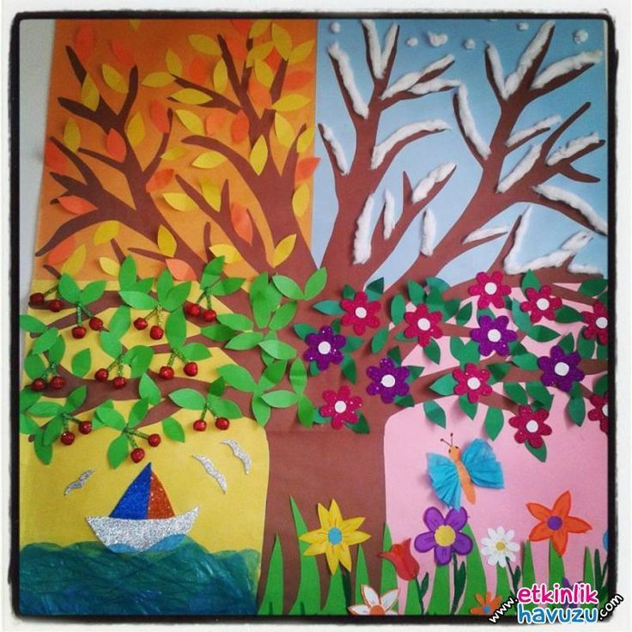 | History –  TIMELINE  Create a simple timeline for a period of time of your choosing.  In class we will be looking at when our 3 explorers travelled and placing them on our class timeline. Can you chose an individual or period of time and create a timeline for this? It could even be a timeline of your own life, or someone in your family! | Science –  Materials Hunt  What do you have in your home? What is it made from? What does it do?  Go on a search round your house and explore what materials you can see. Why is that materials good for its job?  You can present this as a photo diary/collage, a tick sheet, a poster of your findings or in another way that you wish.
Geography -  Where would you like to explore? And Why?  We will be looking at explorers in our Connected Curriculum and you may be inspired to explore somewhere new. Where would you go? Can you find it on a map? Why would you go there?  Think about what you would see there.  Can you create a poster or model of your chosen place and what you would see there? | Art –  Create a piece of artwork inspired by one of the 3 places visited by our explorers (poles, space, crossing oceans). What would they have drawn/painted?  You can present this in a manner of your choice. | Reading (continued to aid a joy of sharing what we have read)  Create a book review for a favourite book of yours. This can be in any form you would like – a poster, a written report or maybe a video review!  Go to the library and find a book about one of our 3 explorers (Ernest Shackleton, Amelia Earhart, Neil Armstrong). Can you tell the class all about it?

