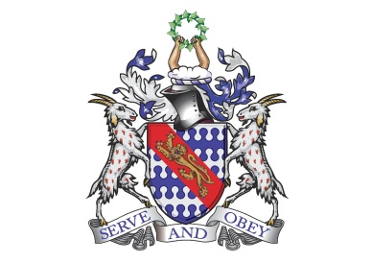

**Bunbury Aldersey CE Primary School**

**My homework tasks for this half term**

**Summer 1**

**Spellings to learn**

Below are the words children are expected to be able to spell by the end of year 1***. The spellings for homework will remain the same all year***. The children are beginning to confidently spell many of these words now. Whilst we will be continuing to follow the weeks below at school, please feel free to work on the words unknown to your child at home.

|  |  |  |  |  |
| --- | --- | --- | --- | --- |
| **Week 1** | **Week 2** | **Week 3** | **Week 4** | **Week 5** |
| full  pull  where  there  were  here | of  says  said  are  love  ask | friend  school  house  our  push | you  your  they  one  once | said  was  come  some |
| **Additional Spellings (if needed):**  Monday, Tuesday, Wednesday, Thursday, Friday, Saturday, Sunday  One, two, three, four, five, six, seven , eight, nine, ten. | | | | |

**Maths**

|  |
| --- |
| **Count to and across to 100, forwards and backwards, beginning with 0 or 1, or from any given number.**  This objective can be practiced in a variety of ways. Here are some ideas:   * Verbal counting. * Chunk up the counting e.g. 30-40 and create number lines. * Verbal counting – shout the odd and whisper the even numbers. * Snakes and ladders.   **Time; telling the time to the hour and half hour, looking at months of the year and days of the week**  This objective can be practiced in a variety of ways. Here are some ideas:   * Telling the time at different key point of the day * Playing games that involve time – what's the time Mr wolf? * Matching clock faces to times written down (12 o clock, half past 10)   **Money; recognising notes and coins**  This objective can be practiced in a variety of ways. Here are some ideas:   * Matching/snap games with coins and their amounts * Looking at the costs of items in shop, what coins can pay for this? |

**Recommended reading linked to our theme**

|  |
| --- |
|  |