Y1 Spring Term Takeaway Homework
Choose one task and bring your work into school for sharing on Wednesday 12th February
Choose a different task and bring your work into school for sharing on Wednesday 2nd April.
Science -  Senses Day  Can you create a diary of what you experience with your senses in a day. Take lots of photos to present what you did.  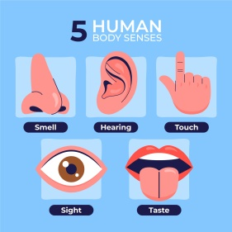 | History –  Create a fact file  This can be about Mary Anning or the Jurassic Coast.  What key information should you include?  Can you draw pictures to go with this?  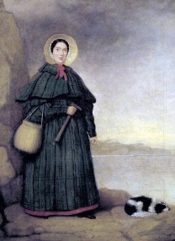 | D&T/Science –  Create a new animal!  We are going to be learning about what different animals need to survive, and key characteristics to identify and compare them.  Can you create a new animal? What will it eat? Where would it live?  You can create a poster, or create the actual 3D animal out of craft materials!
Geography -  The EQUATOR  Can you find out about a country on the equator? You can create a fact file, or a model of that country. How does being on the equator change the way those in the country live? | Art/History –  Create a junk model of a dinosaur based on your favourite fossil.  What do you think it would have looked like? Would it have scales, feathers or fur?  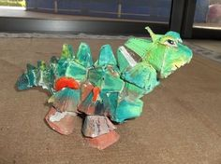 | Reading  Create a book review for a favourite book of yours. This can be in any form you would like – a poster, a written report or maybe a video review!  Go to the library and find a book about fossils. Can you tell the class all about it?

