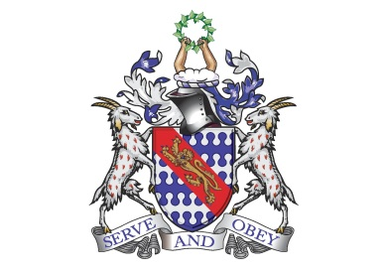
Bunbury Aldersey CE Primary School
My homework tasks for this half term
Spring 1
Spellings to learn
Below are the words children are expected to be able to spell by the end of year 1. The spellings for homework will remain the same all year. Whilst we will be continuing to follow the weeks below at school, please feel free to work on the words unknown to your child at home.
Week 1 | Week 2 | Week 3 | Week 4 | Week 5
full  pull  where  there  were  here | of  says  said  are  love  ask | friend  school  house  our  push | you  your  they  one  once | said  was  come  some
Additional Spellings (if needed):

Monday, Tuesday, Wednesday, Thursday, Friday, Saturday, Sunday

One, two, three, four, five, six, seven , eight, nine, ten.
Maths
Count to and across to 40, forwards and backwards, beginning with 0 or 1, or from any given number.
This objective can be practiced in a variety of ways. Here are some ideas:
- Verbal counting.
- Verbal counting – shout the odd and whisper the even numbers.
- Board games. Card games with numbers.
- Using objects to create tens and ones. Which represent the tens? How many tens have I got? What number have I created?
Recognise 2D and 3D shapes
This objective can be practiced in a variety of ways. Here are some ideas:
- Looking at objects in the home and identifying what shape they are.
- Shape hide and seek – ‘can you find the sphere?’
Height and Length
This objective can be practiced in a variety of ways. Here are some ideas:
- Begin comparing heights of objects at home and in public.
- Discuss different ways to measure – standard and non-standard
Recommended reading linked to our theme:
How to be a Lion by Ed Vere
The Tiger Who Came To Tea by Judith Kerr
Zoo-ology by Joelle Jolivet

