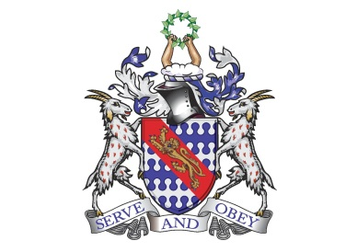
Bunbury Aldersey CE Primary School
My homework tasks for this half term
Autumn 2
Spellings to learn
Below are half the words children are expected to be able to spell by the end of year 2. The second half of will be part of autumn 2 homework. This rotation of words will be repeated during the spring and summer terms. The full list of words is available to download on the Year 2 website page, should you wish to.
Week 1 | Week 2 | Week 3 | Week 4 | Week 5 | Week 6 | Week 7
bath  path  move  prove  improve | sugar  eye  would  could  should | who  whole  any  many  clothes | people  water  again  half  money | Mr  Mrs  parents  Christmas  everybody | hour  busy  sure  beautiful  only | Revise unknown words from autumn 1 and autumn 2

Maths
Counting in 2s, 5s and 10s – verbal counting only.
Times Tables Rock Stars (passwords in reading records)

Recommended reading linked to our theme
WORLD ATLASES
Owl Babies – Martin Waddle
The Owl Who Came For Christmas – by John Hay
Little Owl by Autumn Publishing
Non-fiction books on Owls

