**Book Recommendations –**

**Sensory Processing**

## ****Dyspraxia****

## Great Children's Books about Neurodiversity and Autism: You're So Clumsy CharleyGreat Children's Books about Neurodiversity and Autism: Don't Hug Doug (He Doesn't Like It!)

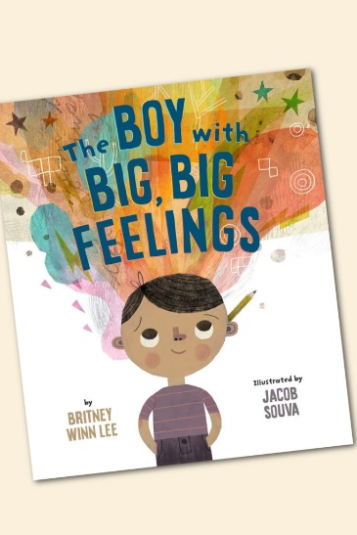

## ****Emotional Regulation****

## ****Non-Verbal Communication****

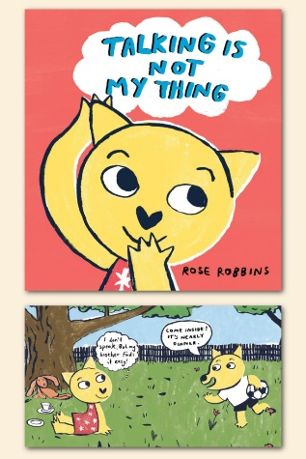

**Autism from a**

## ****Dyslexia****

**Sibling’s Perspective**

## ****ADHD****

