Y1 Autumn Term Takeaway Homework
Choose one task and bring your work into school for sharing on Wednesday 23rd October.
Choose a different task and bring your work into school for sharing on Wednesday 18th December.
Science  Complete a plant walk – what common and wild plants can you find and name, including trees.  Take some photos and chose a way to present what you have found. You may wish to create a poster of the plants that you find. | History – ask questions about the past  Create a family tree. Where did your family live?  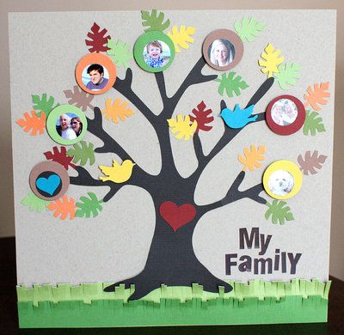 | D&T - Create a home for the penguin.  What will the penguin need to survive? What resources will you need?  You can present this as an image, or by making a miniature model of the home!  
Geography  Chose one capital city in the United Kingdom and create a fact file about it. You can present this in any way that you wish.   | Science – Seasons  Design two outfits, one for Autumn and one for Winter.  Label the different items in your outfit and get ready to explain why you need them! | Computing  Internet Safety!  Can you choose a way to teach others about how to be safe on the internet? You may like to record a video of all the important things you know!

