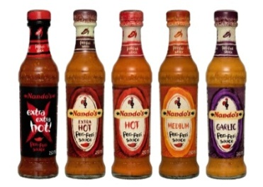
Spring Term (1) 2016
Y6
Take Away Homework!

Choose your homework from the menu below:
The Peri-ometer suggests the difficulty or challenge the homework may offer.
Over the half term try to complete at least three take away tasks (no more than six).
You could challenge yourself and take an option from the ‘EXTRA HOT’ section of the menu!
Bring your work to share on Wednesday 10th February 2016
Re-tell all or some of the story of King Kong from the point of view of Kong.  English | Find out about Gorillas and create a fact file or PPT to represent your findings  Science/ICT | Make a model of a building or vehicle that would be found in New York that either lights up or makes a sound.  Science-electricity
Create an information leaflet or travel guide to New York  ICT | Read another book by Anthony Browne and write a book review for it.  English | Draw a skyline of New York using skills learnt about creating 3D buildings  Art
Research one of the many diverse faiths found in New York and present it in any form you wish  RE/ English | Make up lyrics or a melody for the film version of King Kong. You could record it or perform it to the class.  Music/ICT | Think about the UNCRC rights for children. Make a poster to represent one of the rights that you feel is most important  PSHE
Find an American recipe, cook it and bring it in to share.  Maths skills/Food tech | Make a weather chart for the months of the year showing the average temperatures in New York and compare it with London  Geography/Maths | Free choice!  Choose anything you have been learning about in class and research it more and present it in a form of your choice
