W/C 13.07.20

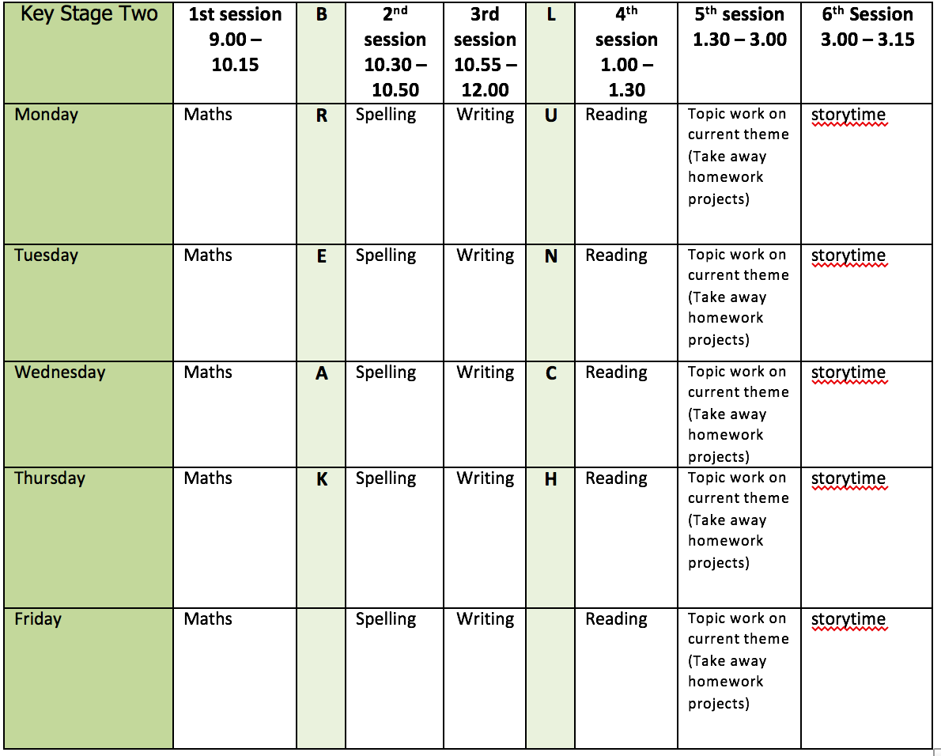

English writing activities

Monday: Visit the Literacy Shed for this wonderful resource on ​The Blackhat​ https://www.literacyshedplus.com/en-gb/resource/the-black-hat-ks2-activity-pack-
Follow the instructions for watching the clip on page 3 and 4 and answer the questions.

Tuesday: Watch ‘The Blackhat’ again https://www.literacyshedplus.com/en-gb/resource/the-black-hat-ks2-activity-pack-. Then, follow the instructions on page five thinking about the 3 important moments from the boy’s perspective and what he might say if he was given an opportunity to share his thoughts.

Wednesday: Watch ‘The Blackhat’ again https://www.literacyshedplus.com/en-gb/resource/the-black-hat-ks2-activity-pack-. Then, complete the comic strip on page six.

Thursday: Imagine the film is going to be made into a beautiful and exciting picture book. Using the information on page 15 and what you know about the story from the clip, write the blurb. Remember, it must be exciting but not give away too much information!

Friday: Complete page 16 – let your imagination run wild drawing and describing all the sorts of strange and magical items you might find inside the shop where The Black Hat came from!

Reading:

Alongside the release of ‘The Ickabog’, JK Rowling’s publishers have started a competition for children to illustrate the book! Each week I am going to set you a new illustration to complete. If you would like to enter any of your illustration ask an adult to find out a little bit more about it for you https://www.theickabog.com/competition/

Monday: Read chapter 13 of The Ickabog https://www.theickabog.com/the-accident/ Now, return to the prediction you made last week. Have any of your predictions come true at this point in the story? Add any new predictions that spring to your mind!

Tuesday: Choose one of the following to illustrate:
- King Fred’s jewelled sword
- King Fred covered in mud
- Major Roach
- Patch the dog, in the brambles
- The imaginary monster with lamp-like eyes
- The blunderbuss

Wednesday: At the end of last week we looked at atmosphere and how it is created in a story. Remember, it is the feeling, emotion or mood that the author creates in a narrative using descriptive language. Read chapter 14 of The Ickabog https://www.theickabog.com/lord-spittleworths-plan/ What atmosphere is created for the setting in the beginning of chapter and how? Remember to provide evidence for your ideas e.g. It creates a spooky atmosphere because it talks about ghostly elephants. Create a mind-map and share your ideas with an adult.

Thursday: Read Chapter 15 for pleasure and choose one of the following to illustrate:
- A worried innkeeper
- The keys to the cellar
- King Fred with his bedclothes pulled up to his eyes
- Lord Spittleworth and his candle
- The body wrapped in cloaks on the horse

Friday: Now that you are at the end of the summer term, finish reading the rest of this fantastic book for pleasure over the summer holidays. Once you have finished, you could write a book review. Remember to keep illustrating too!

Spelling:
As we are at the end of the term, I would like you to divide the year 3 – 4 spelling list into 5 and test yourself on a group of words each day. Make a list of any that you get incorrect, so that you know which ones you need to practice over the summer. Good luck!

Maths activities for the week:
Monday: Compare capacity
Tuesday: Add and subtract capacity
Wednesday: Pictograms
Thursday: Bar Charts
Friday: Create a beautiful multiplication flower or have a go at some of the other inspiring ways of learning your times tables. Follow the link and scroll down to number 9 https://www.weareteachers.com/22-fun-hands-on-ways-to-teach-multiplication/

Topic work
Monday: Design and draw/make a magic hat with a different power of your choice. What would come out of your hat?

Tuesday: Using the information on page 8 https://www.literacyshedplus.com/en-gb/resource/the-black-hat-ks2-activity-pack- , design and draw your own magical creature! As an extension, can you write an information text about it?

Wednesday: Set up a tally chart to record the birds that you see visiting your garden. Can you identify any of them? You may need to be early and nice and quiet!

Thursday: Can you make a bird mobile? Follow this link to the tutorial https://www.youtube.com/watch?v=18s8UUV99kQ&feature=youtu.be and find the materials list in the documents saved for this week. You will need an adult to support you, but it is not too tricky once you have got the hang of it!

Friday: Write a story about one of your own items (from the mysterious shop) and what happens once someone has purchased it.

