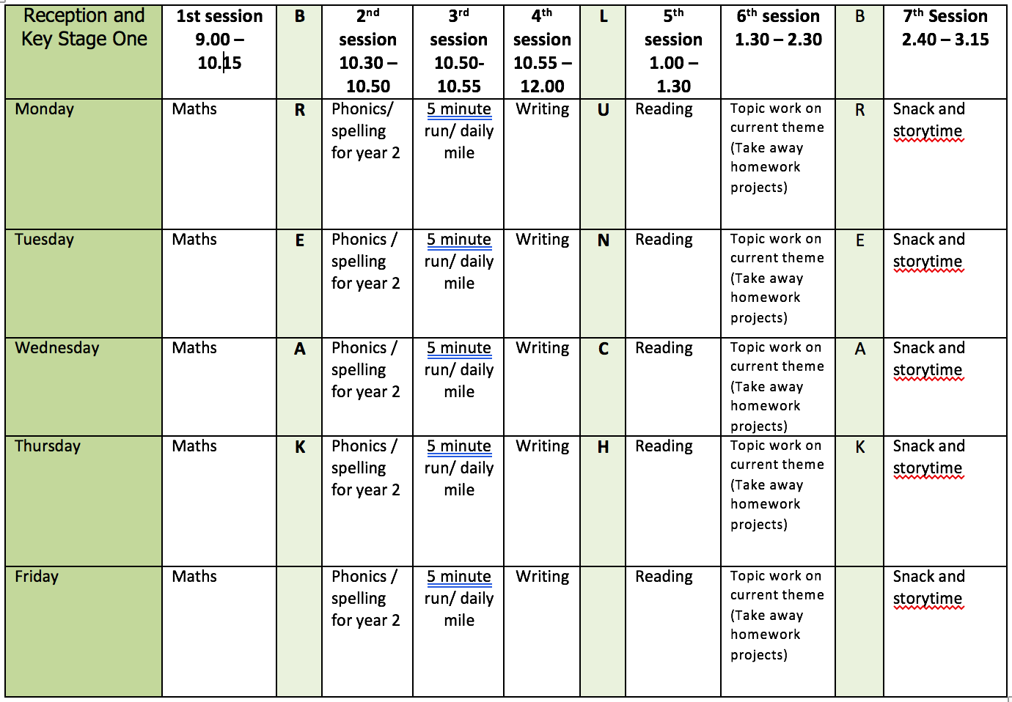

If you are attending provision as well as home learning please could you bring any work you do in English to school with you, as we will be working on this activity in provision English lessons.

ENGLISH WRITING: Story Writing
The IPEELL planning sheet is different for story writing.
MONDAY – IPEELL Sheet Planning
- Use the picture ‘Neptune’s Kingdom’ for your story.
- Use ‘The Story Begins’ sheet to help you think about and plan your story.
- Complete the IPEELL planning sheet with your ideas.
- In the INTRODUCTION box write your gripping opening sentence. You could the following-
  - Start with one word and an exclamation sentence – Stop! Run! Help! No! Quick! Crash!
  - Start with a question - What was that? shouted the diver as he swam below the surface of the ocean.
  - Start with the name of your main character. E.g. Neptune stood tall holding his silver trident high into the air.
- In the PEOPLE box draw your characters
- In the PLACE box plan your setting.
- In the PROBLEM box your problem.
- In the PEACE box your ending or resolution to the problem.
- In the LINKS –OPENERS box chose some opener words from the lists in the resource file.
- In the LINKS – CONJUNCTIONS box chose some words from the lists in the resource file
- In the LANGUAGE box write some noun phrases (adjective + noun) and a question, exclamation and command sentence you could use.

TUESDAY TO THURSDAY
- Write the story of Neptune’s Kingdom concentrating on one or two parts of the story each day.
- Write at least 3 sentences for each part joining some of them with links (conjunctions) using co-ordination (or, and, but) or subordination (when, if, that, because).
- Use openers to start each sentence.
- Use the correct punctuation. At Y2 the following punctuation is used
  - Capital letters, full stops, question marks and exclamation marks to demarcate sentences
  - Commas to separate items in a list
  - Apostrophes to mark where letters are missing in spelling (contractions) and to mark singular possession in nouns (for example, the girl’s name.)
  - Inverted commas to punctuate direct speech are NOT introduced until Y3.
- Use different sentence types- statements, questions, exclamations and commands?

FRIDAY
- At school we call editing work Green for Growth. Look at your work from this week.
  - Check your punctuation.
  - Does your work make sense when you read it out loud? Is the tense correct?
  - Check the spellings of common expectation words using the Y1 and Y2 Word Lists.
  - Have you used interesting language in your work?
  - Have you used different sentence types- statements, questions, exclamations and commands?
- Change any parts you think you can improve.

READING
Daily - reading out loud to develop reading fluency and expression. You could read the extracts from Spike: The Hedgehog Who Lost His Prickles as well as watching the story on the video.
Monday
- Spike: The Hedgehog Who Lost His Prickles by Jeanne Willis https://www.bbc.co.uk/bitesize/articles/z8q83j6
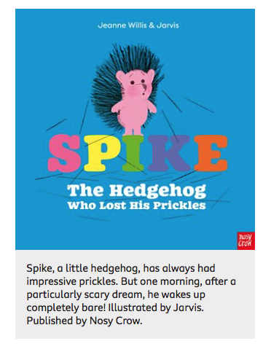
- Watch both extracts and answer the questions that go with the extracts.
- Questions on page 2 and 3 of the PDF file.
Tuesday
- Activity 1 Finding evidence in the text.
- Page 4 of PDF file.
Wednesday
- Activity 2 Describing a character.
- Page 5 of PDF file.
Thursday
- Activity 3 Predictions
- Page 6 of PDF file.
Friday
- Finish all comprehension activities.
- Practice reading words from the words lists provided in Week 1.
SPELLING
With the dictation say the sentences one at a time. Check the spelling and punctuation in these sentences. Then practice the spelling focus. This is also an opportunity to work on handwriting and presentation.
I have made a spelling quiz for each week’s spelling focus in the Purple Mash 2Dos section.

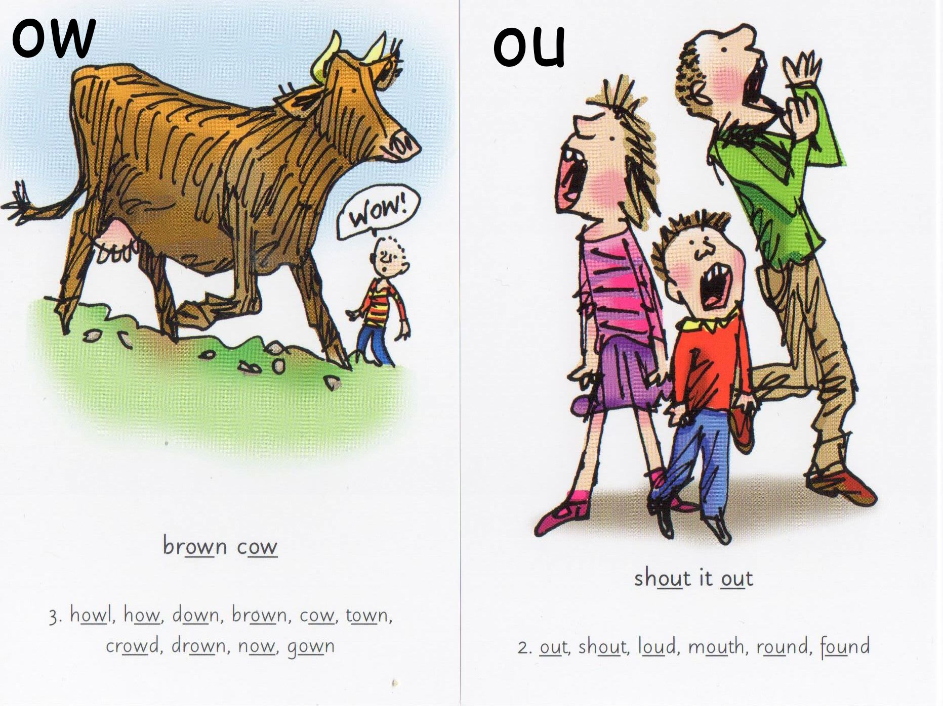
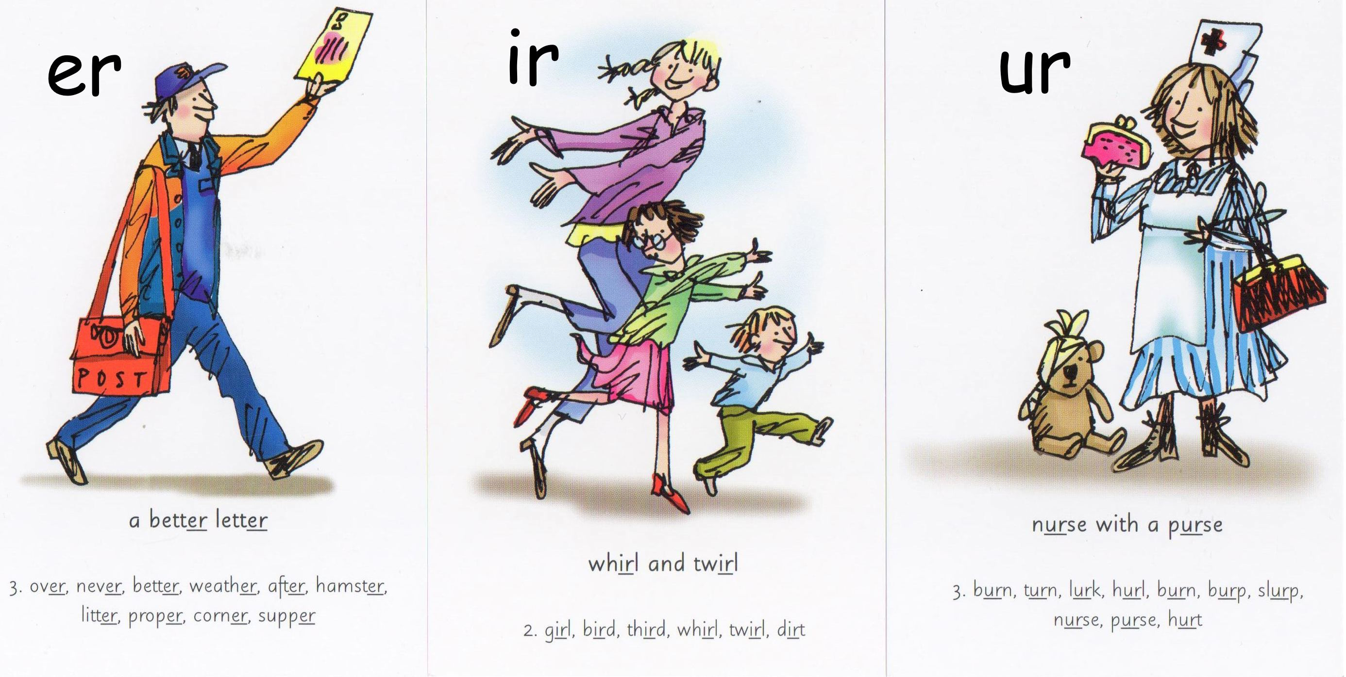

Monday
- Spelling OW words – cow crowd brown down town how now
- Dictation - Sam is on a train with a crowd of people. He cannot sit down on a seat.
Tuesday
- Spelling OU Words – cloud loud round found shout out house mouse
- Dictation - Jim found a mouse in his house. He gave a loud shout for help.
Wednesday
- Spelling ER words - dinner supper sister letter winter summer yesterday her under September November
- Dictation – Yesterday Sam had a letter from his sister. She will stay with him in September.
Thursday
- Spelling IR words - girl bird skirt shirt dirt first
- Dictation – Sam has dirt on his shirt. First he will scrub the dirt with soap.
Friday
- Spelling UR words - church burn fur hurt turn burst Saturday Thursday turkey
- Dictation –On Saturday Sam and his wife went to church. At home the turkey, the peas and the beans burn.

Further resources to support Phonics and Spelling
- Word Lists – Y1, Y2, Y3/4 (on Week 1 Home Learning Page)
- Help Your Child With Spelling Document (on Week 1 Learning Page)
- Read Write Inc. – daily phonics/spelling lesson starting at 9.30 and then available for 24 hours after that https://www.youtube.com/channel/UCo7fbLgY2oA_cFCIg9GdxtQ

MATHEMATICS (WHITE ROSE)
All these resources are on the webpage with the exception of Friday.
Monday
- Lesson 1 – Telling time to 5 mins
Tuesday
- Lesson 2 – Hours and days
Wednesday
- Lesson 3 – Find durations of time
Thursday
- Lesson 4 – Compare durations of time
Friday
- Friday Maths Challenge - White Rose in partnership with BBC Bitesize https://www.bbc.co.uk/bitesize/tags/z7s22sg/year-2-and-p3-lessons/1

Further resources to support mathematics:
- Times Table Rockstars https://ttrockstars.com
- Purple Mash https://www.purplemash.com/sch/bunburyaldersey
- Mathletics https://login.mathletics.com

TOPIC & WELL BEING
For this week’s afternoon topic work there are some activities based around Food to link with the pages Food Waste and Eat Up. At Y2 in Science children are expected to describe the important for humans of eating the right amounts of different kinds of food.

Monday - Food & Nutrition
https://www.bbc.co.uk/bitesize/articles/z6fc86f
- Learning about a balanced diet.
- Watch the 2 videos.
- Complete activity 1 - Healthy Eating Meal.
- Worksheet for this activity on the webpage.

Tuesday - Packaging
https://www.bbc.co.uk/bitesize/articles/zkf8jhv
- Learn about product packing design and production.
- Watch the 2 videos and complete the activities.
- With Activity 2 you might like to design new packaging for a food item using what you have learnt in Activity 1.
- Download the nets from the webpage.

Wednesday - Self Portrait
https://www.bbc.co.uk/bitesize/articles/zmcp7yc
- Learn about famous artists who drew self-portraits and have a go at creating your own self-portrait.
- Acrimboldo painted fruity faces. Have a go at Activity 2 creating a self-portrait in this style.
- Help sheet for drawing self - portraits on the webpage.

Thursday - Purple Mash
Continue with the keyboard skills and coding activities that have been set in the 2Dos.

Friday Well Being - Happiness Bucket
- Write or draw anything in the bucket that makes your happy.
- If you want you could continue this throughout the summer break and bring it back to school in September to share with Mrs Smith and me.
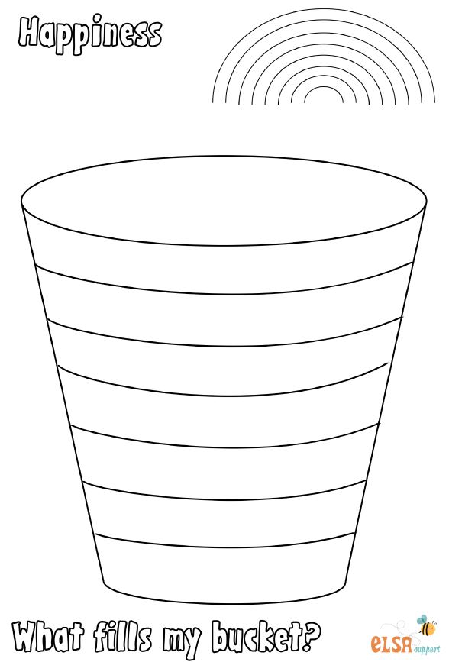

PHYSICAL EDUCATION
- Use the links and resources from Mr Dooley already available on the class home learning webpage. Mr Dooley has sent more resources for this term, which are on a separate page.
- PE with Joe https://www.youtube.com/channel/UCAxW1XT0iEJo0TYlRfn6rYQ
- Go Noodle Activities https://family.gonoodle.com

