Week beginning: 13.7.20
Year 6
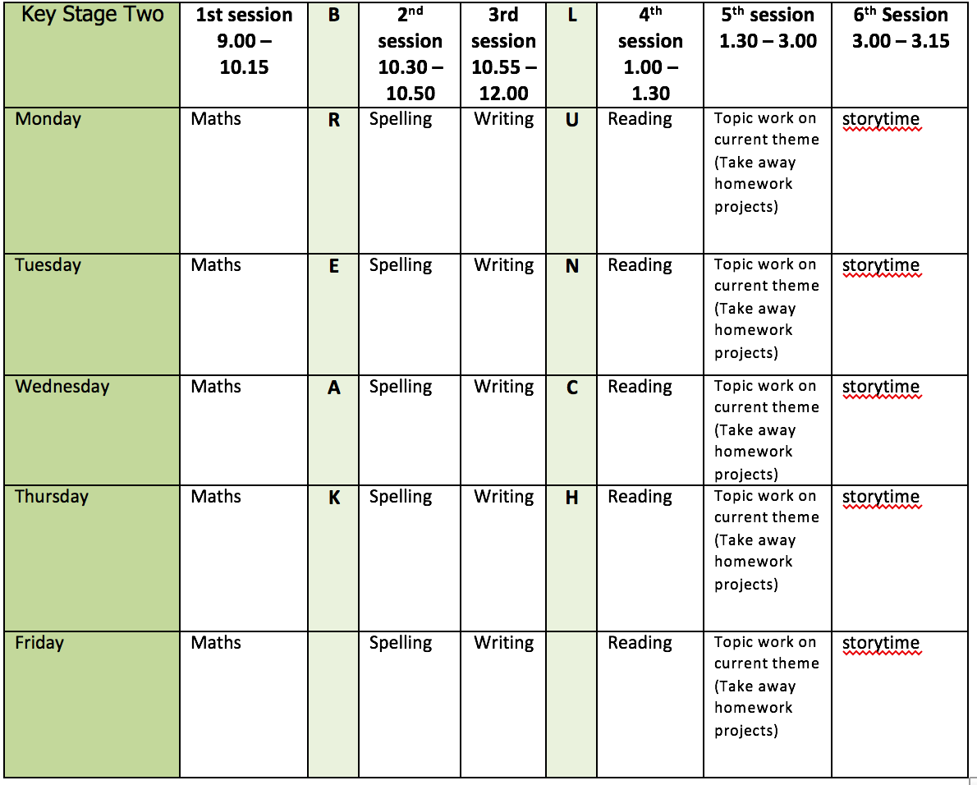
Mental health and well being
Choose an activity from the list below as and when you need it:
1. Colouring sheets.
2. Crosswords
3. Sudoku
4. Doodling/drawing
5. Reading
6. Listen to relaxing music https://www.youtube.com/watch?v=qFZKK7K52uQ
7. Yoga - https://www.youtube.com/watch?v=Td6zFtZPkJ4

Maths activities for the week: (12)
1. Monday Lesson 1 - Nets of 3D shapes
2. Tuesday Lesson 2 – Circles
3. Wednesday Lesson 3 - Read and interpret pie charts
4. Thursday Lesson 4 - The mean
5. Friday Lesson 5 - Practise your timestables (on TT rock stars if you wish) and then complete the appropriate timestable sheet (5 minute timer) Complete the Friday Maths Challenge https://whiterosemaths.com/homelearning/year-6/

Spelling:
The spelling pattern focus for this week is: Year 5/6 word list

Teach tips: The words from the Year 5/6 word list follow the different patterns which the children have been learning during the year.

1. Monday use the 5/6 word list and look up definition in a dictionary of any word meanings not known. Write your own definitions to explain them.
2. Tuesday create 6 sentences using the words from the list.
3. Wednesday highlight the words on the list which you do not know. Learn these words (Use different colours, write mnemonics to remember the letter order, draw around the shape of the word, play hangman, test yourself)
4. Thursday complete a test of these words.
5. Friday Complete the wordsearch.

English writing activities for the week: Leaver’s writing activities
1. Monday – Write a paragraph explaining why children should come to Bunbury School. Sell it to them! Be persuasive!
2. Tuesday – Write a paragraph about your favourite memory of Year 6. It could be a school trip, an achievement, a particular topic or lesson etc. Give as much detail as possible.
3. Wednesday – Write an acrostic poem for BUNBURY SCHOOL to summarise it.
4. Thursday – Write a couple of paragraphs about your new school for September. Tell me all about it in as much detail as possible. Where? What’s it like? What is the uniform like? Which subject are you most excited to learn more about?
5. Friday – finish and/or proof read and edit any of the above writing activities.

Reading:
1. Monday - 30 mins of independent reading
2. Tuesday - Comprehension (complete questions 1-6 - this week’s is extract 7: The Sound of Breaking Glass)
3. Wednesday - 30 mins of independent reading
4. Thursday –Comprehension (complete questions 7-11 on The Sound of Breaking Glass)
5. Friday – 30 mins of independent reading

Topic work:
1. Monday Leavers – write a leavers message to each child in our class. You might want to share a memory, say good luck or share a positive quote.
2. Tuesday Art – as you have seen in your writing, sea turtles are one of the animals most affected by plastic pollution. Draw a sea turtle using a pencil (you can use the cheat method if you would like to!) try and include as much detail as possible.
3. Wednesday transition – Lesson 2 (organisation) Please see the PowerPoint.
4. Thursday leavers – celebration of time at Bunbury. Watch our leavers’ videos. Decorate your own Bunbury shirt. You can write all your classmates names on it, draw our logo, decorate it with patterns or write quotes!
5. Friday Free choice from the takeaway homework list or a mental health and well-being activity.

PE:
Please find ideas for daily PE activities on the PE documents on the webpage and via the link below:
https://homelearning.primarypepassport.co.uk/#/
This week’s daily challenge: how many lunges can you do in 2 minutes? Can you improve your score each day?

