Plants of the Ocean
Today is World Oceans Day (June 8th 2020)
Have a look at these beautiful collages of different plants found in the ocean. Use them as inspiration to create your own piece of artwork based on plants found in our seas.
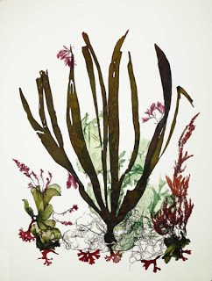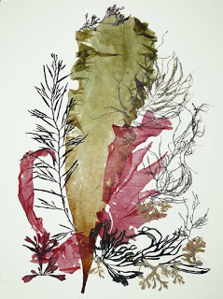

You could use paint to paint similar images
or
You could find a variety of media to make a collage

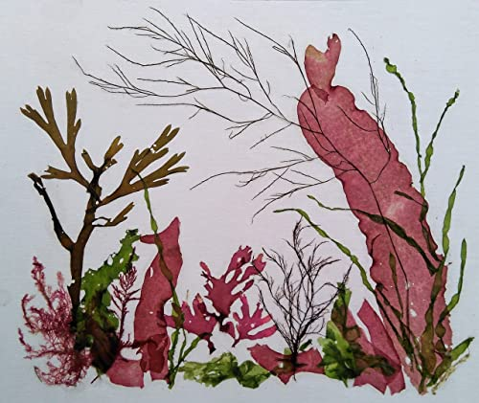
Look carefully at the different types of seaweed. You could experiment with different sized lines when mark making.

