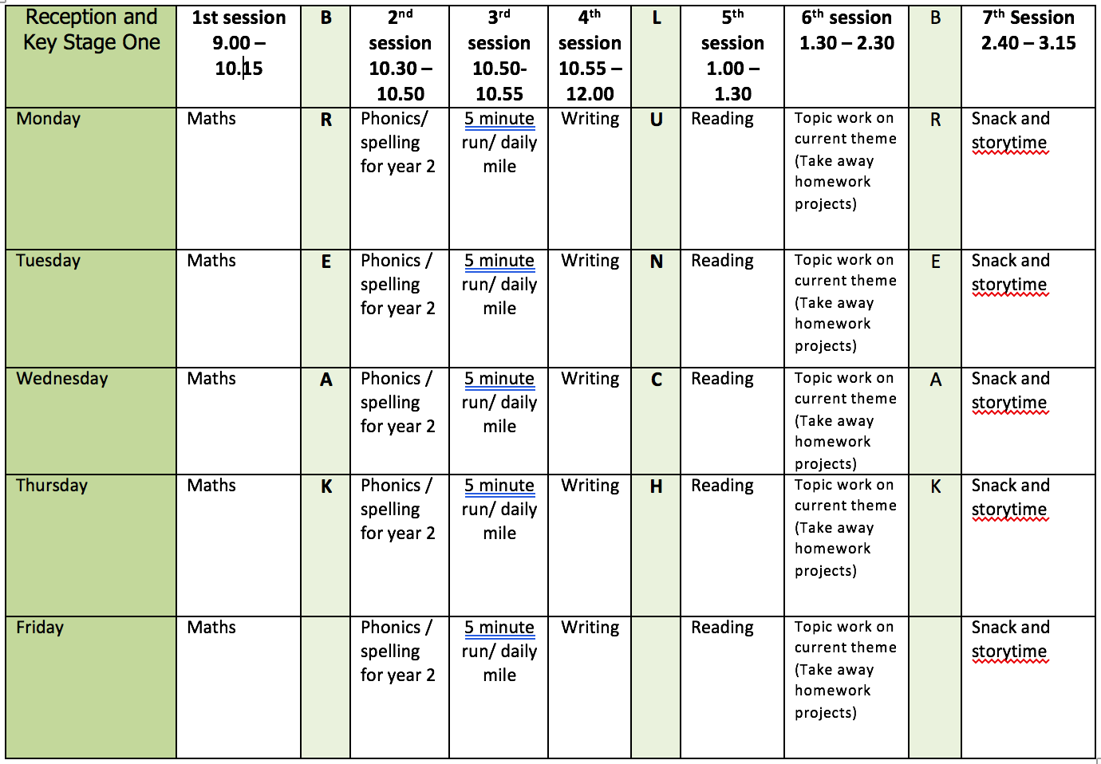

If you are attending provision as well as home learning please could you bring any work you do in English to school with you, as we will be working on this activity in provision English lessons.

ENGLISH WRITING: Non-Chronological Writing
We use the word point to help structure our work, a point is like a paragraph. In each point I would expect Y2 to write at least 3 sentences joining some of them with conjunctions using co-ordination (or, and, but) or subordination (when, if, that, because). At school we call conjunctions sentence links. Every sentence needs to have the correct punctuation.

This week we are completing a plan as well as writing a report. You can complete the entire plan and then write the report or plan and write each section one at a time.

MONDAY – Sea Turtles Plan
- Look at the Save Our Seas page in the resource PDF file. Find the fact about Sea Turtles.
- Find out some more facts about Sea Turtles and complete the IPEELL planning sheet using the example of the class plan for Plants. The planning sheet is on the website.
- You could keep the I introduction similar – All About Sea Turtles. Remember your introduction has general facts.
- You could keep the E ending similar – Looking After Sea Turtles.
- Points – you can decide your own points but some suggestions might be food, habitats or specific points about how they are endangered.
- The second L is for Language where you write any technical and specific vocabulary linked to Sea Turtles.
Web links for Turtle Information
- https://www.wwf.org.uk/learn/wildlife/marine-turtles
- National Geographic Video https://www.youtube.com/watch?v=5Rmv3nliwCs
- https://www.nationalgeographic.com/animals/reptiles/group/sea-turtles/
- TED ED Video https://www.youtube.com/watch?v=t-KmQ6pGxg4

TUESDAY TO THURSDAY – Sea Turtles Writing
- Writing your report using your plan.
- Add pictures and diagrams if you want to.

FRIDAY
- At school we call editing work Green for Growth. Look at your work from this week.
  - Check your punctuation.
  - Does your work make sense when you read it out loud? Is the tense correct?
  - Check the spellings of common expectation words using the Y1 and Y2 Word Lists.
  - Have you used interesting language in your work?
  - Have you used different sentence types?
- Redraft any parts you think you can improve.

READING

Daily - reading out loud to develop reading fluency and expression. You could read the extracts from Ella Bella as well as watching the story on the video.

Monday
- Ella Bella Ballerina and A Midsummer Night’s Dream by James Mayhew https://www.bbc.co.uk/bitesize/articles/z6djr2p
- Watch both extracts and answer the questions that go with the extracts.
- Questions on paged 1 and 2 of the PDF file.
Tuesday
- Activity 1 Ordering the events in Extract 1.
- Page 3 of PDF file.
Wednesday
- Activity 2 Answering questions using exact wording from the text.
- Page 4 of PDF file.
Thursday
- Activity 3 Writing a short summary.
- Page 5 of PDF file.
Friday
- Finish all comprehension activities.
- Practice reading words from the words lists provided in Week 1.

SPELLING
With the dictation say the sentences one at a time. Check the spelling and punctuation in these sentences. Then practice the spelling focus. This is also an opportunity to work on handwriting and presentation.
I have made a spelling quiz for each week’s spelling focus in the Purple Mash 2Dos section.

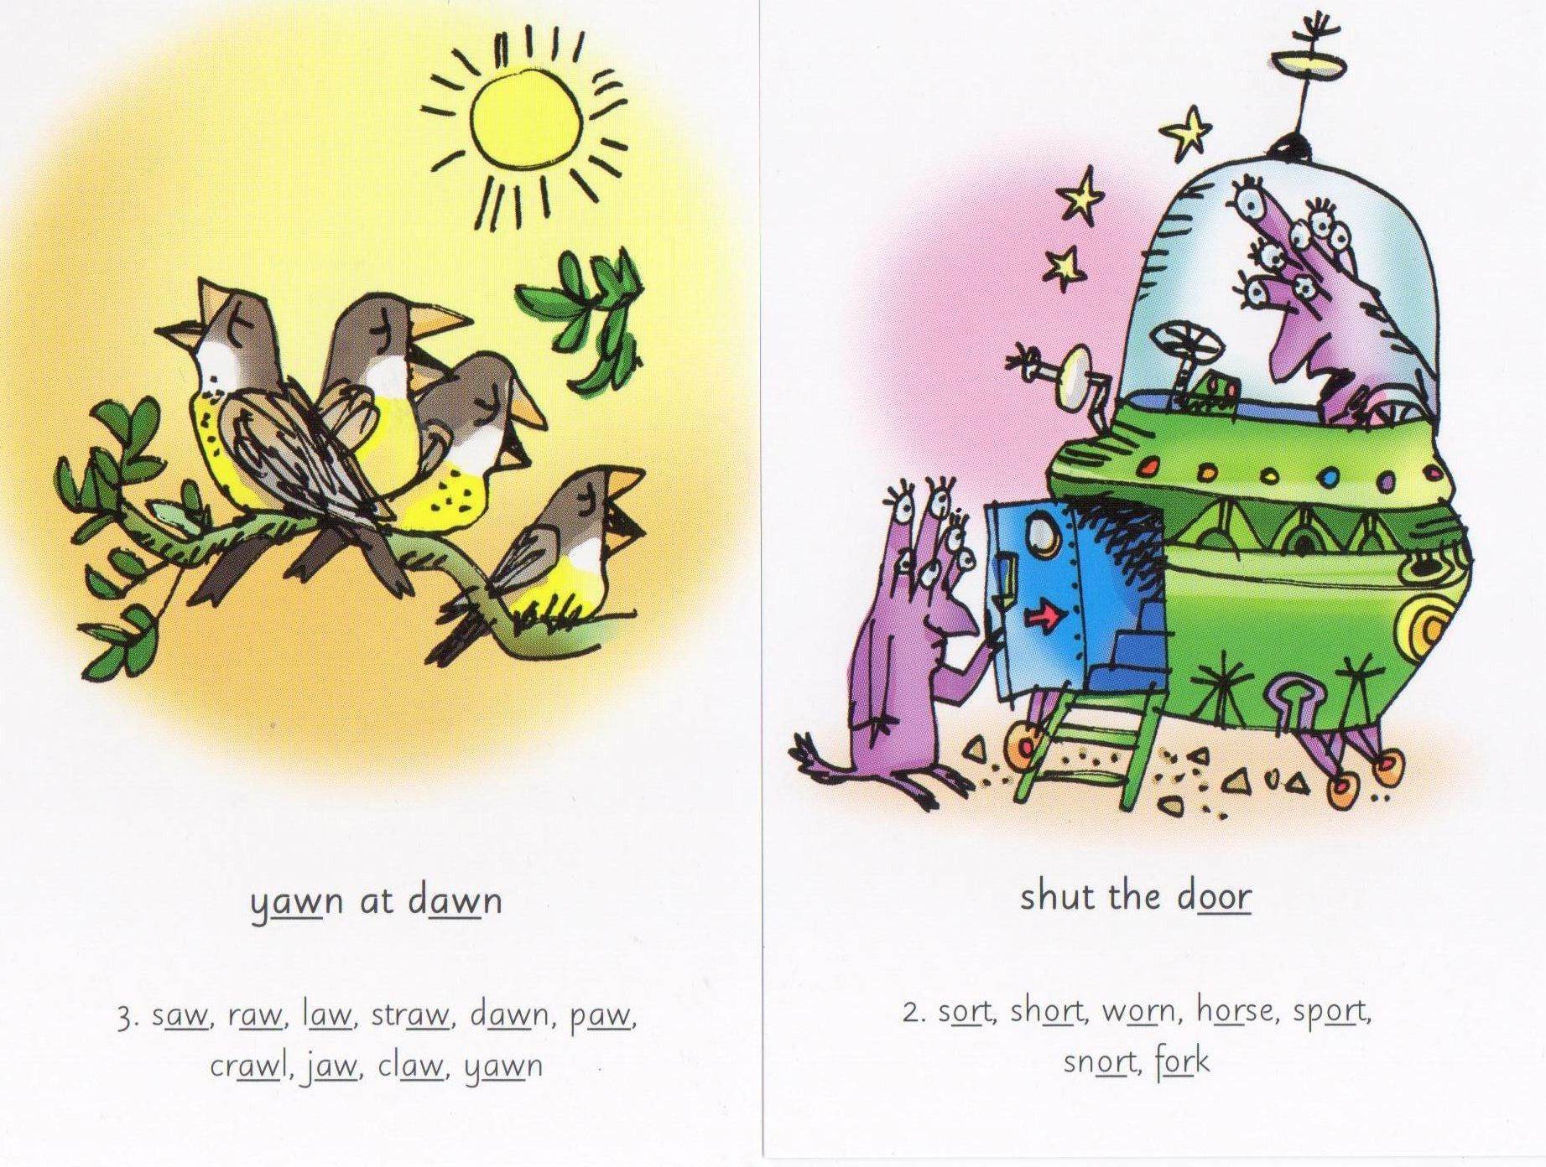
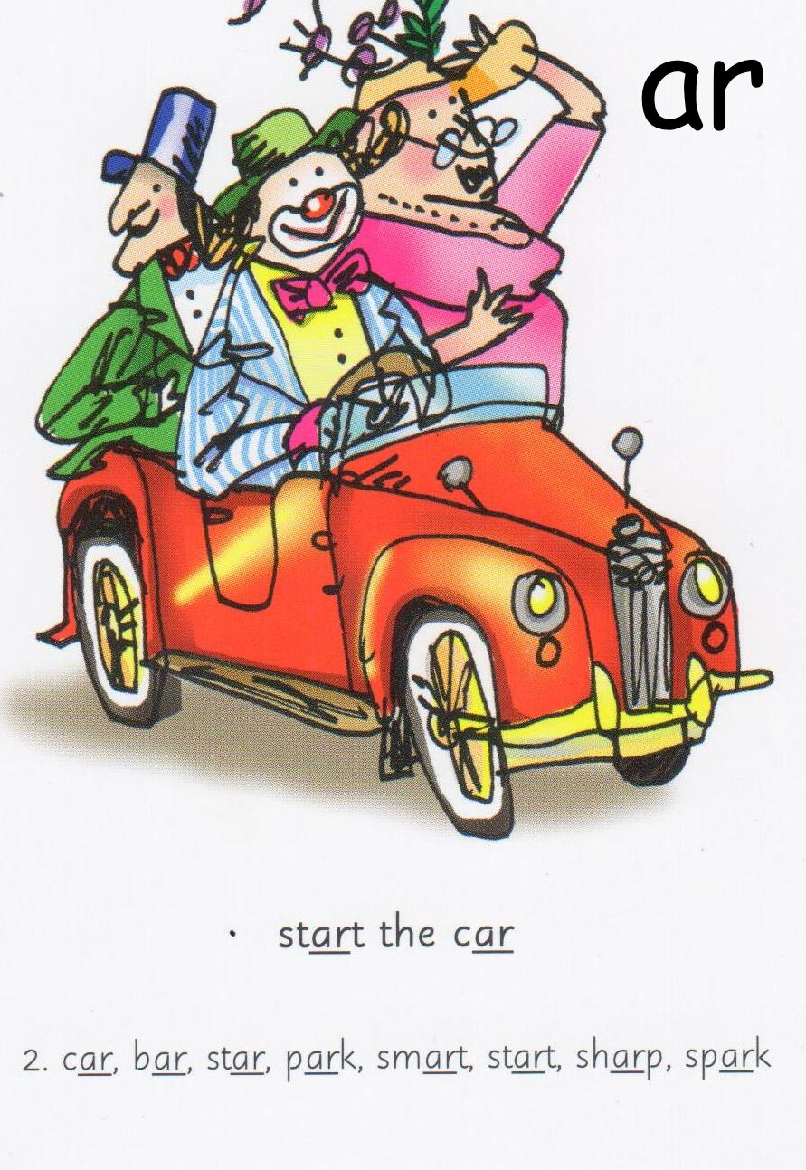

Monday
- Spelling AW words – yawn saw jaw claw draw lawn crawl
- Dictation - On Thursday Sam gave a big yawn. He broke his jaw. Jim saw him crawl to a seat on the lawn.
Tuesday
- Spelling OR Words – fork cork pork corn for horse storm sport
- Dictation - The storm is bad. The dog and the horse run. The fat man runs but it is hard for him.
Wednesday
- Spelling AR words - car far park dark jar star bark tart scarf
- Dictation –It is dark in the car. The fat mans sits on the jam tart. His dog jumps up and barks.
Thursday
- All Words – ball call fall all tall hall wall small
- Dictation - Sam stands in the hall and calls Jim. Jim is on a ladder painting his house. He turns and falls.
Friday
- Use the words lists (common exception words) on the webpage. Look for any of this week’s sound/spelling focus on these lists and practice spelling them.
- If there aren’t any choose a selection of words to learn and write in a sentence.

Further resources to support Phonics and Spelling
- Word Lists – Y1, Y2, Y3/4 (on Week 1 Home Learning Page)
- Help Your Child With Spelling Document (on Week 1 Learning Page)
- Read Write Inc. – daily phonics/spelling lesson starting at 9.30 and then available for 24 hours after that https://www.youtube.com/channel/UCo7fbLgY2oA_cFCIg9GdxtQ

MATHEMATICS (WHITE ROSE)
All these resources are on the webpage with the exception of Friday.
Monday
- Lesson 1 – Litres
Tuesday
- Lesson 2 – Temperature
Wednesday
- Lesson 3 – o’clock and half past
Thursday
- Lesson 4 – quarter past and quarter to
Friday
- Friday Maths Challenge - White Rose in partnership with BBC Bitesize https://www.bbc.co.uk/bitesize/tags/z7s22sg/year-2-and-p3-lessons/1

Further resources to support mathematics:
- Times Table Rockstars https://ttrockstars.com
- Purple Mash https://www.purplemash.com/sch/bunburyaldersey
- Mathletics https://login.mathletics.com

TOPIC & WELL BEING

Monday - Oceans
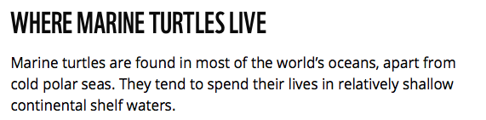

- Find out about the world’s oceans here by watching the videos. Complete the quiz and the map activity.
- https://www.bbc.co.uk/bitesize/articles/zmmp7yc

Tuesday – The Water Cycle
https://www.bbc.co.uk/teach/class-clips-video/geography-ks1ks2-the-water-cycle/zbcmxyc
- Watch the video to find out about the water cycle.
- Make you own water cycle diagram/book and write a brief explanation of each part.

Wednesday - Beach Poster
- Design and make a beach poster to encourage people to keep beaches clean and tidy.
- Use whatever colouring or art materials you have at home.
- I have out some ideas in the resource file.

Thursday – Keyboard Skills
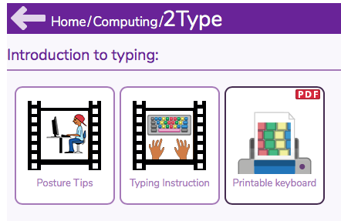

- Watch the 2 videos above before starting the activities in your 2Dos list.
- I have only put a few tasks in your 2Dos list.
- If you complete the set tasks there are lots of further activities in 2Type to extend your typing skills.
- The games below are good to use too.

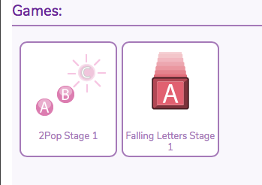

Friday
- Well Being – Feelings Mandala
- Choose a mandala to colour in
- List different feelings below or above the mandala.
- Draw a small circle next to each feeling.
- Pick a colour for each feeling and fill in the circles with the colours to use a guide to remember which colours belong to which feelings.
- Colour the mandala with the feelings colour to show how often you have the feelings.
- If there is a feeling you have a lot of in your life, colour more of the picture with that colour. If there is a feeling you don’t notice having very much, only colour a little of the picture with that colour.”
- This can be helpful to start conversations like, “I notice you only have a little bit of green in your picture and that is your happy colour. What can we do to get more happy in your life?” Or “I notice there is a lot of red in your picture and that is your angry colour. Thank you for being so honest with your feelings in this activity! I wonder what are some of the things that cause that much anger in your life… What do you think?”
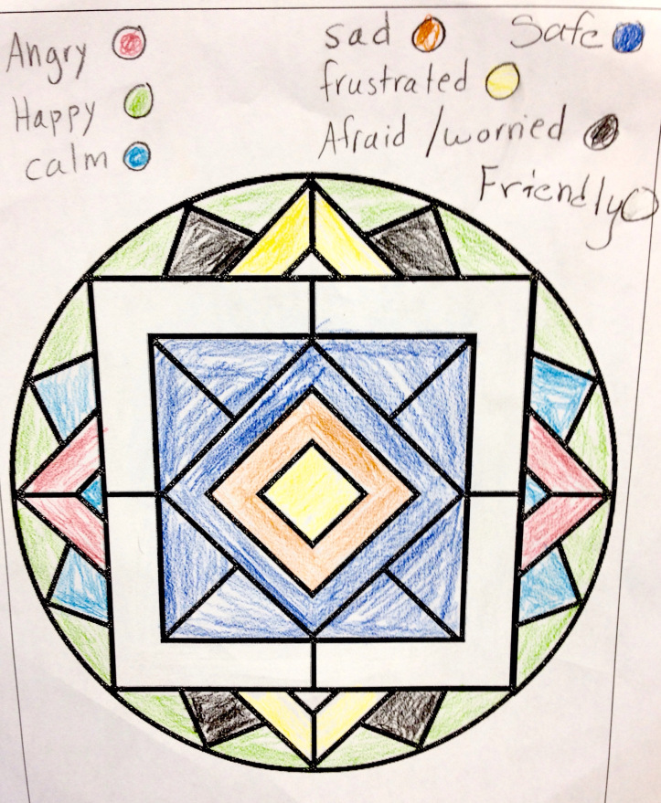

PHYSICAL EDUCATION
- Use the links and resources from Mr Dooley already available on the class home learning webpage. Mr Dooley has sent more resources for this term, which are on a separate page.
- PE with Joe https://www.youtube.com/channel/UCAxW1XT0iEJo0TYlRfn6rYQ
- Go Noodle Activities https://family.gonoodle.com

