Year 4
WB 13.7.2020

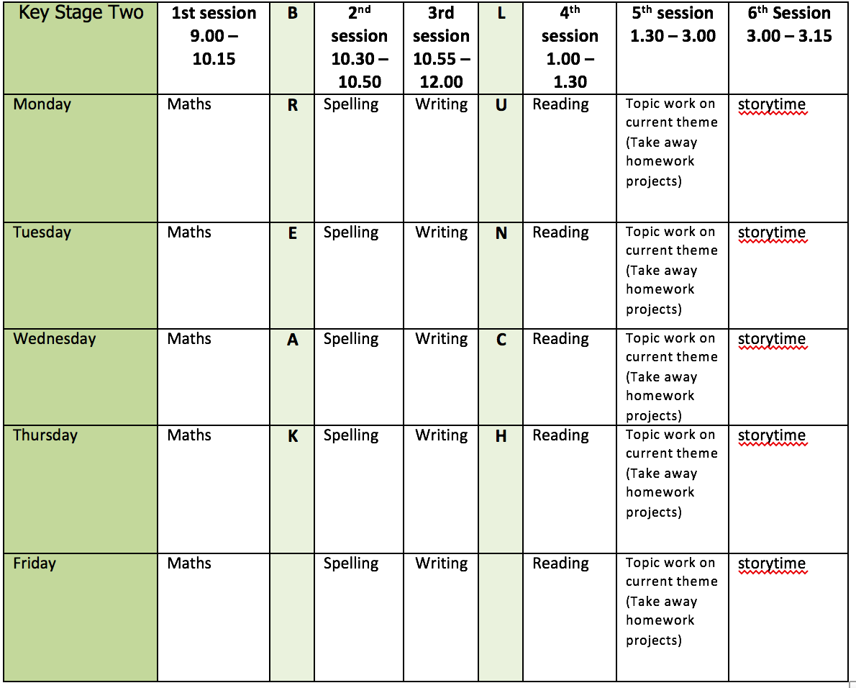

Mental health and well being
Take some time to talk to someone at home about starting Y5. What are you excited for and looking forward to? Is there anything you are worried about?

English writing activities for the week: Persuasive leaflet on reducing waste
Monday - Plan and write the third Point of your leaflet. Choose a final type of waste e.g. food and get persuading! Proof-read it and make any corrections you need to.
Tuesday - Plan and write the Ending of your leaflet. Summarise why reducing waste is so important and how it will impact on our future. Proof-read it and make any corrections you need to.
Wednesday - Write up and present your persuasive leaflet. Don’t forget to include lots of colour and images to engage your reader.
Thursday - Share your leaflet with someone. Have you persuaded them to make some changes? You could even send a copy of your leaflet to someone else in the class to read or share it on a video call.
Friday - Free choice! Write about anything you would like to as it is your last day of Y4.

Reading:
‘The Suitcase’ comprehension
Fill in your 20 books for 2020 sheet. How many have you ticked off already? Create your own summer reading challenge to find books that tick off any you are missing.

Spelling:
Play some spelling games on Purple Mash each day. Well done for working so hard all year on your spellings!

Maths activities for the week:
All worksheets, answers and video links attached.
Monday - Lines of symmetry
Tuesday - Complete a symmetric figure
Wednesday - Describe position
Thursday - Draw on a grid
Friday - Revision of anything tricky from week/Mathletics/Times Tables Rock Stars/Purple Mash maths games

Topic work
Monday - Create a crossword or a wordsearch around our ‘What a Waste’ topic. Try and make it tricky so you can challenge your grown up to complete it.
Tuesday – Write a ‘topic alphabet’. Can you come up with a word for every letter that links to our topic?
e.g. R – recycle, S – sea, T – toxic…
Wednesday - Write a prayer for our class Prayer Book. Present it as beautifully and creatively as you can and think about what you have to be thankful for and what you would like God to help you to do/be in the future.
Thursday - Draw your favourite memory from Y4 and share it with your family.
Friday - Free choice! Enjoy your last official afternoon in Y4 by spending it doing some of your favourite things. We would have had a picnic on the field, played games and listened to music so you might like to do this with your family.

PE
This week’s challenge – 5-minute run! Complete your own daily 5-minute run around your garden or (if an adult will come with you) somewhere nearby.

