Year 4
WB 6.7.2020

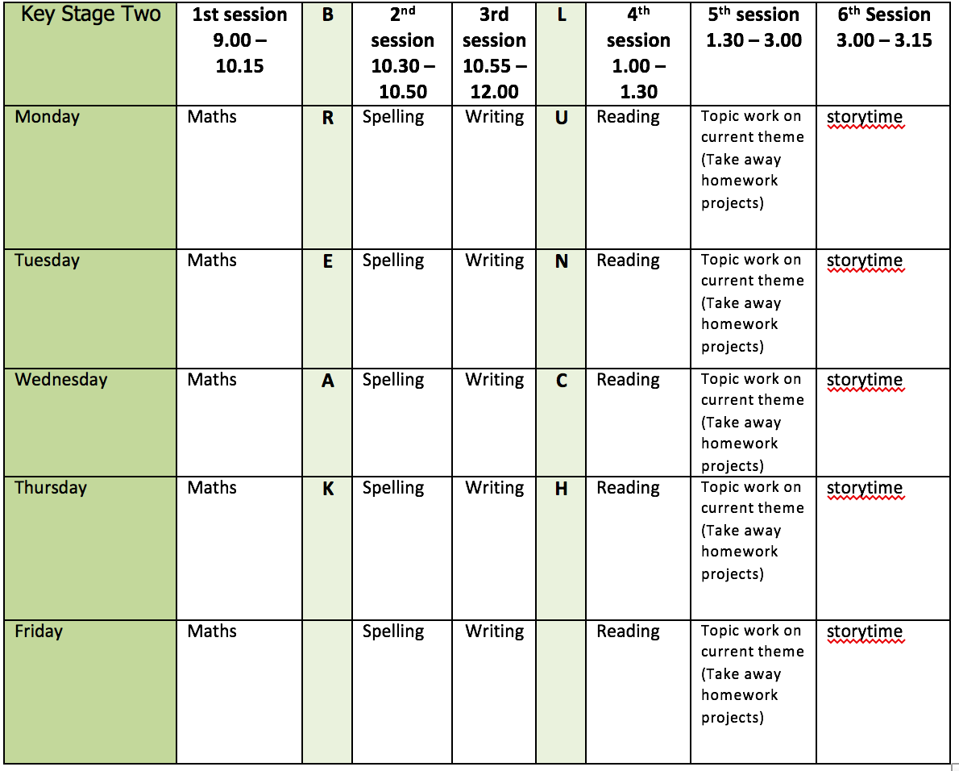
Mental health and well being
Write a gratitude journal. Each day, write down three things that you are grateful for. They can be small things like a walk in the sunshine or big things like your family.

English writing activities for the week: Persuasive leaflet on reducing waste
Monday – Write a letter to your Reception buddy. Introduce yourself and tell them a bit about school and what they can look forward to. This week I will be texting you your Reception buddy's name so you can address it to them when you receive the text. I have attached some paper that you might like to write your letter on and if you post it in the box at the front of school, we will send it to your buddy. If you can't get to school, please send us a photo of your letter and I will print it out to send.
Tuesday - Read the attached persuasive writing and create a toolkit for your leaflet. What do you think you need to include? Think about persuasive techniques and also how you will present your leaflet. Research some facts and statistics that you can use to persuade people to reduce their waste.
Wednesday - Plan and write the Introduction of your leaflet. This needs to explain what you are writing about and why, without going into too much detail yet. Proof-read it and make any corrections you need to.
Thursday - Plan and write the first Point of your leaflet. You need to choose a particular kind of waste to focus on e.g. plastic and then persuade people not to waste it and to recycle as much as they can. Proof-read it and make any corrections you need to.
Friday - Plan and write the second Point of your leaflet. Do the same again with another type of waste e.g. clothing. Proof-read it and make any corrections you need to.

Remember our persuasive techniques: rhetorical questions, statistics, power of 3, exaggeration, emotive language. This video might help remind you of some of them:
https://youtu.be/Mlka2xBvV5Q

Reading:
Choose a new book and predict what it might be about from just the front cover (day 1), then the back cover and blurb (day 2) then the first page (day 3). Make sure you write your predictions down each day. Keep reading (days 4 and 5) to see if your predictions were accurate!

Spelling:
Homophones: there/their/they’re, who’s/whose, our/are, to/too, past/passed (2 days)
weather/whether, mist/missed, team/teem, scene/seen, mail/male, bawl/ball, piece/peace, main/mane, fair/fare (3 days)
Use some of the normal strategies to practise and complete some of the homophone wordsearches.

Maths activities for the week:
All worksheets, answers and video links attached.
Monday - Identify angles
Tuesday - Compare and order angles
Wednesday - Triangles
Thursday - Quadrilaterals
Friday - Revision of anything tricky from week/Mathletics/Times Tables Rock Stars/Purple Mash maths games

Topic work Science (electricity)
Monday - Identify all of the appliances in your home that run on electricity. How many are there? Draw and label them all.
Tuesday - Conductors and insulators – https://www.bbc.co.uk/bitesize/topics/z2882hv/articles/zxv482p
Create a table of conductors and insulators you can find in your home.
Wednesday - Electrical circuit symbols - https://www.bbc.co.uk/bitesize/topics/zq99q6f
Read about electrical circuits and their symbols. Draw some of your own using the correct symbols. You could even use string or wool to represent the wires.
Thursday - Is it a circuit? Look at the attached cards and predict whether or not they show a complete circuit. It says test them but I know you won’t all be able to do that at home – don’t worry!
Friday - Create a zigzag book all about electricity. Present it as neatly and carefully as you can and then share it with someone in your household. Make sure that somewhere in your booklet you talk about reducing waste.

PE
This week’s challenge – create your own obstacle course at home! Try and make sure it uses as many of your muscles as possible and make it as challenging as you can. Then time how quickly you and your family can complete it!

