Week beginning: 6.7.20
Year 6
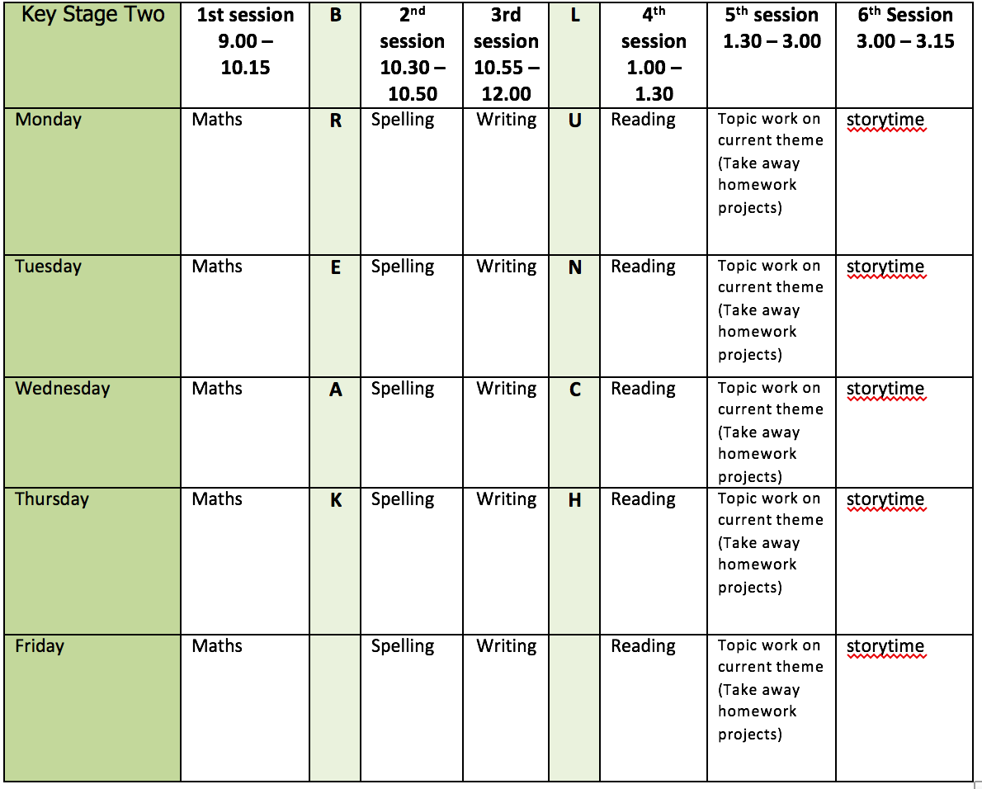
Mental health and well being
Choose an activity from the list below as and when you need it:
1. Colouring sheets.
2. Crosswords
3. Sudoku
4. Doodling/drawing
5. Reading
6. Listen to relaxing music https://www.youtube.com/watch?v=qFZKK7K52uQ
7. Yoga - https://www.youtube.com/watch?v=Td6zFtZPkJ4

Maths activities for the week: (11)
1. Monday Lesson 1 - Vertically opposite angles
2. Tuesday Lesson 2 - Angles in triangles
3. Wednesday Lesson 3 - Angles in quadrilaterals
4. Thursday Lesson 4 - Angles in polygons
5. Friday Lesson 5 - Practise your timestables (on TT rock stars if you wish) and then complete the appropriate timestable sheet (5 minute timer) Complete the Friday Maths Challenge https://whiterosemaths.com/homelearning/year-6/

Spelling:
The spelling pattern focus for this week is: Homophones

Teach tips: Homophones are words that sound the same but have different meanings. They also have different spellings. For example: aisle/isle, led/lead, steal/steel, draft/draught
Also, teach the difference between practise/practice ‘I practise (verb) my piano; I attend piano practice (noun)’ and also advise/advice, devise/device. Notice the zzz in the verb form.

1. Monday Create a list of as many homophones as possible.
2. Tuesday Look up the definition in a dictionary of any word meanings not known (past/passed, morning/mourning, cereal/serial, desert/dessert, who’s/whose etc) write own definitions.
3. Wednesday Create 6 sentences using the noun and verb versions (practice/practise, advice/advise, device/devise).
4. Thursday Learn the homophones (Use different colours, write mnemonics to remember the letter order, draw around the shape of the word, play hangman, test yourself)
5. Friday Complete the wordsearch.

English writing activities for the week: Biography writing
1. Monday First, watch this video https://www.youtube.com/watch?v=uCYDT2SVgbY I hope you enjoy watching it! Then, research the life of David Attenborough and write down key facts (make sure you include some on his work with plastic pollution and looking after our planet) https://www.biographyonline.net/scientists/david-attenborough.html
https://www.britannica.com/biography/David-Attenborough
2. Tuesday Read the example biography paragraph (you might recognise this from the autumn term). Highlight any phrases and punctuation which can be used in your own piece of writing. Look at the list of subheadings and create at least 5 of your own subheadings. There is also a helpful list of sentence openers.
3. Wednesday Plan your biography (challenge: could you include a quote from someone else about how they would describe David Attenborough?)
4. Thursday Write 3 paragraphs
5. Friday Write the next 2 paragraphs/the rest of your biography

Reading:
1. Monday - 30 mins of independent reading
2. Tuesday - Comprehension (read the 2nd page of the comprehension and complete questions 1-11 - this week’s is extract 6: The Cave part 2)
3. Wednesday - 30 mins of independent reading
4. Thursday –Comprehension (complete questions 12-21 on The Cave part 2)
5. Friday – 30 mins of independent reading

Topic work:
1. Monday Leavers - On a new page in your book, write what you want to be when you are older. Write it clearly on a whiteboard/piece of paper and decorate it. Take a photo of you holding this. Please email me the photo!
2. Tuesday Art – as you have seen in your writing last week, sea turtles are one of the animals most affected by plastic pollution. Draw a sea turtle using a pencil (you can use the cheat method if you would like to!) try and include as much detail as possible.
3. Wednesday Transition – Lesson 1 (feelings about high school) Please see the PowerPoint.
4. Thursday Science/Art – Using your knowledge of how animals adapt to their environment from the autumn term, invent your own sea creature to survive against plastic pollution. What would it look like? What ocean would it live in? What features would it have to help it survive? Draw and label your creature.
5. Friday Free choice from the takeaway homework list or a mental health and well-being activity.

PE:
Please find ideas for daily PE activities on the PE documents on the webpage and via the link below:
https://homelearning.primarypepassport.co.uk/#/
This week’s daily challenge: how many burpees can you do in 2 minutes? Can you improve your score each day?

