W/C 27.06.20

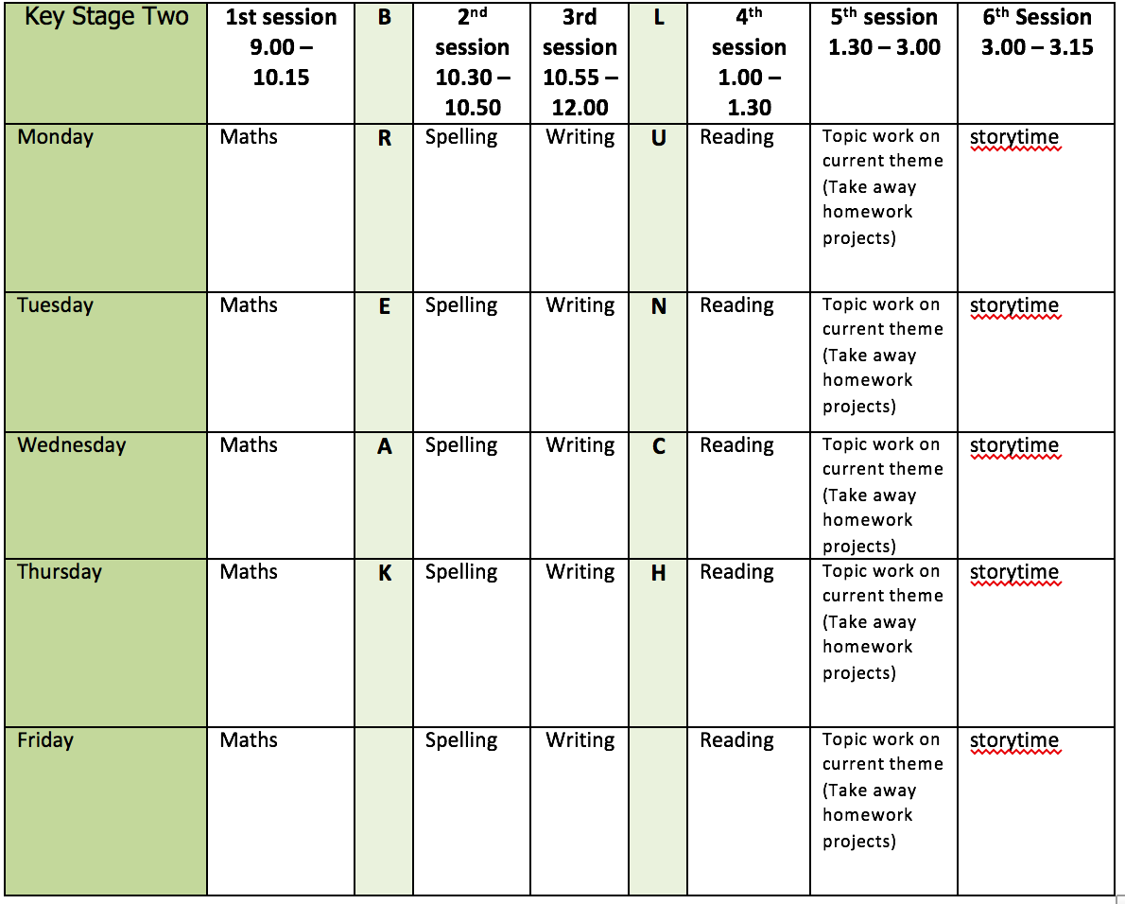
Mental health and well being
Wildlife trusts 30 days wild (resources included)

English writing activities for the week: Flotsam
Monday: Watch Flotsam Session 5 pausing at 7 minutes and 35 seconds. Create a storyboard for what you consider to be the 6 main events in the story. Resume the session pausing at 11 minutes and 15 seconds. Now, add captions underneath your pictures. Remember, you are summarising what has happened in short notes so keep them short and simple for now. Finish watching the session and add the adverbials to the captions to tell the reader when, where or how each event happened. This will help you to sequence and retell the story when you come to writing it.

Tuesday: Watch Flotsam Session 6 pausing at 5 minutes and 50 seconds. Check you storyboard and make any changes that you think you need to. Resume the session pausing at 13 minutes and 50 seconds. Write out the opening sentence, ‘The boy went to the beach’ on a strip of paper. Now, improve it! Remember, because we want to hook our reader and make them want to read on, do not introduce the character or the exact location too soon! Resume the session pausing at 22 minutes and 26 seconds. Using post-it notes (or pieces of paper) answer the when, where and how questions and choose where you think they best fit within your sentence. Remember, if you choose to use one of your adverbial phrases at the beginning of a sentence, it must be followed by a comma.

Wednesday: Finish watching Flotsam session 6. Now, it is time to retell the story. Remember to consider the language you are using. Include well-chosen verbs, adverbs and adjectives. As a challenge, can you use a simile in your writing? Remember to use a range of conjunctions and vary how you start sentences to make your writing more interesting for your reader. Good Luck!

Thursday: Watch Flotsam session 7. Pause the video at 5 minutes and 21 seconds. Cut out 6 pieces of paper to cover the original sections of your storyboard. Pause the session at 11 minutes and 25 seconds. Now, using the pieces of paper you prepared earlier, create a new storyboard for the 6 main events in your new story. Give yourself some time to come up ideas for your version of the story. Who is the main character? What might they find on the film? Could there be problems with plastic in some of the picture? What strange things might the animals be getting up to? Then, add captions underneath your pictures. Remember, you are summarising what has happened in short notes so keep them short and simple for now.

Friday: Finish watching session 7 and add your own adverbials to your new captions. This will help you to sequence and retell the story when you come to writing it.

Reading:

Alongside the release of ‘The Ickabog’, JK Rowling’s publishers have started a competition for children to illustrate the book! Each week I am going to set you a new illustration to complete. If you would like to enter any of your illustration ask an adult to find out a little bit more about it for you https://www.theickabog.com/competition/

Monday: Read Chapter 6 of ‘The Ickabog’ https://www.theickabog.com/the-fight-in-the-courtyard/ and talk with an adult about the following:
- Do you think Daisy over-reacted? Fighting never solves anything. What would you have done if you were in Daisy’s position?
- What was it the word ‘silly’ that finally made Daisy crack?
- Overall, do you think Daisy is a strong character or a weak character? Be ready to explain why you think what you do.

Tuesday: Today you are going to be thinking about atmosphere. The Atmosphere is the feeling, emotion or mood that the author creates through descriptive language. Read to the end of the second paragraph of Chapter 7 (ends with ‘…eating a second plate of Fairies’ Cradles.’) of ‘The Ickabog’ https://www.theickabog.com/lord-spittleworth-tells-tales/.
- What is the atmosphere like at the beginning of the chapter and why?
- When did the atmosphere change and what happened in the story to indicate this?

Wednesday: Read the rest of Chapter 7 of ‘The Ickabog’ and, using what you have learnt about him in the story so far, Illustrate Major Beamish.

Thursday: Read chapter 8 of ‘The Ickabog’ (with an adult if possible) https://www.theickabog.com/the-day-of-petition/. Discuss/think about the King’s motives for his behaviour.
- What do you think about the King’s actions? Is he being kind for the right reasons?
- Is he really a kind King?

Friday: Based upon what you have learned about the characters so far, use the resource provided to create a character profile for King Fred and Daisy.

Spelling:
Introduce the homophones from the supporting resource and discuss their meanings with an adult or look them up in a dictionary.
Your challenge is to create sentences that contain both, or all of the words – for example, He’ll find that his heel will not heal.
How many more homophones do you know? Can you do the same for these?

Continue practise of words from Y3/4 list (3 days) using the strategies provided.

Maths activities for the week:
Monday: Draw accurately
Tuesday: Recognise and describe 2D shapes
Wednesday: Recognise and describe 3D shapes
Thursday: Telling time to 5 minutes
Friday: Revision of anything tricky from week/Mathletics/Times Tables Rock Stars/Purple Mash maths games

Topic work
Monday: Can you remember how to design and create your own shadow puppet? Follow the link for a full tutorial from Diana Bayliss - the lovely and talented lady who our Hansel and Gretel workshop - and create an underwater creature with a difference just like in Flotsam https://www.youtube.com/watch?v=NPSuWb_MY7Q&feature=youtu.be. There is also a materials list in the resources section.
Tuesday: Make a protest poster https://www.tate.org.uk/kids/make/paint-draw/make-protest-poster. Send a positive message out into the world in your own unique style. You could create a poster with a message about something you care about or you could follow our learning theme and use the opportunity to send a message about plastic waste.
Wednesday: Wellbeing Wednesday - Complete one of the Random Acts of wildness from the wildlife trusts 30 days wild or tune into your sense and go on sound hunt. Go for a walk and pause every so often to tune in to your surroundings. What can you hear? Birds tweeting? Dogs barking? Footsteps? Traffic? The wind in the trees? Make a note of everything you hear.
Thursday: PE – Mr Dooley has shared some new resources for you to have a go at (see weekly learning page) or have a go at some of the athletics activities shared last week.
Friday: Have a go at one of the starters for stem activities. Can you build a bionic hand or a Space Rocket? https://www.stem.org.uk/resources/elibrary/resource/468235/starters-stem#&gid=undefined&pid=15

