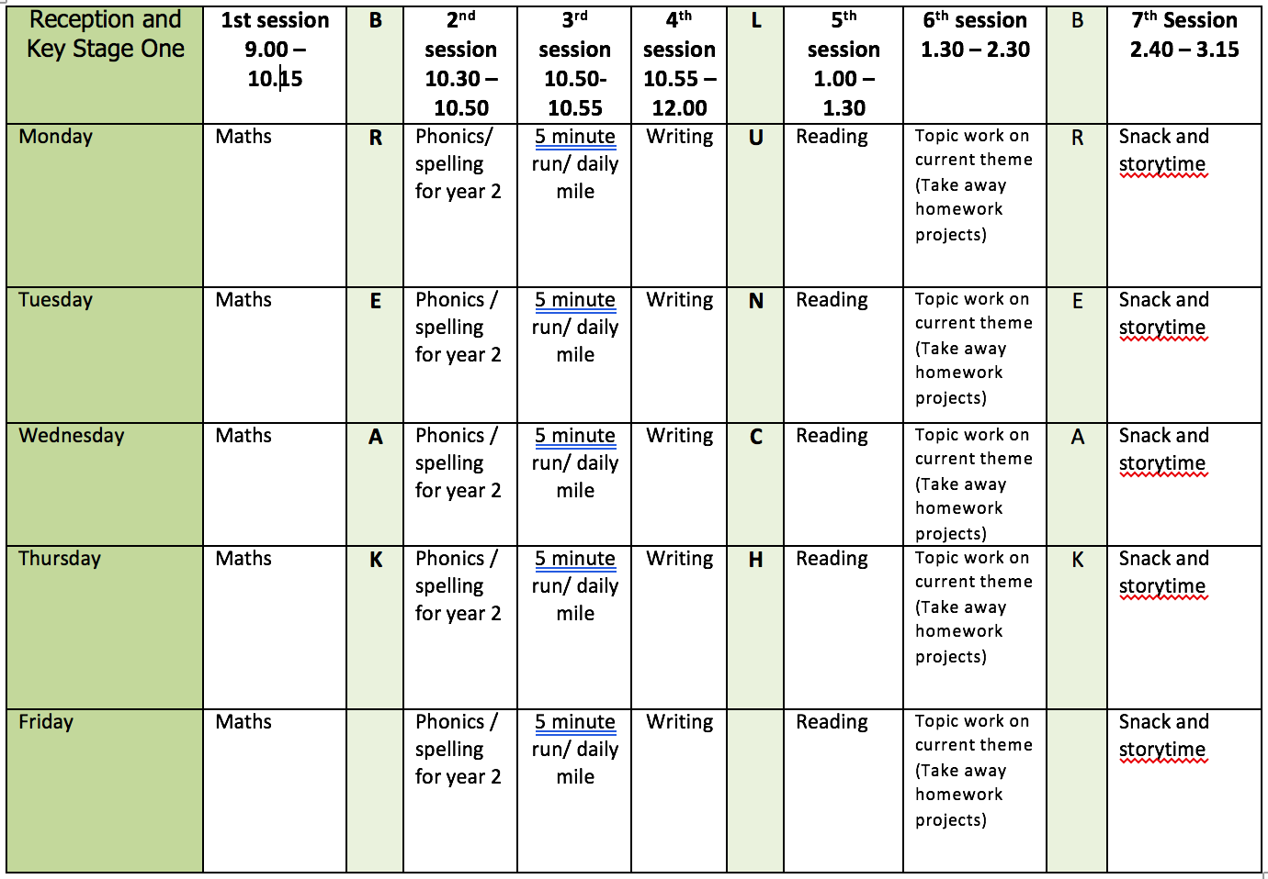

ENGLISH WRITING:
This week I have included the pages from What a Waste that are linked to Water. The writing focus this week is Poetry. Although these poems are not water related when you write your own you might like to link them to water or animals that live in water. All the poems are by Pie Corbett.
There is a copy of each poem on the learning webpage and in the resources file there is a poetry toolkit and poetry glossary.

Monday – City Cafe
- Read the poem. Look at the way the poem is written. What do you notice? – The poet has used a simple pattern and senses.
- Follow the over to you part to write your own poem.
- You might like to link this one to water with looking at a waterfall, listening to water running, tasting a glass of water

Tuesday – Yesterday
- Read the poem. Can you spot the noun phrases using adjectives and nouns? Look at how the poet has expanded the sentences
- Use the structure of the poem and the Over To You section write you own.
- Be inventive with the imaginary things you saw.

Wednesday – Silly Alphabet People
- Choose a few letters from the alphabet or maybe use the letters in your name.
- Let’s see who is up to the challenge of using all the letters of the alphabet.

Thursday – The Animal Ark
- This poem uses alliteration and lots of noun phrases.
- Use the water theme and choose animals that live or go in water.

Friday
- At school we call editing work Green for Growth. Choose one piece of work from this week.
  - Check your punctuation.
  - Does your work make sense when you read it out loud? Is the tense correct?
  - Check the spellings of common expectation words using the Y1 and Y2 Word Lists.
  - Have you used interesting language in your work?
  - Have you used different sentence types?
- Redraft any parts you think you can improve.

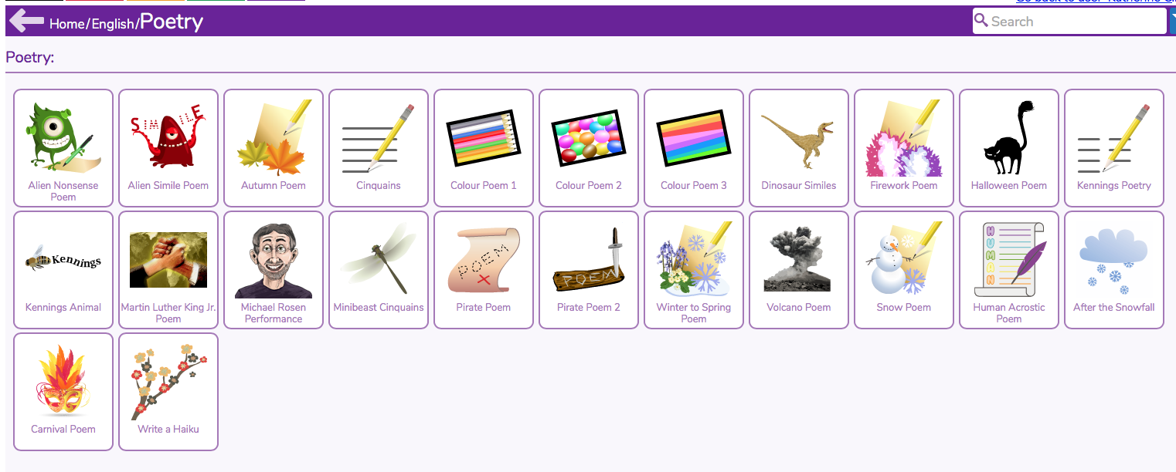
If you enjoy the Poetry work there are lots of activities in Purple Mash.

READING
Monday
- Fluency Expression - reading out loud to develop reading fluency and expression. Continue this daily throughout the week.
- Practice reading words from the words lists provided in Week 1.
Tuesday
- Cake by Sue Hendra & Paul Linnet https://www.bbc.co.uk/bitesize/articles/zhqr47h
- Activity 1 True or False
Wednesday
- Activity 2 Answering questions about the text.
Thursday
- Activity 3 Writing a verse for Cake to sing.
Friday
- Complete any work from Cake.
- As Monday.

SPELLING
With the dictation say the sentences one at a time. Check the spelling and punctuation in these sentences. Then practice the spelling focus.
I have made a spelling quiz for each week’s spelling focus in the Purple Mash 2Dos section.
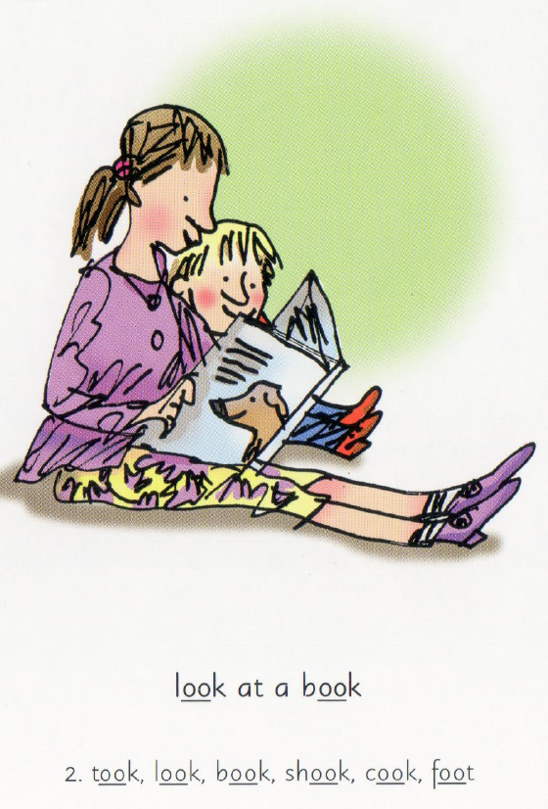
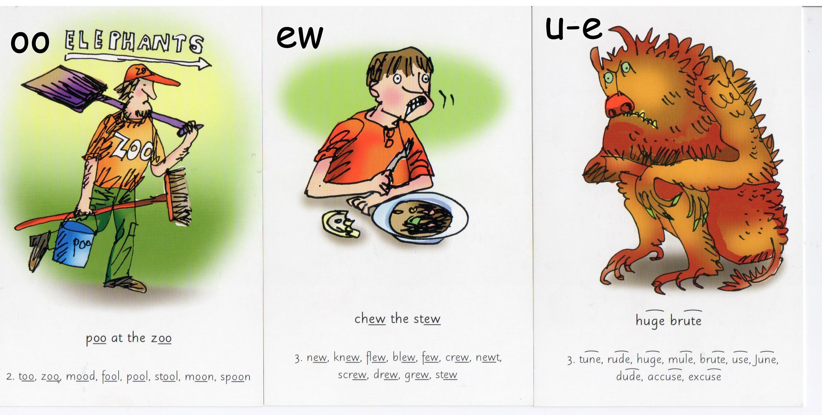

Monday
- Spelling U-E words – blue June tune tube rude
- Dictation - In June, Jim gets a big, red car. Sam is rude to him. He just has a bent, blue bike.
Tuesday
- Spelling OO (long sound) OO (short sound) words – food moon room soon spoon zoo cook look foot good
- Dictation - The fat man cook lots of good, hot food. The dog soon looks in the room.
Wednesday
- Spelling EW words - new flew blew few crew screw grew stew
- Dictation – Sam blew his nose. His stew was too hot to chew.
Thursday
- The /∧/sound spelt o – other mother brother nothing, Monday
Friday
- Use the words lists (common exception words) on the webpage. Look for any of this week’s sound/spelling focus on these lists and practice spelling them.
- If there aren’t any choose a selection of words to learn and write in a sentence.

Further resources to support Phonics and Spelling
- Word Lists – Y1, Y2, Y3/4 (on Week 1 Home Learning Page)
- Help Your Child With Spelling Document (on Week 1 Learning Page)
- Read Write Inc. – daily phonics/spelling lesson starting at 9.30 and then available for 24 hours after that https://www.youtube.com/channel/UCo7fbLgY2oA_cFCIg9GdxtQ

MATHEMATICS (WHITE ROSE)
All these resources are on the webpage with the exception of Friday.
Monday
- Lesson 1 – Measure mass in grams
Tuesday
- Lesson 2 – Measure mass in kilogram
Wednesday
- Lesson 3 – Compare Volume
Thursday
- Lesson 4 – Millilitres
Friday
- Friday Maths Challenge - White Rose in partnership with BBC Bitesize https://www.bbc.co.uk/bitesize/tags/z7s22sg/year-2-and-p3-lessons/1

Further resources to support mathematics:
- Times Table Rockstars https://ttrockstars.com
- Purple Mash https://www.purplemash.com/sch/bunburyaldersey
- Mathletics https://login.mathletics.com

TOPIC & WELL BEING

Monday
- BBC Bitesize Which Materials Dissolve in Water https://www.bbc.co.uk/bitesize/topics/zrssgk7/articles/zpd6hyc
- With adult supervision try dissolving the different materials in water. If you click on each of the pictures there is an explanation. You could experiment first and then listen to explanations. Think about how to record your observations. You could take a photograph or draw what happens before, during and after the experiment.
Tuesday
- BBC Bitesize States of Matter https://www.bbc.co.uk/bitesize/articles/z6j2mfr
- Watch the videos and complete the activities.
- Adult supervision is required for Activity 2

Wednesday
- Purple Mash Computing - Coding
- I have put the activities in your 2Dos so they are easy to find.
- We have already used Fun With Fish and Bubbles but have a go at them again to remind you of what we have done previously.
- Then try Air Traffic Control and Snail Race

Thursday
- PE Orienteering – Message From Mr Dooley This week I'd like you to try something different and use your fantastic creativity having a go at some orienteering. I have included some worksheets to help you design your own orienteering map and course. Further information can be found at https://www.britishorienteering.org.uk/home_resources
Also, please find attached the Chester School Sports Partnerships newsletter, which includes some more great ideas and activities if you want to challenge yourselves further this week. Stay fit and active everyone. Mr Dooley.

Friday
- Well Being – Wheel Of Coping Skills
- Take two paper plates and cut out a small triangle towards the middle of one plate.
- Spin the plate and write the skills in each section of the second plate that is exposed in the section that was cut out.
- Insert a paper fastener so the plate can spin and reveal the skills.
- Decorate any way you like!
- These work great to have available in a calm down area or in a coping skill box at home or in the classroom.
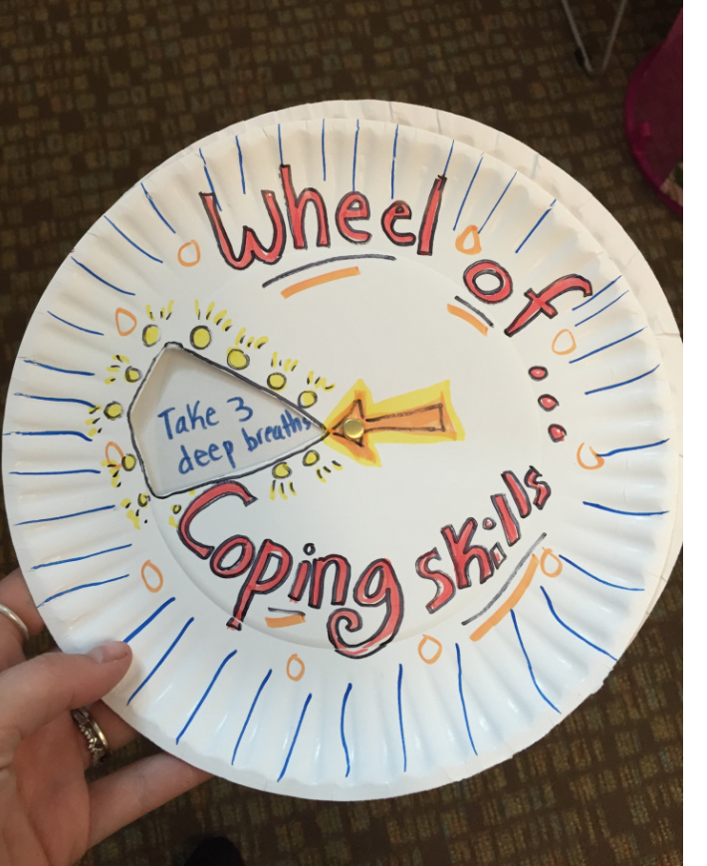
- Another way to use the wheel is to act out situations with puppets or role-play and use the wheel to choose which skill to use given the situation. This helps children learn to choose skills that best suit the setting and get more practice using them!

PHYSICAL EDUCATION
- Use the links and resources from Mr Dooley already available on the class home learning webpage. Mr Dooley has sent more resources for this term, which are on a separate page.
- PE with Joe https://www.youtube.com/channel/UCAxW1XT0iEJo0TYlRfn6rYQ
- Go Noodle Activities https://family.gonoodle.com

