Galapagos Giant Tortoise

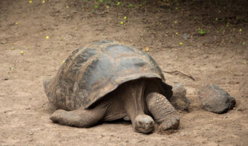

The **Galapagos Tortoise, which** is the largest tortoise on the planet, is arguably the most well-known animal of the Galapagos Islands and this is the only place on earth where they can be found. The Giant Tortoises are thought to belong to just one species, Geochelone elephantopus, with 14 different races or sub-species, four of which are believed to be extinct.

Did you know?

The Galapagos Giant Tortoise can live for more than 100 years, the oldest recorded tortoise being 152 years old.

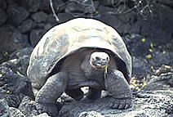

**HABITAT**

The environment and climate of the Galapagos vary from island to island. Saddle-backed tortoises tend to inhabit the hotter, drier islands with sparse vegetation, whereas domed tortoises inhabit the cooler, wetter islands with lush ground vegetation.

Like other reptiles, Galapagos tortoises are cold-blooded animals. They spend much of their day soaking up the sun to warm themselves. When the sun goes down and the temperature cools, tortoises sleep partially submerged in mud, water or brush to keep warm.

Other birds which share their habitat - including Galapagos Hawks and Flycatchers - often use tortoises as observation posts from which to sight their prey.

**DIET**

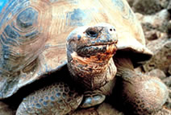

Galapagos tortoises are herbivores which means they do not eat meat, only vegetables. Their diet consists of an array of different foods: cactus, fruits, vines, grasses and other vegetation. Tortoises can store food and water very efficiently and for a very long time. This means that they are able to go without eating or drinking for up to one year. Giant Tortoises can also survive for long periods of time being forcefully deprived of all liquids, by breaking down their body fat to produce water.

**Appearance**

Galapagos tortoises have different shells depending on the island which they live on. Some have domed carapaces – shells - and others have saddleback carapaces.

Galapagos Giant Tortoises keep growing until they are about 40 – 50 years old and can reach a weight of 500 pounds. The Galapagos Giant Tortoise can grow to be 5 feet tall. They are one of the longest living of all vertebrates (animals with backbones).

The tortoises are slow-moving reptiles with an average long-distance walking speed of 0.3 km/h. However, although feeding giant tortoises move about slowly, browsing with no apparent direction, if they have a purpose, such as moving to water or nesting grounds, they can move with surprising speed and determination given their size. Marked individuals have been reported to have travelled 8 miles in 2 to 3 days.

**Adaptation**

The original ancestor of the tortoises is thought to be of normal size and evolved into the present-day giants after its arrival in Galapagos. This is due to a phenomenon seen in many island ecosystems where gigantism evolves because there is no longer any need to hide from predators and because there are no other similar animals to compete with for food. Once the tortoises spread around the archipelago, they evolved on their isolated islands into the different races we see today - some with domed carapaces, and others with saddleback carapaces. The unusual saddle shape is believed to have evolved several times on different islands, showing that it must be a very successful design for life in Galapagos.