Week beginning: 29.6.20
Year 6
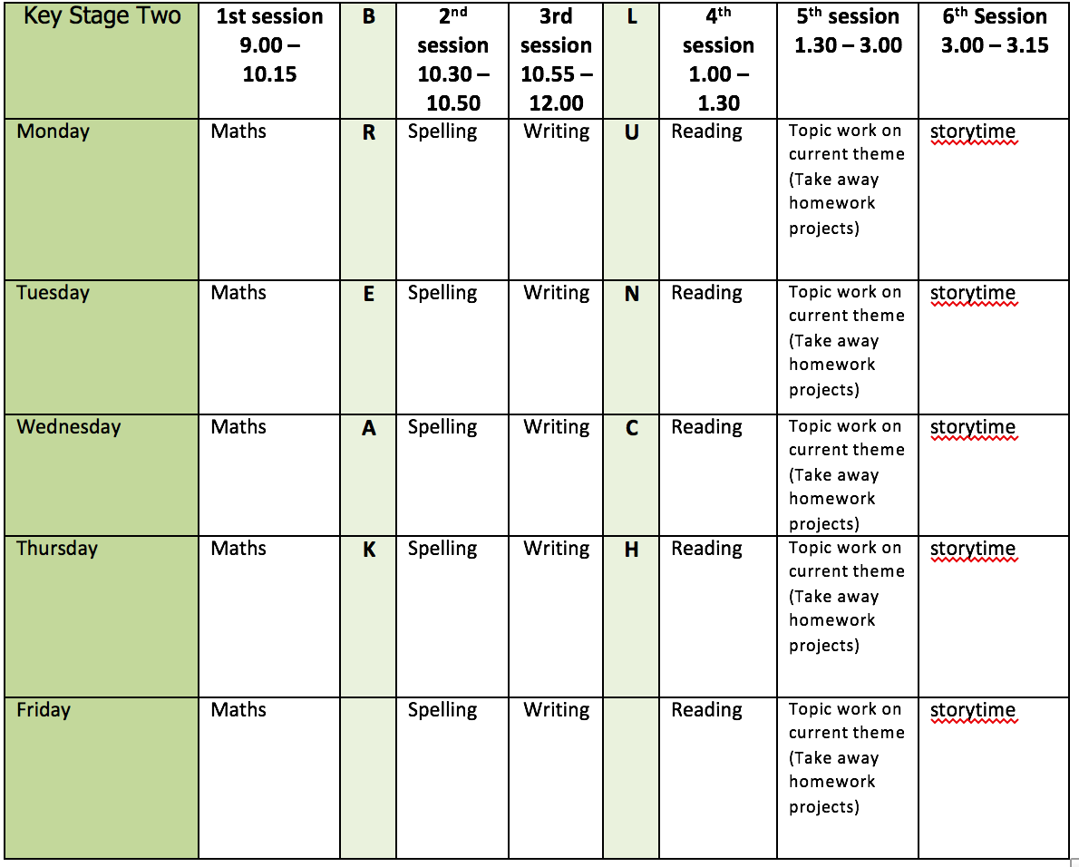
Mental health and well being
Choose an activity from the list below as and when you need it:
1. Colouring sheets.
2. Crosswords
3. Sudoku
4. Doodling/drawing
5. Reading
6. Listen to relaxing music https://www.youtube.com/watch?v=qFZKK7K52uQ
7. Yoga - https://www.youtube.com/watch?v=Td6zFtZPkJ4

Maths activities for the week: (10)
1. Monday Lesson 1 - Introducing the ratio symbol
2. Tuesday Lesson 2 - Calculating ratio
3. Wednesday Lesson 3 - Using scale factors
4. Thursday Lesson 4 - Ratio and proportion problems
5. Friday Lesson 5 - Practise your timestables (on TT rock stars if you wish) and then complete the appropriate timestable sheet (5 minute timer) Complete the Friday Maths Challenge https://whiterosemaths.com/homelearning/year-6/

Spelling:
The spelling pattern focus for this week is: silent letters

Teach tips: play spot the silent letter e.g. island, lamb, solemn, knight, wreck. Some letters which are no longer sounded used to be sounded hundreds of years ago: e.g. in knight, there was a /k/ sound before the /n/, and the gh used to represent the sound that ‘ch’ now represents in the Scottish word loch.

1. Monday create a table according to the silent letter in a word then highlight the silent letter e.g.
k b w n d p u
Add own examples to lists.
2. Tuesday Look up the definition in a dictionary of any word meanings not known and create 5 sentences using any of the words.
3. Wednesday Dictation – read out the paragraph of words to your child. They write down the silent letter words and then mark them. “When I was a knight, I knelt down on one knee to tie a knot in my shoelace. This happened in autumn, after I wrestled the dragon and slayed it with my knife. For lunch, I ate a sandwich and a biscuit which left a few crumbs, but I guessed it would not wreck the castle building or its columns. Last Wednesday, we sang a hymn and I felt quite numb.”
4. Thursday Learn the silent letter words. (Use different colours, write mnemonics to remember the letter order, draw around the shape of the word, play hangman, test yourself)
5. Friday Complete the wordsearch.

English writing activities for the week: Information Text writing
1. Monday First, watch this video https://www.youtube.com/watch?v=5Rmv3nliwCs
and then watch this one: https://www.youtube.com/watch?v=ZaQ_AqiKz-w
Write down facts about sea turtles and about the effects of plastic pollution.
2. Tuesday Read the example information text on the Galapagos Tortoise (you might recognise this from the autumn term). Highlight any phrases and punctuation which can be used in your own piece of writing. Look at the list of subheadings and create 4 of your own subheadings including one on the effects of plastic pollution.
3. Wednesday Plan your information text (remember to include a ‘did you know?’ fact).
4. Thursday Write 2 paragraphs
5. Friday Write the next 2 paragraphs

Reading:
1. Monday - 30 mins of independent reading
2. Tuesday - Comprehension (read the 1st page of the comprehension and complete questions 1-10 - this week’s is extract 5: The Cave)
3. Wednesday - 30 mins of independent reading
4. Thursday –Comprehension (complete questions 11-19 on the 1st page of The Cave)
5. Friday – 30 mins of independent reading

Topic work:
1. Monday Well-being - create a team flag made up of smaller flags. Use an A4 piece of paper for your flag. It should include a value or quote that you feel is important in the middle and can be decorated any way you wish. Please email me your flag. You are all part of the Year 6 family!
2. Tuesday Leavers – make a paper book to write all of the leaver’s activities in. You can hole punch some pieces of paper and tie string through to create a book or you can create one like in this video: https://www.youtube.com/watch?v=21qi9ZcQVto. Decorate the front cover. Think of a list of questions which you want to be included in the video year book. For example: what is your favourite memory of primary school at Bunbury?
3. Wednesday Leavers – Answer the list of questions. Practise answering the virtual year book questions. Film your individual leavers’ book video. Please send it to me!
4. Thursday Leavers – discuss any other areas you want to include in the video. It could be a poem or playing an instrument. Please film yourself reading the poem or playing the instrument and send it to me if you want to include something.
5. Friday Free choice from the takeaway homework list or a mental health and well-being activity.

PE:
Please find ideas for daily PE activities on the PE documents on the webpage and via the link below:
https://homelearning.primarypepassport.co.uk/#/
This week’s daily challenge: how many squats can you do in 2 minutes? Can you improve your score each day?

