Year 4
WB 29.6.2020

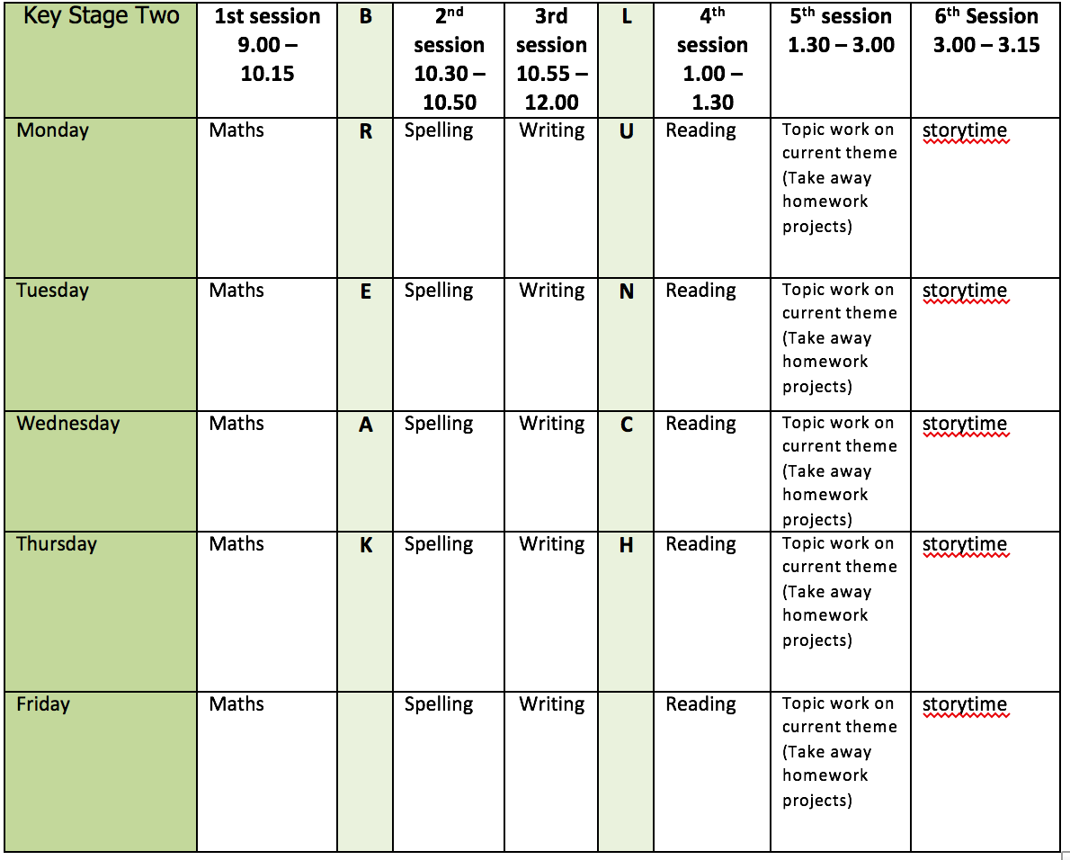
Mental health and well being
Try 5 minutes of ‘mindfulness colouring’ each day this week. You could print off some of the attached colouring sheets or draw something of your own to colour. Try putting some calming music on while you do it.

English writing activities for the week: Biography
Monday - Plan and write your Ending paragraph. This should summarise Greta as a person and why she is so well known. It might also look to the future.
Tuesday - Proof-read through each paragraph of your biography and make any corrections to spelling or punctuation. Are there any sections you might want to edit and improve further? You could make your own ‘editing flaps’ if you would like to of edit in a different coloured pen/pencil.
Wednesday/Thursday - Write up your whole biography and present it as neatly and carefully as you can. You might want to fold your own book to present it in like we sometimes do in school.
Friday - Now that you have learnt all about Greta Thunberg, can you find out about some other young activists? Write down your research either on paper or in a PowerPoint presentation.

Reading:
3 days reading for pleasure
2 days creating a detailed book review. Follow this link for tips on how to write your review: https://www.booktrust.org.uk/books-and-reading/tips-and-advice/writing-tips/writing-tips-for-teens/how-to-write-a-book-review/
You can use the template attached or write your own using these tips – it is up to you!

Spelling:
Spend this week concentrating on the words from the Y3/4 list that you got incorrect last week. If you managed them all (well done!) then try some from the Y5/6 list which I have attached. Use the strategies for spelling document to help you practise.

Maths activities for the week:
All worksheets, answers and video links attached.
Monday - Interpret charts
Tuesday - Comparison, sum and difference
Wednesday - Introducing line graphs
Thursday - Line graphs
Friday - Revision of anything tricky from week/Mathletics/Times Tables Rock Stars/Purple Mash maths games

Topic work D&T (cooking)
Monday - Choose something you would like to learn to cook this week. The skills we need to develop in year 4 are peeling, chopping, slicing and assembling so make sure whatever you choose requires some of these. Spend today finding a recipe to follow and making sure you have everything you need to make your chosen dish.
Tuesday - Cook your dish of choice! If you can, take a photo of the finished product before you tuck in as I would love to see it.
Wednesday - Evaluate your dish. Rate it out of 5 for taste, texture, appearance and level of difficulty. Write a short paragraph to sum up how the cooking went – did you develop any new skills? Did something go really well? Is there anything you would change for next time?
Thursday - Use your peeling, chopping, slicing and assembling skills to make either a fruit kebab or a fruit smoothie. You should be more confident using a knife now but still make sure you have a grown up with you. Again, I would love to see some pictures!
Friday - Did you have some waste when you were making either of your meals this week? How can we reduce waste when cooking? Do some research to see if you can find some ways to create less waste or to use up any waste created when cooking.

PE
This week’s challenge – design your own game involving a recycled plastic bottle. Get as inventive as you can and don’t forget to send us photos or videos!

