Year 3
W/C 21.06.20

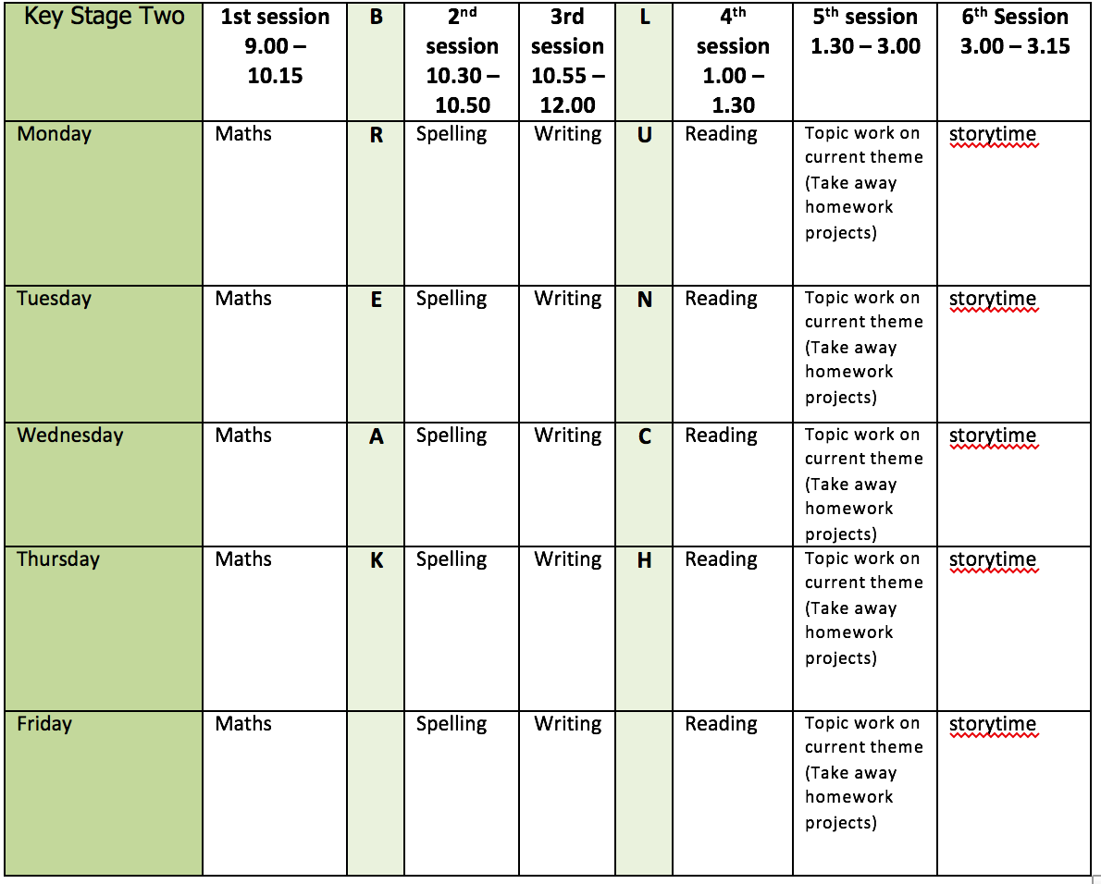
Mental health and well being
Wildlife trusts 30 days wild (resources included)

English writing activities for the week: Flotsam
Monday: Watch the Flotsam Session 2 up to 13 minutes and 21 seconds. Using the grid and images provides complete the ‘What I think I know’ task for at least 2 of the photographs giving your evidence. If possible, talk to an adult about what you can see in each picture.

Tuesday: Watch the rest of Flotsam Session 2 and have a go at writing a diary entry in character. Remember to vary the conjunctions you use (because/as/since/although/therefore/so) and try to start some of your sentences with a conjunction to make it more interesting for the reader.

Wednesday: Watch Flotsam Session 3 up to 7 minutes and 45 seconds. Using one of the images, choose the adjectives and verb that you think will best help you to describe the image. Can you add any of your own? Continue watching the video and pause at 13 minutes and 45 seconds. Use your adjectives to create expanded noun phrases. Remember to place the comma between the adjectives. Continue watching up to 22 minutes and 30 seconds. Now, use you expanded noun phrases to write a sentence that describes the image/scene. Remember to use prepositions to help the reader to really paint a picture in their mind.

Thursday: Finish watching Flotsam Session 3 from where we left it yesterday – 22 minutes and 30 seconds. Now, write your own message in a bottle! As an additional challenge, can you write about more than one of the images/photographs in your letter?

Friday: Watch Flotsam Session 4. Pause the video at 1 minute and 58 seconds. Predict what the next image might be – let your imagination run wild! Pause the session at 8 minutes and 51 seconds on the list of cameras. With the permission of an adult, see how many different types of camera you can find at home. Then either research the camera’s you found or choose 3 to research. Once you have completed your research, return to the session. Pause the session again at 13 minutes and 40 seconds and try to order the cameras Anthony has found. Finish watching the session and write your own leaflet ‘All About Cameras’ using your research. Make sure you use heading and subheadings? Could you start with a rhetorical question or an interesting fact to hook your reader?

Reading:

Alongside the release of ‘The Ickabog’, JK Rowling’s publishers have started a competition for children to illustrate the book! Each week I am going to set you a new illustration to complete. If you would like to enter any of your illustration ask an adult to find out a little bit more about it for you https://www.theickabog.com/competition/

Monday: Read the first 3 paragraphs of Chapter 4 of ‘The Ickabog’ https://www.theickabog.com/the-quiet-house/. It is a time of mourning in Chouxville after Mrs Dovetail’s death. Write a letter to Dovetails to say sorry for their loss. Perhaps you could offer some help to the family? Maybe you could arrange to pay a visit or to do some errands? Then design your very own Chouxville stamp for your letter? You could use a potato/plasticine/cork or foam to print it?

Tuesday: Answer these inference questions about the first part of chapter 4. Remember to use the wording of the question to help you to write your answers. E.g. I think Bert kept looking back at Daisy because…

- Why do you think Bert kept looking back at Daisy at the funeral?
- Why might King Fred have chosen purple for the wreath?
- Hint - try researching what purple symbolizes!
- Why would the Dovetail’s house never be the same again?
- Whose house do you think had black drapes at their window?

Wednesday: Use the website https://www.colormatters.com/the-meanings-of-colors/purple to look up the meaning of the colours: green, blue, orange, yellow, red and pink.

Thursday: Read the rest of the chapter and Illustrate the Dovetail’s home using the clues from the text and your imagination. Then, answer the following:

- How would you feel if you were asked to swap homes with another family to give them more space?
- How do you think the Dovetail’s felt when they were asked to leave?
- Using a thesaurus, find as many words as you can to describe how the Dovetail’s might be feeling?

Friday: Read chapter 5 for pleasure.

Spelling:
Revise Y2 apostrophes for contraction.
Using the words in the resource provided (full word for contraction), write the contracted form of each by placing the apostrophe in the correct position.
Throughout the week, use the contractions in sentences and make sure that you are reading you are using them correctly in your writing.

Continue practise of words from Y3/4 list (3 days) using the strategies provided.

Maths activities for the week:
Monday: Right angles in shapes
Tuesday: Compare angles
Wednesday: Horizontal and vertical
Thursday: Parallel and perpendicular
Friday: Revision of anything tricky from week/Mathletics/Times Tables Rock Stars/Purple Mash maths games

Topic work
Monday: Create your own imaginary polaroid picture of an underwater scene. Be as creative as you can. There is a template on the web page, or you could draw your own!
Tuesday: Create an information report about one of the world’s oceans. This could include a map locating the ocean, what plants and animals live there and the impact humans have on it. https://www.dkfindout.com/uk/earth/oceans-and-seas/
Wednesday: Complete one of the Random Acts of wildness from the wildlife trusts 30 days wild or have a go at an activity from England Athletics Funetics Home Pack.
Thursday: Watch the following clip https://safeyoutube.net/w/B2w6 . Imagine you are a deep sea diver. Write a detailed description about the ocean and include specific species? Include lots of well-chosen adjectives to describe in detail what you saw.
Friday: Have a go at one of the starters for stem activities. Can you create a floating garden or hold take part in a Jelly race? https://www.stem.org.uk/resources/elibrary/resource/468235/starters-stem#&gid=undefined&pid=14

PE
- Mr Dooley has provided you with a new resource ‘Funetics’ from from England Athletics. Why not have a go at a few of the activities.

