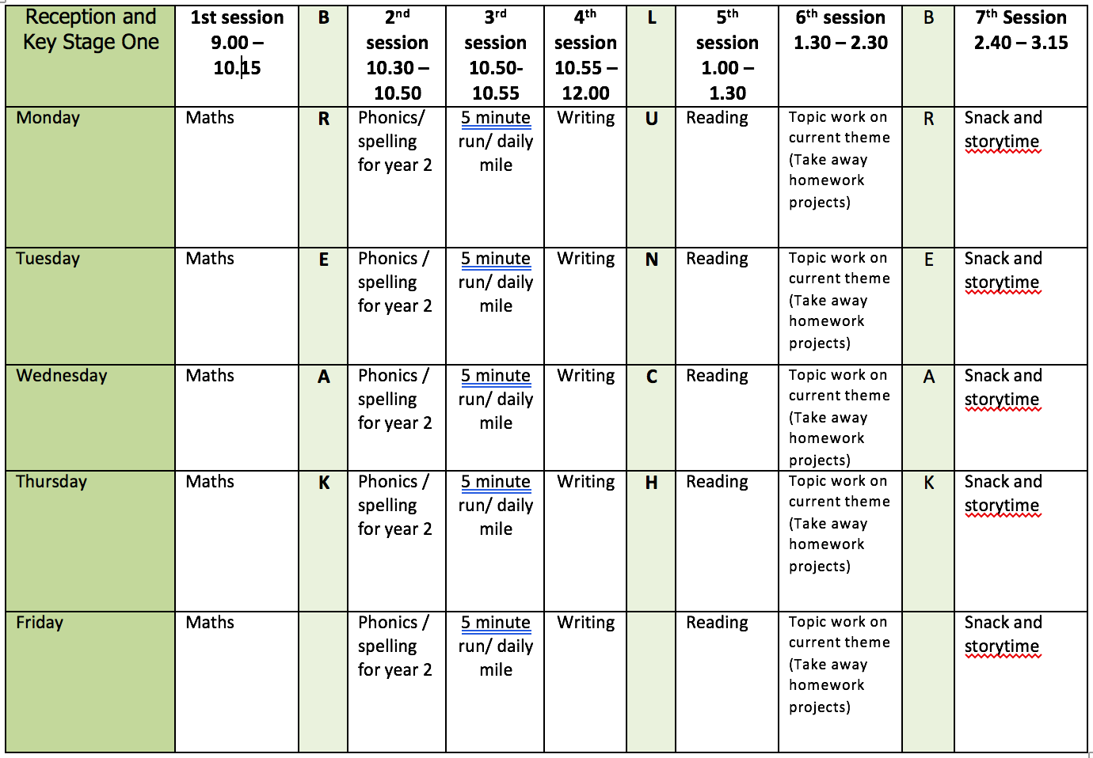

ENGLISH WRITING:
This week I have included the pages from What a Waste that are about Reduce, Reuse and Recycle and Use Less, Waste Less for you to read. We are also using the book Michael Recycle.

Monday - Character Description
- Read the story of Michael Recycle.
- Draw a picture of Michael. Write noun phrases around the picture. E.g. green caped crusader, green and keen, big rubbish dump,
- Use your ideas to write a short character description. Use these questions to help you think of ideas.
  - What sort of person is he?
  - What does he look like?
  - How does he behave?
  - Is he kind or nasty? Why?
  - Would you like him as a friend?

Tuesday - Sentences Using Contractions
- https://www.bbc.co.uk/bitesize/articles/zjwcsk7
- Watch the first video about contractions
- Complete Activity 2 Creating contracted words
- Complete Activity 3 Writing sentences about recycling using contractions
- Finish with Activity 1 if you have time https://www.bbc.co.uk/games/embed/small-town-superheroes?exitGameUrl=https%3A%2F%2Fbbc.co.uk%2Fbitesize%2Farticles%2Fzncgvk7

Wednesday - Letter
- Imagine you live in the town and write a letter to Michael Recycle.
- Use the Fan Letter resource as a model for your work.
- Say why you are writing and ask questions. Thank him for what he did and tell him how you have been improving the town.
- Take ideas from the story e.g. “We have been transforming old junk into fantastic new things.”

Thursday – Invitation
- Write an invitation for The Grand Celebration at the end of the Michael Recycle story.
- Decorate it to suit the theme of the party – perhaps you could write it on or make it using materials you have recycled.
- Use the Party Time resource as a model for your work.

Friday
- At school we call editing work Green for Growth. Look at all your work from this week.
  - Check your punctuation.
  - Does your work make sense when you read it out loud? Is the tense correct?
  - Check the spellings of common expectation words using the Y1 and Y2 Word Lists.
  - Have you used interesting language in your work?
  - Have you used different sentence types?
- Redraft any parts you think you can improve.

READING
Monday
- Fluency Expression - reading out loud to develop reading fluency and expression. Continue this daily throughout the week.
- Practice reading words from the words lists provided in Week 1.
Tuesday
- The Night Box by Louise Greig https://www.bbc.co.uk/bitesize/articles/zj6qmfr
- Activity 1 Answering questions about the text.
Wednesday
- Activity 2 Personification
Thursday
- Activity 3 Writing diary entry.
Friday
- Complete any work from The Night Box.
- As Monday.

SPELLING
With the dictation say the sentences one at a time. Check the spelling and punctuation in these sentences. Then practice the spelling focus.
I have made a spelling quiz for each week’s spelling focus in the Purple Mash 2Dos section.
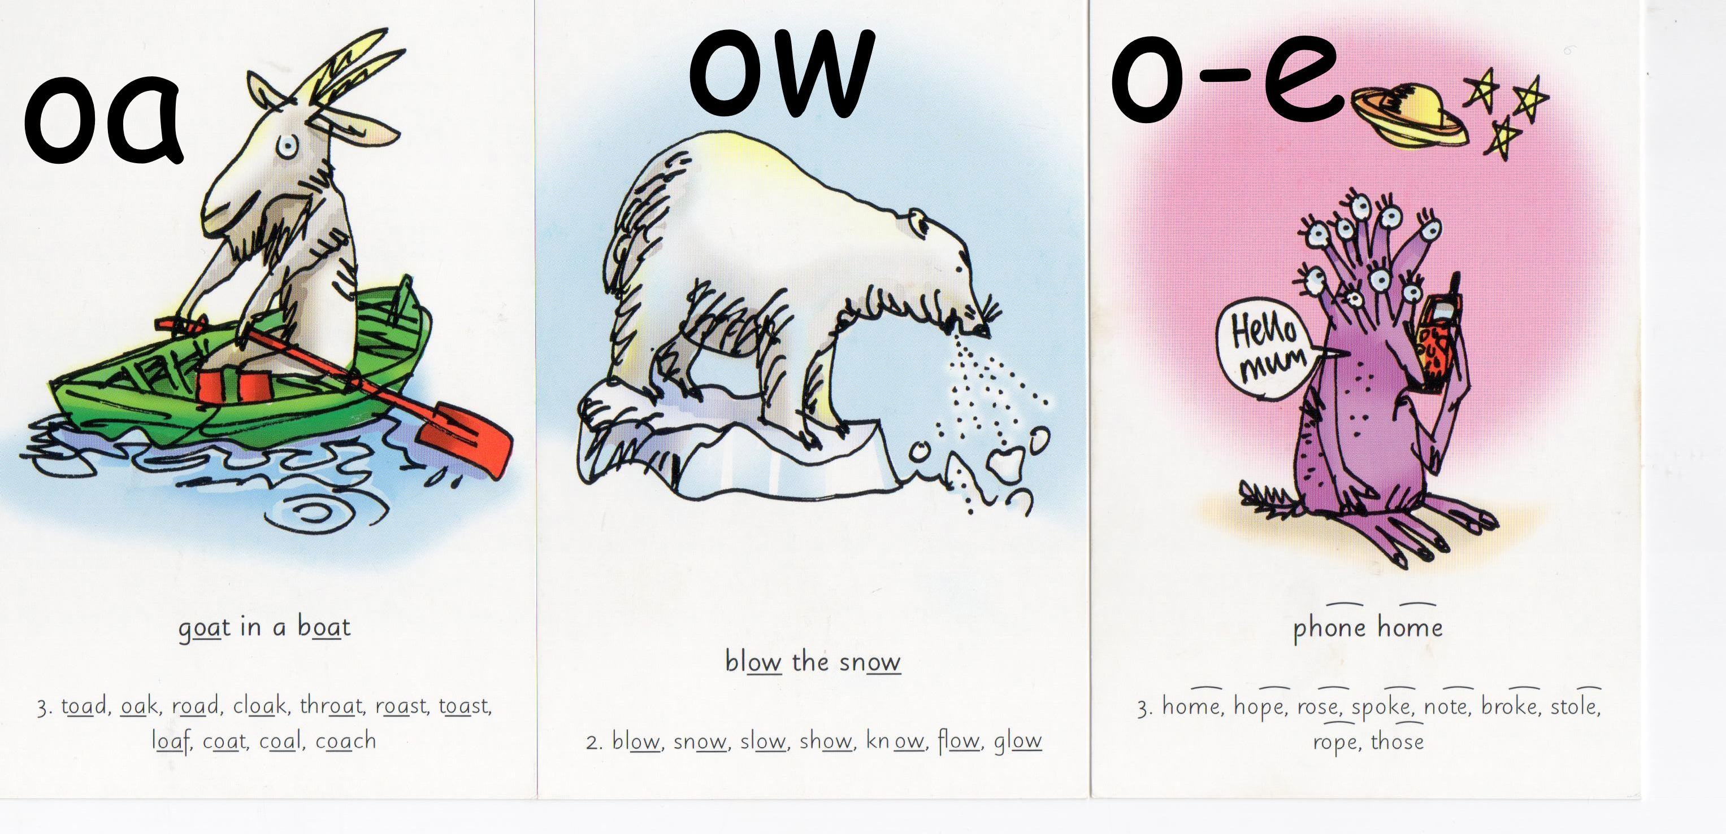

Monday
- Spelling O-E words – home joke nose toe bone rope smoke broke
- Dictation - Sam broke the bone in his big toe. He sat at home and did not smile and joke. Jim came to see him.
Tuesday
- Spelling OA words – boat coat road loaf toast soap groan float
- Dictation - Sam cuts the loaf and has lots of toast. Jim has got a boat. Let it sink not float Sam groans.
Wednesday
- Spelling OW words - snow grow low slow blow window yellow
- Dictation – Sam grabs the window and bends low. He gives a slow tug and is free. He looks yellow.
Thursday
- The /l/ or /əl/ sound spelt le at the end of words. The –le spelling is the most common spelling for this sound at the end of words. The –el spelling is used after m, n, r, s, v, w and more often than not after s.
- Word list - table apple bottle little middle people
- Word list - tunnel squirrel travel towel tinsel
Friday
- Use the words lists (common exception words) on the webpage. Look for any of this week’s sound/spelling focus on these lists and practice spelling them.
- If there aren’t any choose a selection of words to learn and write in a sentence.

Further resources to support Phonics and Spelling
- Word Lists – Y1, Y2, Y3/4 (on Week 1 Home Learning Page)
- Help Your Child With Spelling Document (on Week 1 Learning Page)
- Read Write Inc. – daily phonics/spelling lesson starting at 9.30 and then available for 24 hours after that https://www.youtube.com/channel/UCo7fbLgY2oA_cFCIg9GdxtQ

MATHEMATICS (WHITE ROSE)
All these resources are on the webpage with the exception of Friday.
Monday
- Lesson 1 – Measure Length (cm)
Tuesday
- Lesson 2 – Compare Lengths
Wednesday
- Lesson 3 – Four operations with length
Thursday
- Lesson 4 – Compare mass
Friday
- Friday Maths Challenge - White Rose in partnership with BBC Bitesize https://www.bbc.co.uk/bitesize/tags/z7s22sg/year-2-and-p3-lessons/1
Further resources to support mathematics:
- Times Table Rockstars https://ttrockstars.com
- Purple Mash https://www.purplemash.com/sch/bunburyaldersey
- Mathletics https://login.mathletics.com

TOPIC & WELL BEING

Monday/Tuesday/Wednesday/Thursday
- Spend this week up cycling materials to make your own family orchestra.
- Read the page From Trash To Treasure from What A Waste.
- Watch the videos - Instruments From Jam https://www.bbc.co.uk/bitesize/articles/zd748xs
- Make An Instrument - up cycle materials from your home. There are lots of ideas on BBC Bitesize link and in the resource PDF.
- Playing To A Beat – use the What’s Next? page in the resource document.
- Compose A Piece Of Music – use the resource sheet to help up.

Friday
- Well Being - Self Esteem Pizza
- Paint or draw a pizza shape or use a paper plate.
- Cut out toppings using paper.
- Write a strength, proud moment, or talent on each topping.
- Stick the toppings on the pizza.
- Think about the difference between strengths and talents.
- For example, a talent could be “good at drawing” while the strength is “creativity.”
- Strengths are important as they can be applied to different circumstances and situations.
- Character strengths can include leadership, love of learning, kindness, fairness, honesty, humour, creativity, and generosity.
- Talents can come and go but strengths are always present. For example, someone who suffers a hand injury may not be able to draw but is still creative
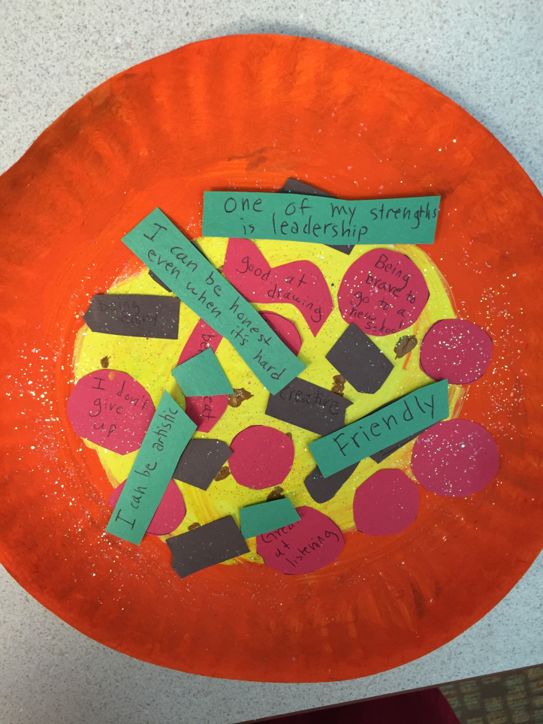

PHYSICAL EDUCATION
- Use the links and resources from Mr Dooley already available on the class home learning webpage. Mr Dooley has sent more resources for this term, which are on a separate page.
- PE with Joe https://www.youtube.com/channel/UCAxW1XT0iEJo0TYlRfn6rYQ
- Go Noodle Activities https://family.gonoodle.com

