Week beginning: 22.6.20
Year 6
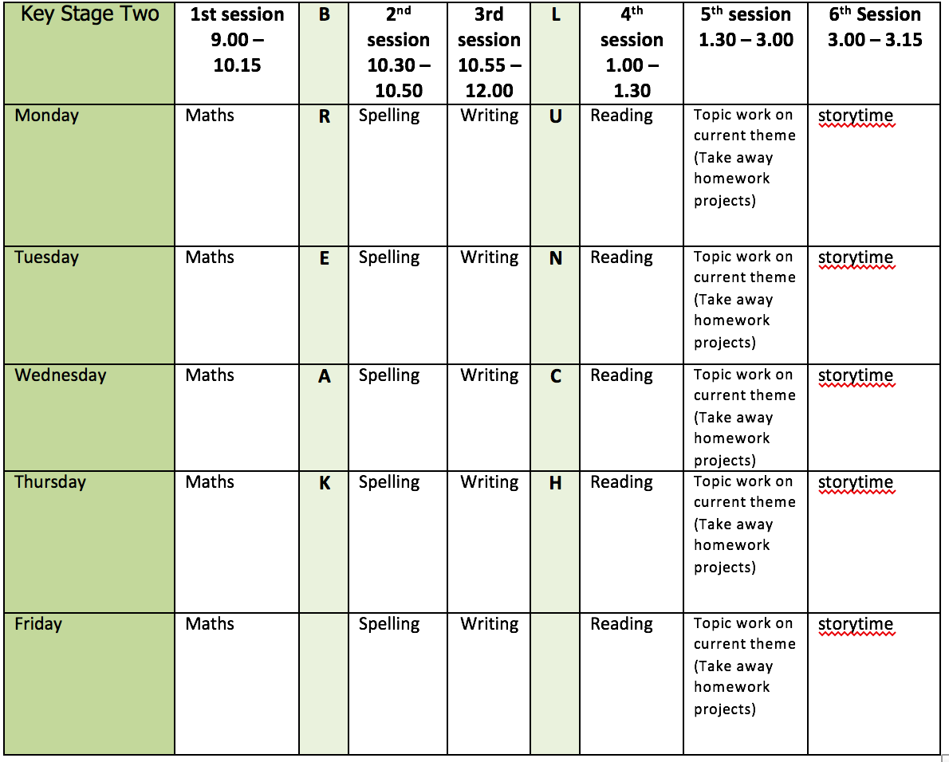
Mental health and well being
Choose an activity from the list below as and when you need it:
1. Colouring sheets.
2. Crosswords
3. Sudoku
4. Doodling/drawing
5. Reading
6. Listen to relaxing music https://www.youtube.com/watch?v=qFZKK7K52uQ
7. Yoga - https://www.youtube.com/watch?v=Td6zFtZPkJ4

Maths activities for the week: (9)
1. Monday Lesson 1 - Area and perimeter
2. Tuesday Lesson 2 - Area of a triangle
3. Wednesday Lesson 3 - Area of a parallelogram
4. Thursday Lesson 4 - Volume of a cuboid
5. Friday Lesson 5 - Practise your timestables (on TT rock stars if you wish) and then complete the appropriate timestable sheet (5 minute timer) Complete the Friday Maths Challenge https://whiterosemaths.com/homelearning/year-6/

Spelling:
The spelling pattern focus for this week is: fer/double the r

Teach tips: rule about doubling the r to words ending in ‘fer’. The r is doubled if the –fer is still stressed when the ending is added e.g. referring, referred, referral, preferring, preferred, transferring, transferred.
The r is not doubled if the –fer is no longer stressed e.g. reference, referee, preference, transference.

1. Monday Create a table with words which double the r and words which don’t. Say the words aloud to hear why the r is doubled or not.
2. Tuesday Look up the definition in a dictionary of any word meanings not known and create 5 sentences using any of the words.
3. Wednesday Make word webs for transfer and prefer. Here is an example for the word unobservant.
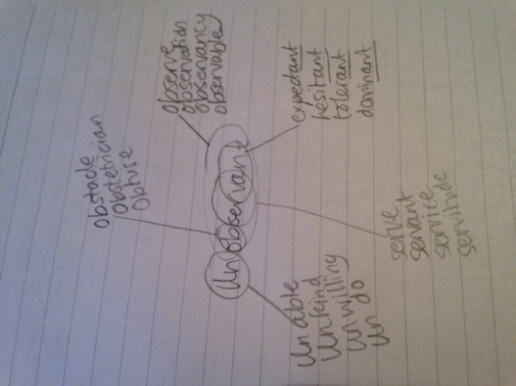
4. Thursday Learn the fer/double the r words. (Use different colours, write mnemonics to remember the letter order, draw around the shape of the word, play hangman, test yourself)
5. Friday Complete the wordsearch.

English writing activities for the week: Formal Letter writing
1. Monday First, watch this video https://www.youtube.com/watch?v=IA9O9YUbQew Write down a list of some of the key facts which were shown in the video. Read the list of facts from the help sheet and choose 2 to add to your list. Research more if you want to add any extras. You are going to write a letter to our MP Edward Timpson to highlight the issue of plastic pollution.
2. Tuesday Read the example formal letter. Write down the features of a formal letter to make a toolkit. What is the language like? What is the structure (start and end)? What types of punctuation can you include? Read the list of helpful phrases. Can you add any formal phrases or words to this list? Write 8 sentences using this list which you could include in your writing. Think about your sentence openers and include a range of punctuation such as brackets, dashes and colons if you can.
3. Wednesday Plan your letter. Make sure it includes at least an opening paragraph (which explains why you are writing), a main paragraph and a closing paragraph.
4. Thursday Write the opening paragraph and main paragraph.
5. Friday Write your ending paragraph. Proof read your writing and make any changes/corrections. You can even send this letter off to Mr Timpson 58A High Street, Tarporley, Cheshire, CW6 0AG or edward.timpson.mp@parliament.uk Last year, Year 6 sent letters to Antoinette Sandbach and she replied!

Reading:
1. Monday - 30 mins of independent reading
2. Tuesday - Comprehension (complete the retrieval and inference questions - this week’s is extract 4: Spirit by Sally Christie)
3. Wednesday - 30 mins of independent reading
4. Thursday –Comprehension (complete the choice and challenge questions on Spirit)
5. Friday – 30 mins of independent reading

Topic work:
1. Monday Science - Bioluminescence: Lighting up Our Oceans - Many sea creatures possess a fascinating light-producing ability called bioluminescence. Some fish dangle a
lighted lure in front of their mouths to attract prey, while some squid shoot out bioluminescent liquid, instead of ink, to confuse their predators. Watch this video https://www.youtube.com/watch?v=oKjFVBVGad0&t=23s Find out about bioluminescence and how some sea creatures rely on this for their survival. Choose a sea creature which uses bioluminescence (like the anglerfish – information saved and video: https://www.youtube.com/watch?v=XUVerZsbYiw&t=29s) and create a poster fact sheet about it, including what bioluminescence is and how their chosen sea creature uses it.
2. Tuesday Spanish – https://www.bbc.co.uk/bitesize/topics/zfgt6v4/articles/zbw4f4j watch the video. Write some sentences to say which food you like and don’t like using your vocabulary list from last week. Challenge: can you film yourself pronouncing these?
3. Wednesday History – finish your timeline of plastic. Consider your presentation. Can you add pictures?
4. Thursday DT – make a pulley with help from an adult. Can you think of a use for it? https://www.youtube.com/watch?v=rc0cpp3i8GA
5. Friday Free choice from the takeaway homework list or a mental health and well-being activity.

PE:
Please find ideas for daily PE activities on the PE documents on the webpage and via the link below:
https://homelearning.primarypepassport.co.uk/#/
This week’s daily challenge: how many press ups can you do in 2 minutes? Can you improve your score each day?

