Year 4
WB 22.6.2020

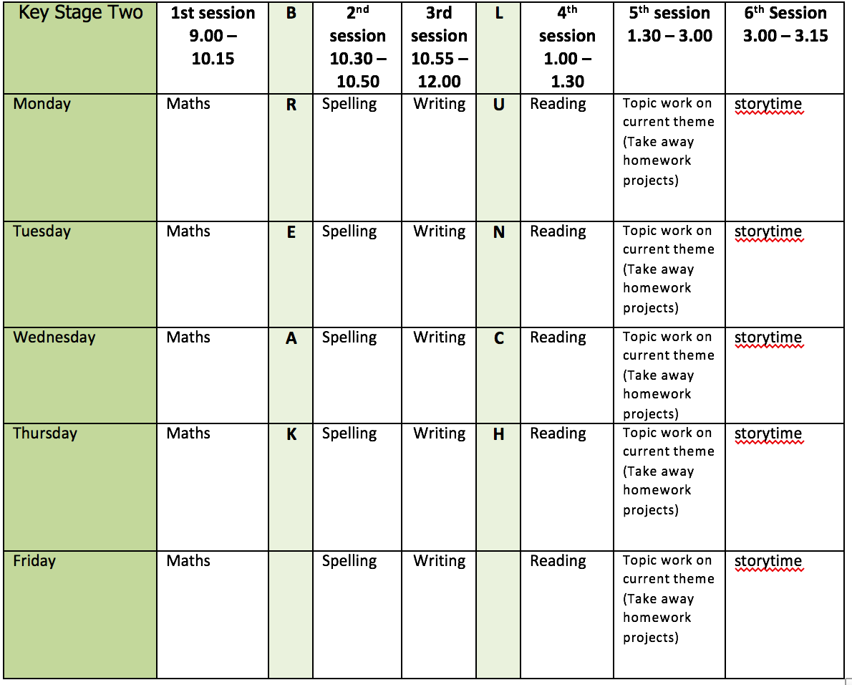
Mental health and well being
https://www.bbc.co.uk/teach/class-clips-video/pshe-ks2-growth-mindset/zkph92p
Watch some of these videos about the importance of having a growth mindset. Design and make a bookmark to remind you of this.

English writing activities for the week: Biography
The example for your reading this week will help you with writing your own and make sure you have a look at the attached Biography Features Mat too.
Monday - Research as much as you can about Greta Thunberg, the climate change activist. You can decide how to present your research – you could do a poster, PowerPoint, notes, zigzag book etc.
Tuesday - Plan and write the Introduction of your biography. This should explain why Greta is well known, without going into too much detail yet. It should also engage the reader and make them want to read on. Make sure you proof-read and make any corrections.
Wednesday - Plan and write your first Point. This should be a section about Greta’s early life and could have its own sub-heading if you want it to. You might want to include any anecdotes you find – an anecdote is a short story about something interesting or funny that happened in real life. Make sure you proof-read and make any corrections.
Thursday - Plan and write you second Point. This should be about how Greta’s activism began and again you might want to include an anecdote. Make sure you proof-read and make any corrections.
Friday - Plan and write you third Point. This should be about Greta’s activism up to the present day. What has she achieved so far? Make sure you proof-read and make any corrections.

Reading:
3 days on Roald Dahl biography - version 1=easiest, version 3=most challenging – you can choose which one to have a go at but make sure you challenge yourself!
2 days reading for pleasure

Spelling:
Spelling test of words from Y3/4 list – 20 each day
Get a grown up to test you and mark your answers together after each test

Maths activities for the week:
All worksheets, answers and video links attached.
Monday - Pounds and pence
Tuesday - Ordering money
Wednesday - Estimating money
Thursday - Four operations
Friday - Revision of anything tricky from week/Mathletics/Times Tables Rock Stars/Purple Mash maths games

Topic work Computing – Logo on Purple Mash
Monday - Use 2Logo to draw the shapes on worksheet 1.
Tuesday - Use 2Logo to help you write sets of instructions for drawing the letters on worksheet 2.
Wednesday - Worksheet 3 – predict what it will draw, then use 2Logo to find out.
Thursday - Logo flowers
Friday - Time-Crimes! Purple Mash Computing Logo

PE
This week’s challenge – break your own record! Choose something to challenge yourself with e.g. keepy-uppies, tennis rally, skipping, running etc and try to beat your total/time every day. What is your record by Friday?

