Year 3
W/C 15.06.20

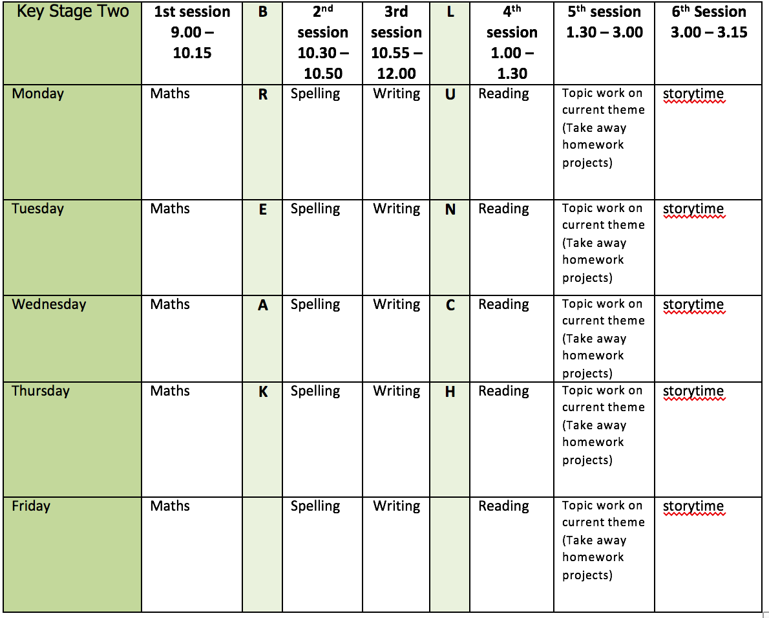
Mental health and well being
Days 15 – 19 of the Wildlife trusts 30 days wild (resources included)

English writing activities for the week: Flotsam
Monday: Look carefully at the front cover of the book. What do you notice about the eye of the fish? What does the word Flotsam mean? Can you write a definition? How do you think the story will start? Can you write the opening? You could write a setting description, or you could start in the middle of the action!

Tuesday: https://literarycurriculum.co.uk/planning-sequences/sequence/flotsam/ Watch the first Flotsam session. Pause the session at 11 minutes 30 seconds. Can you find any objects around your home that could be Flotsam? Find at least 5 items, label them and pop them into your very own Flotsam box (an old shoe box would be perfect). Resume the video and pause at about 19 minutes and 30 seconds. Now, choose three of your items to write about. You must state which item you have found and give your reason using either one of the following conjunctions: since, because, as. Now play the rest of the session.

Wednesday: Using the blurb and the front cover write and illustrate a beautiful Glossary for Flotsam.

Thursday: Look at the images of the objects provided. Who do you think they might have belonged to and why? Discuss this with an adult if possible. Then, look at the images and match the objects to their owners. Now, choose one set of objects and write 4 statements explaining whom you think they belong and what else the items might tell you about the owner (see my example for support).
Friday: Read my character description. Then, using what you inferred about your chosen character yesterday, have a go at writing your own. Remember, that as well as telling the reader what a character is like, you can show the reader what a character with your language choice. For example, “With his pipe hanging from the corner of his blistered lips, Harry smiled and began to sing”, tells the reader that Harry is brave and calm even though the situation is extremely dangerous. You could also try using speech to convey character.

Reading:

Alongside the release of ‘The Ickabog’, JK Rowling’s publishers have started a competition for children to illustrate the book! Each week I am going to set you a new illustration to complete. If you would like to enter any of your illustration ask an adult to find out a little bit more about it for you https://www.theickabog.com/competition/

Monday: Read the rest of chapter 2 of the Ickabog https://www.theickabog.com/the-ickabog/ Answer the following questions:
- How does Mrs Beamish reassure Bertie Beamish that there is no such thing as an Ickabog? Can you give at least two examples from the text?
- Could the myth of the Ickabog cause trouble?
- What does the word Engulf mean?
- Make a prediction about what kind of terrible troubles you think might be about to Engulf Cornucopia?
Tuesday: Read up end of the 4th paragraph of chapter 3 https://www.theickabog.com/death-of-a-seamstress/. Using what you have learned about Bertie Beamish so far, can you illustrate what you imagine him to look like?
Wednesday: Read up to the end of the 10th paragraph of the 3rd chapter where King Fred says, ‘But I’m sure one of the other ladies will be able to fix on the last button for Your Majesty.’ Answer the following questions:
- What is Dora Dovetails job?
- What does the author mean by ‘the history books of Cornucopia’?
- What is the ‘nasty incident’ which the history books of Cornucopia would later record as the beginning of all the troubles that were to engulf the Kingdom?
- What does King Fred’s first reaction when hearing of the death of Dora Dovetail tell you about his character?
Thursday: Read the rest of the third chapter 3 of the Ickabog
- Did King Fred feel guilty about the death of Dora Dovetail?
- Can you find two pieces of evidence from the text to support your answer?
- The following passage is taken from the end of the chapter:
Well, anyway,’ he said impatiently to his reflection, ‘life goes on.’
He put on his silk nightcap, climbed into his four-poster bed, blew out the candle and fell asleep.
What does this tell us about how guilty King Fred is really feeling?
Friday: Can you illustrate King Fred’s purple suit or read for pleasure?

Spelling:
Adding the ‘-ly’ suffix to rrot words ending in ‘le and ‘ic’.
Add the suffix to the following words: quick, nice, late, close, happy, funny, lucky, gentle, simple, humble, basic, frantic, dramatic
Put each of the words into a sentence.

Remember:
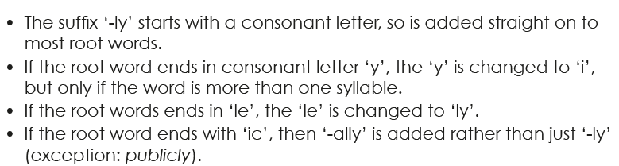

Continue practise of words from Y3/4 list (3 days) using the strategies provided.

Maths activities for the week:
All worksheets and video links available on White Rose maths tab
Monday: Order fractions
Tuesday: Add fractions
Wednesday: Subtract fractions
Thursday: Problem solving with fractions
Friday: Revision of anything tricky from week/Mathletics/Times Tables Rock Stars/Purple Mash maths games

Topic work
Monday: Pinhole cameras were one of the earliest types of cameras. They use the principle of "camera obscura," in which light travels through a small hole in a dark box to form a picture. It is the same science that today's cameras use. Follow these online instructions to make a pinhole "camera" and learn how real cameras work https://kids.nationalgeographic.com/explore/books/pinhole-camera/
Tuesday: Identify the geographical features of beaches and coastlines. Can you create a report about some of them? https://www.bbc.co.uk/programmes/p0115g2f https://www.dkfindout.com/uk/earth/coasts/
Wednesday: Complete one of the Random Acts of wildness from the wildlife trusts 30 days wild or complete your virtual sports day!
Thursday: Learn about Barbara Hepworth https://www.tate.org.uk/kids/explore/who-is/who-barbara-hepworth. Then, have a go at sculpting your very own costal inspired necklace https://www.tate.org.uk/kids/make/sculpture/make-hepworth-necklace
Friday: Have a go at one of the starters for stem activities. Can you make a sun dial or a boat from a single sheet of paper? https://www.stem.org.uk/system/files/elibrary-resources/2020/06/13_Starters%20for%20STEM_15%20June.pdf

PE
- Mr Dooley has set you the challenge of taking part in our virtual school sports day (see class page for details)

