Roald Dahl

Roald Dahl was born in Wales on 13th September 1916 to Norwegian parents. His father died when he was 3 years old and he was raised by his mother. He had a fairly unhappy time at boarding school which provided some of the inspiration for his later stories.
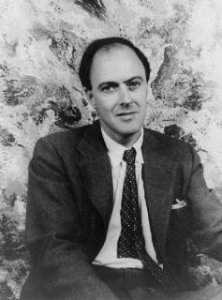
After leaving school, he worked for the Shell Oil Company based in Africa until the outbreak of World War II, when he signed up with the Royal Air Force. Unfortunately, he was injured in action and eventually returned home as an invalid. He was then sent to Washington DC to work as an attaché where, almost by accident, he started his writing career. When he was interviewed for an article about his time in action, he offered to write about his experiences. His piece was published in the Saturday Evening Post, who signed him up to write more articles.
In 1943, he wrote his first children’s book, The Gremlins, which was originally intended to be made into an animated film by Walt Disney. The film was not made and instead Dahl turned to writing adult fiction, not writing another children’s story until the 1960s.
By this time, he was a father himself and had started making up stories to entertain his own children. From this came the stories of James and the Giant Peach and Charlie and the Chocolate Factory. He went on to write 21 children’s books including: The BFG, Matilda, and The Witches, all of which have been made into films. Roald Dahl died on the 23rd November 1990.
