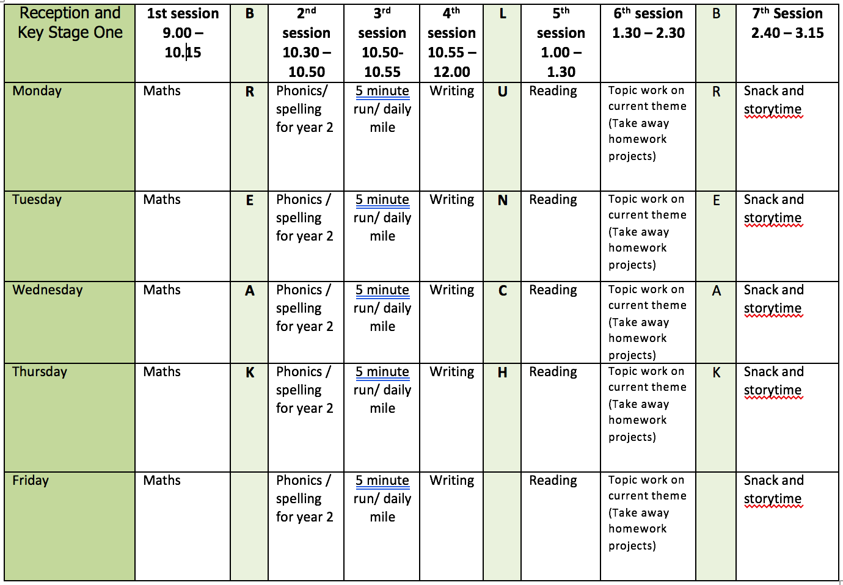

ENGLISH WRITING: Non-Chronological Reports
Using the pages Deforestation and Conversation from the What a Waste text we will continue writing reports this week. If you want to use any of your own information books or resources please do so. Spend the beginning of the week researching and writing about deforestation or you could choose one of the animals from the Conservation page. This week include a life story/cycle. I have put an example of a life cycle/story in the resource document.

Resources:
- BBC Bitesize animal information https://www.bbc.co.uk/bitesize/topics/z6882hv
- Oxford Owl Non Fiction Texts -Horses, Blackbirds, Things That Sting and Save the Whales. To find these quickly use the search option and make sure no age group is chosen. See screenshot.

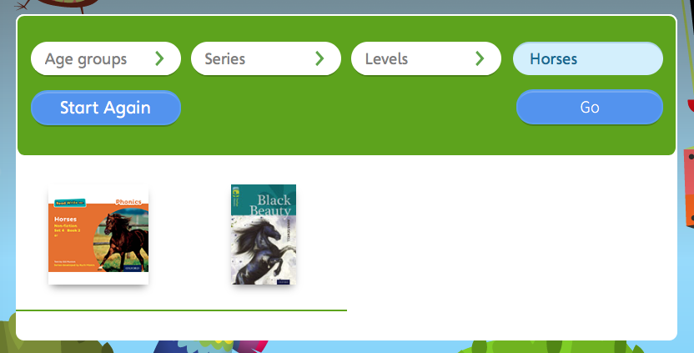

Monday
- Introduction point. Write a general opening point for your work.
Tuesday
- Point 1 – Write a specific paragraph. Remember to use a title. Add a labelled diagram.
Wednesday
- Point 2 – Write a specific paragraph. Remember to use a title. Add a lifecycle/story.
Thursday
- Types of Sentences - use the videos from the BBC Bitesize link to remind yourself about sentence types. Can you see any of the different sentence types in the 2 pages we are using this week?
- Can you write 4 different types sentences using information on these pages? Can you turn some of the statements on the pages into commands, questions and exclamations?
- https://www.bbc.co.uk/bitesize/articles/zhh6pg8
Friday
- At school we call editing work Green for Growth. Look at all your work from this week. Check your punctuation? Does your work make sense when you read it out loud? Is the tense correct? Check the spellings of common expectation words using the Y1 and Y2 Word List. Have you used interesting language in your work?
- If you haven’t already done so add different sentence types to your work?
- Redraft any parts you think you can improve.

READING
Monday
- Fluency Expression - reading out loud to develop reading fluency and expression. Continue this daily throughout the week.
- Practice reading words from the words lists provided in Week 1.
Tuesday
- Funny Bones by Janet and Alhberg.
- https://www.bbc.co.uk/bitesize/articles/zfmtpg8
- Activity 1 Character Work.
Wednesday
- Activity 2 Explain your opinion.
Thursday
- Activity 3 Creating new ways to scare skeletons.
Friday
- Fluency Expression - reading out loud to develop reading fluency and expression. Own choice of book.
- Practice reading words from the words lists provided in Week 1.
- Complete any work from Funny Bones.

SPELLING
When practising spelling use the ideas in the school booklet ‘Help You Child with Spelling’.
With the dictation passage parent/carer to dictate sentences one at a time. Check spelling and punctuation in these sentences.
I have made a spelling quiz for each week’s spelling in the Purple Mash 2Dos section.
Monday
- Spelling I-E words – bike bite five nine like time slide shine wife ice prize
- Dictation - Sam will take the cake to Jim. He must not ride this time. The bike will solid on the ice.
Tuesday
- Spelling IGH words – might light midnight tonight sight bright right
- Dictation - It is midnight. The moon is bright. The train stops and Sam gets out. This is the right town but it is late. His sister might not meet him.
Wednesday
- Spelling Y words - cry dry sky fly my by try why
- Dictation – At the next stop Sam and his mother try to get off the bus. Sam is stuck in the seat. Mother begins to cry. Next time I shall sit by myself she sobs.
- Spelling Fact – the /aɪ/ sound y at the end of word is by far the most common spelling for this sound at the end of words.
Thursday
- Adding –es to nouns and verbs ending in -y. The y is changed to i before the -es added.
- Word list – fly/flies, try/tries, reply/replies, dry/dries, cry/cries
Friday
- Use the words lists (common exception words) on the webpage. Look for any of this week’s sound/spelling focus on these lists and practice spelling them.
- If there aren’t any choose a selection of words to learn and write in a sentence.
Further resources to support Phonics and Spelling:
- Word Lists – Y1, Y2, Y3/4 (on Week 1 Home Learning Page)
- Help Your Child With Spelling Document (on Week 1 Learning Page)
- Read Write Inc. – daily phonics/spelling lesson starting at 9.30 and then available for 24 hours after that https://www.youtube.com/channel/UCo7fbLgY2oA_cFCIg9GdxtQ

MATHEMATICS (WHITE ROSE)
All these resources are on the webpage with the exception of Friday.
Monday
- Lesson 1 – Count sides and vertices on 2D shapes.
Tuesday
- Lesson 2 – Count faces, edges and vertices on 3D shapes.
Wednesday
- Lesson 3 – Sort 2D and 3D shapes.
Thursday
- Lesson 4 – Merge 2D and 3D shapes.
Friday
- Friday Maths Challenge - White Rose in partnership with BBC Bitesize https://www.bbc.co.uk/bitesize/tags/z7s22sg/year-2-and-p3-lessons/1

Further resources to support mathematics:
- Times Table Rockstars https://ttrockstars.com
- Purple Mash https://www.purplemash.com/sch/bunburyaldersey
- Mathletics https://login.mathletics.com

TOPIC &WELL BEING
It might be worth looking at the weather forecast to see which day might be best for Mr Dooley’s Virtual Sports Day. According to the Met office on Sunday morning (14th June) Tuesday and Wednesday have rain forecast.

Monday
- BBC Bitesize Habitats https://www.bbc.co.uk/bitesize/articles/zhvmt39
- Habitats around the world.
Tuesday
- Stem Living Things & Their Habitats https://stemlearning.wistia.com/medias/oil59grd13
- Activities (see worksheet for detail) – find and identify living things, drawing and labelling a minibeast and an estate agents advert for animal habitats.
Wednesday
- Complete any habitats work from the Monday and Tuesday lessons.
Thursday
- Mr Dooley’s Virtual Sports Day – see the resource sent by Mr Dooley available on this week’s-learning page.
Friday
- Well Being - Cool Off (Coping Skills) Snowflake
- A simple and fun way to make a coping skill reminder for children (and grown ups) of any age!
- Choose from assortment of paper colours and types, fold and cut out snowflake. Talk about how all snowflakes are different and everyone’s way of calming down can be different and unique too.
- Write and draw calming strategies on the snowflake.
- Decorate with glitter, sequins, felt pens, stickers etc.
- We all need reminders sometimes and reminders of safe ways to calm and relax
are important for everyone! Cool off with a coping skill snowflake today.
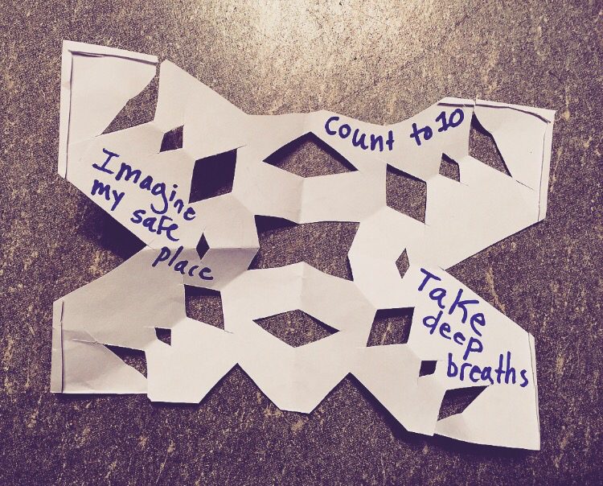

PHYSICAL EDUCATION
- Use the links and resources from Mr Dooley already available on the class home learning webpage. Mr Dooley has sent more resources for this term, which are on a separate page.
- PE with Joe https://www.youtube.com/channel/UCAxW1XT0iEJo0TYlRfn6rYQ
- Go Noodle Activities https://family.gonoodle.com

