Earliest plastics introduced
1869 — Celluloid, which will eventually become the first financially successful plastic product, is invented by American John W. Hyatt. It will begin to be mass produced three years later.
1908 — Cellophane is developed by Swiss chemist Jacques E. Brandenberger. Made from cellulose, it is manufactured in thin, transparent sheets, which made it ideal for food packaging.
1909 — Bakelite is developed in New York by chemist Leo H. Baekeland. It is the first fully synthetic plastic and will be used to make kitchen appliances, jewelry, telephones, radios and auto parts.
1920 — Polyvinyl chloride, or PVC, is invented. Sturdy and chemically resistant to acids and salts, it eventually becomes one of the most widely-produced plastic products in the world.

Plastic gets its name
1925 — The term “plastic” is introduced. The term is derived from the Greek word “plastikos” which means “capable of being shaped or molded.”
1931 — Acrylic glass, best known by the trade names Plexiglas and Lucite, is introduced. It is used to make household products, eyeglasses and dental prosthetics and soon becomes a popular material for artists and furniture makers.
1953 — A patent is given to a polycarbonate resin thermoplastic that will be used to make aircraft windows and, decades later, CDs, DVDs and iPods. Known as Lexan in the U.S., it has gone by the brand names Merlon and Makrolon overseas.
1954 — Extruded polystyrene foam (aka “blue board” and trademarked as Styrofoam) is introduced. A variation, expanded polystyrene foam, known colloquially as “styrofoam” is later used to make disposable cups and fast food packaging. According to surveys, only about 1 percent of it is recycled.
1961 — The non-profit organization Keep America Beautiful joins forces with the Ad Council to create a series of anti-littering commercials. (Decades later, the advertising campaign will be criticized for not targeting manufacturers and distributors of one-use plastics and other containers.)
1977-1979 — American grocery stores introduce plastic bags at their checkout counters, eventually replacing brown paper bags.

Controlling plastic waste
2002 — Ireland introduces a €0.15 tax on plastic checkout bags. An estimated 90 percent of consumers switched over to reusable bags within a year. The tax was increased to €0.22 in 2007.
2008 —​​​​​​​ Chinese officials announce a nationwide ban plastic bags, to take effect in Jan. 2009. The country was using an estimated 3 billion bags per day.
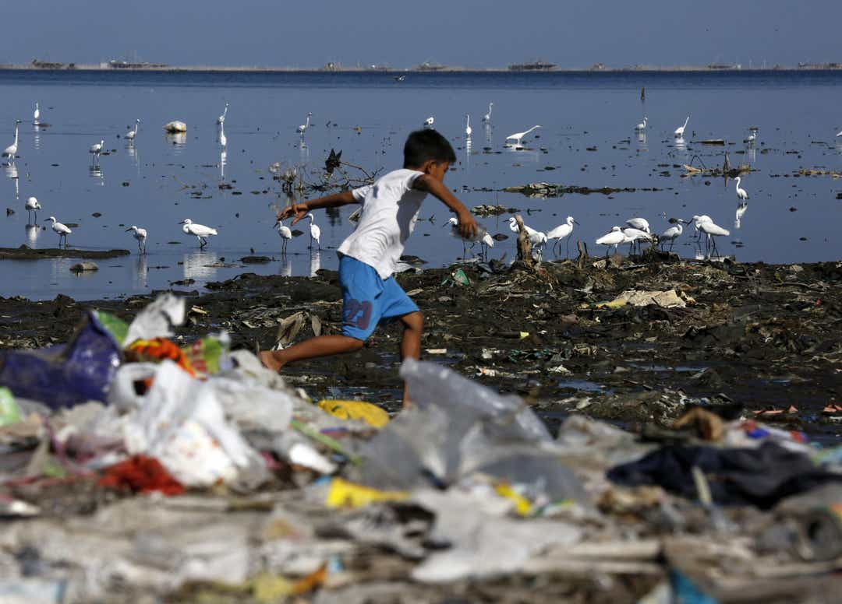
Migratory birds find food at a coastline full of rubbish in Manila, Philippines. According to data from a report of environment advocacy group Ocean Conservancy, roughly eight million tons of plastic enter the ocean every year. Furthermore, over half of the material leaked into the ocean comes from five rapidly developing countries where production and consumption of plastics are outpacing local waste management capacity: China, Indonesia, Philippines, Vietnam and Thailand.
2009 —​​​​​​​ The District of Columbia enacts 5 cents charge for carryout bags from businesses selling food or alcohol.
2011-2014 —​​​​​​​ Three counties in Hawaii prohibit distribution of non-biodegradable bags at checkout counters.
2012 —​​​​​​​ San Francisco becomes the first American city to ban plastic bags.
2014 —​​​​​​​ California becomes the first state to enact a statewide ban on single use plastic bags.
2016 —​​​​​​​ The Netherlands bans free plastic bags and imposes a tax of €0.22 per bag, which leads to a reported drop in plastic bag use by 71 percent.
2017 —​​​​​​​ Environmental groups call for a ban on the intentional release of helium balloons.
2018 —​​​​​​​ A law signed by Gov. Chris Christie bans the manufacture of plastic microbeads used as exfoliants in many face-wash, soap and beauty products. California takes steps to ban plastic straws in restaurants. The Dutch market Ekoplaza introduces the world’s first plastic-free aisle in its Amsterdam store. All items are packaged in compostable or easily recyclable materials.
2020 – In October, the UK government will ban single-use plastic straws, stirrers and cotton buds

