Week beginning: 15.6.20
Year 6
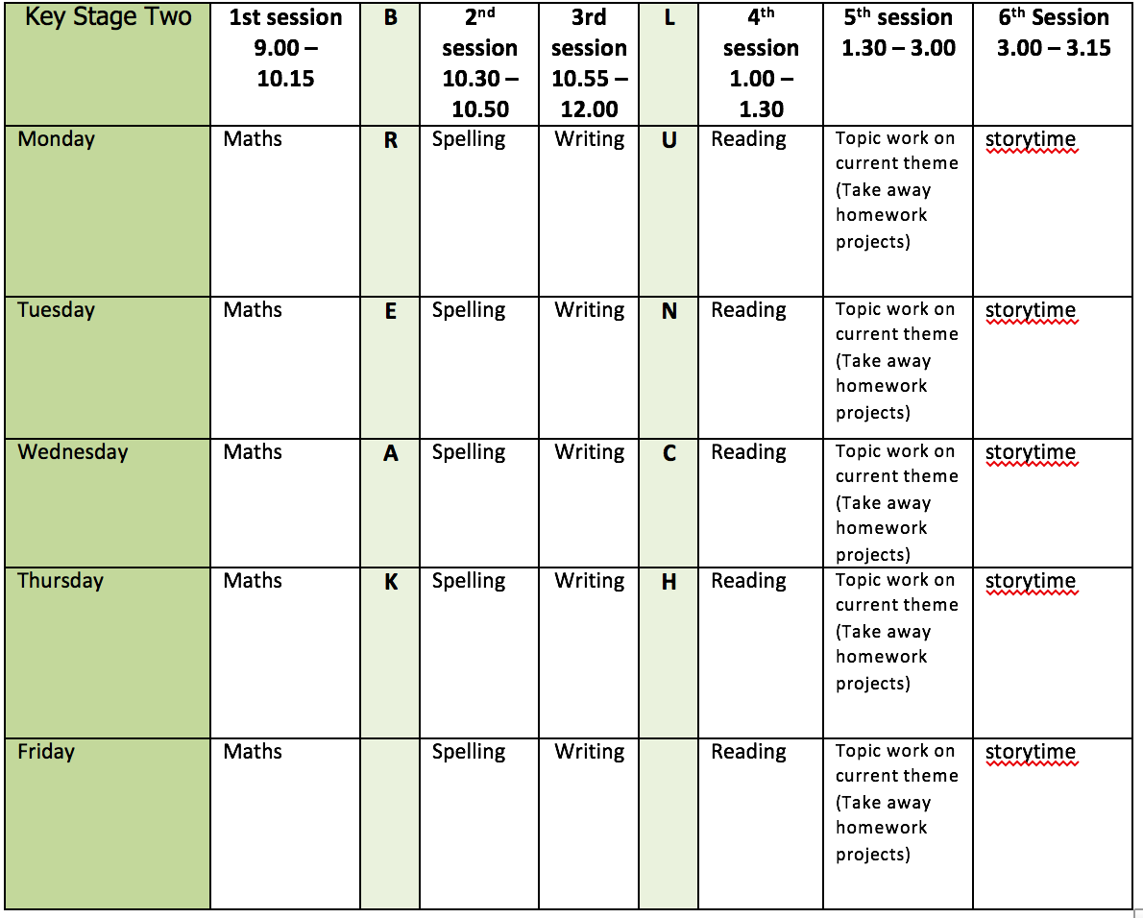
Mental health and well being
Choose an activity from the list below as and when you need it:
1. Colouring sheets.
2. Crosswords
3. Sudoku
4. Doodling/drawing
5. Reading
6. Listen to relaxing music https://www.youtube.com/watch?v=qFZKK7K52uQ
7. Yoga - https://www.youtube.com/watch?v=Td6zFtZPkJ4

Maths activities for the week: (8)
1. Monday Lesson 1 - Solve two-step equations
2. Tuesday Lesson 2 - Find pairs of values
3. Wednesday Lesson 3 - Convert metric measures
4. Thursday Lesson 4 - Miles and kilometres
5. Friday Lesson 5 - Practise your timestables (on TT rock stars if you wish) and then complete the appropriate timestable sheet (5 minute timer) Complete the Friday Maths Challenge https://whiterosemaths.com/homelearning/year-6/

Spelling:
The spelling pattern focus for this week is: cial/tial

Teach tips: –cial is common after a vowel letter and –tial after a consonant letter, but there are some exceptions. official, special, artificial, partial, confidential, essential
Exceptions: initial, financial, commercial, provincial (the spelling of the last three is clearly related to finance, commerce and province).

1. Monday Create a table with different cial/tial words in. Highlight the endings and think about why it has that particular ending. Can you spot any exceptions to the rule?
2. Tuesday Look up and write down the definition in a dictionary of any word meanings not known.
3. Wednesday Create 5 sentences using any of the words.
4. Thursday Learn the cial/tial words. (Use different colours, write mnemonics to remember the letter order, draw around the shape of the word, play hangman, test yourself)
5. Friday Complete the wordsearch.

English writing activities for the week: Narrative writing - recount
1. Monday First, watch this video https://www.youtube.com/watch?v=6HfBbSUORvo
Sequence what happened in the story in bullet points. Describe the setting in 3 sentences.
2. Tuesday Write words to describe the characters: the people of the village and the lighthouse keeper. How do you think the lighthouse keeper feels when he sees the ship? How can we show this through his actions? Can you write a draft action paragraph for this. Try to use some short sentences to build suspense.
3. Wednesday Plan your recount. There is a planning sheet to help. Can you include some speech?
4. Thursday Write the first half.
5. Friday Write until the end. Can you leave it on a cliff-hanger?

Reading:
1. Monday - 30 mins of independent reading
2. Tuesday - Comprehension (complete the words in context and retrieval questions - this week’s is extract 3: William Wenton and the Secret Portal by Bobby Peers)
3. Wednesday - 30 mins of independent reading
4. Thursday –Comprehension (complete the inference, choice and challenge questions on William Wenton and the Secret Portal by Bobby Peers)
5. Friday – 30 mins of independent reading

Topic work:
1. Monday Global Learning - The BBC programme Blue Planet 2 sparked an outcry about the health of our oceans and the huge threat caused by plastics, but lots of people around the world are working hard to help solve this problem. Read about Madison Edwards, a 12 year old environmental activist who has been advocating for the protection of the Belize Barrier Reef https://www.ambergristoday.com/news/2018/05/08/madison-edwards-wwf-president-youth-award Keep a ‘recycling diary’ for a week recording how much plastic and other recycled products your family uses daily. Can you start a family pledge? Write down one thing that you and your family will do to use less plastic. You could get your family to sign it! At the end, create a bar chart to show how many items were recycled on each day.
2. Tuesday Spanish - create a Spanish food vocabulary list and draw some pictures to match. Can you find any cognates? (words which look similar in Spanish and English). Watch this video to help with your list and the pronunciation https://www.youtube.com/watch?v=OhSjoQofCiw
3. Wednesday History – create a timeline of plastic in any form you wish (PowerPoint or on a piece of paper) use the dates on the sheet to help you. Try to finish half of the timeline; you can finish this next week.
4. Thursday Science – create a classification key for an underwater animal. There is a classification key below to help you.
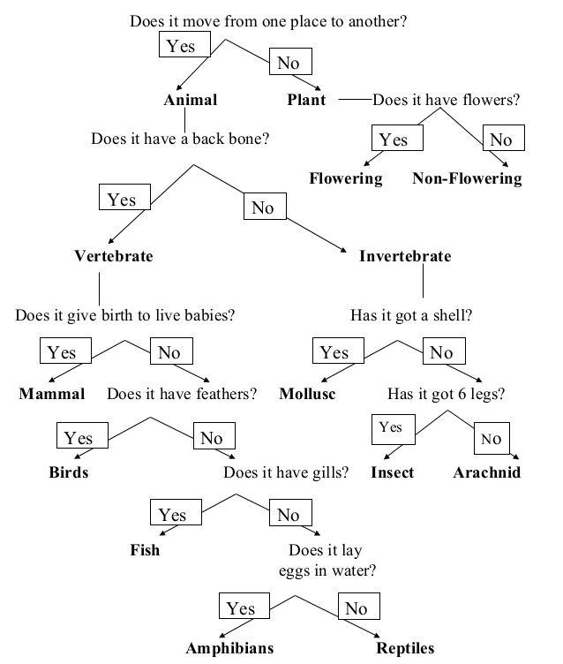
5. Friday Free choice from the takeaway homework list or a mental health and well-being activity.

PE:
Please find ideas for daily PE activities on the PE documents on the webpage and via the link below:
https://homelearning.primarypepassport.co.uk/#/
This week’s daily challenge: how many high knees can you do in 2 minutes? Can you improve your score each day?

