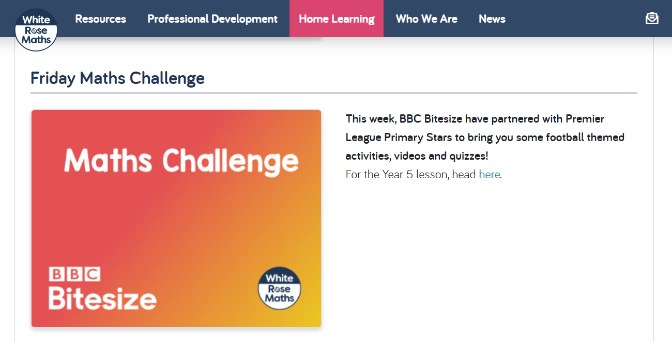

Week 7
Visit the White Rose Maths Home Learning website
https://whiterosemaths.com/homelearning/year-5/
and click on the link to find today’s challenge.

