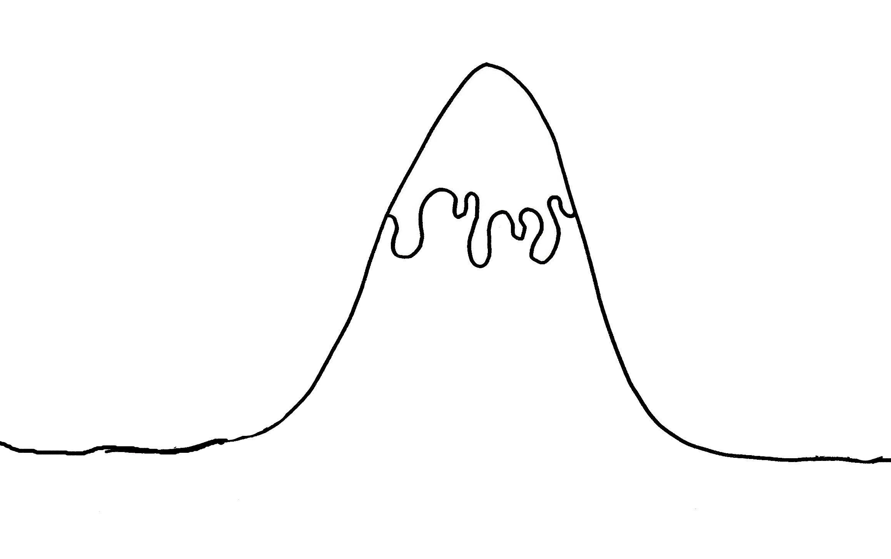

**Resolution**

**Problem**

**Ending**

**Introduction**

**Build up**

**The Story Mountain**

**The Story Mountain**