Year 4
WB 15.6.2020

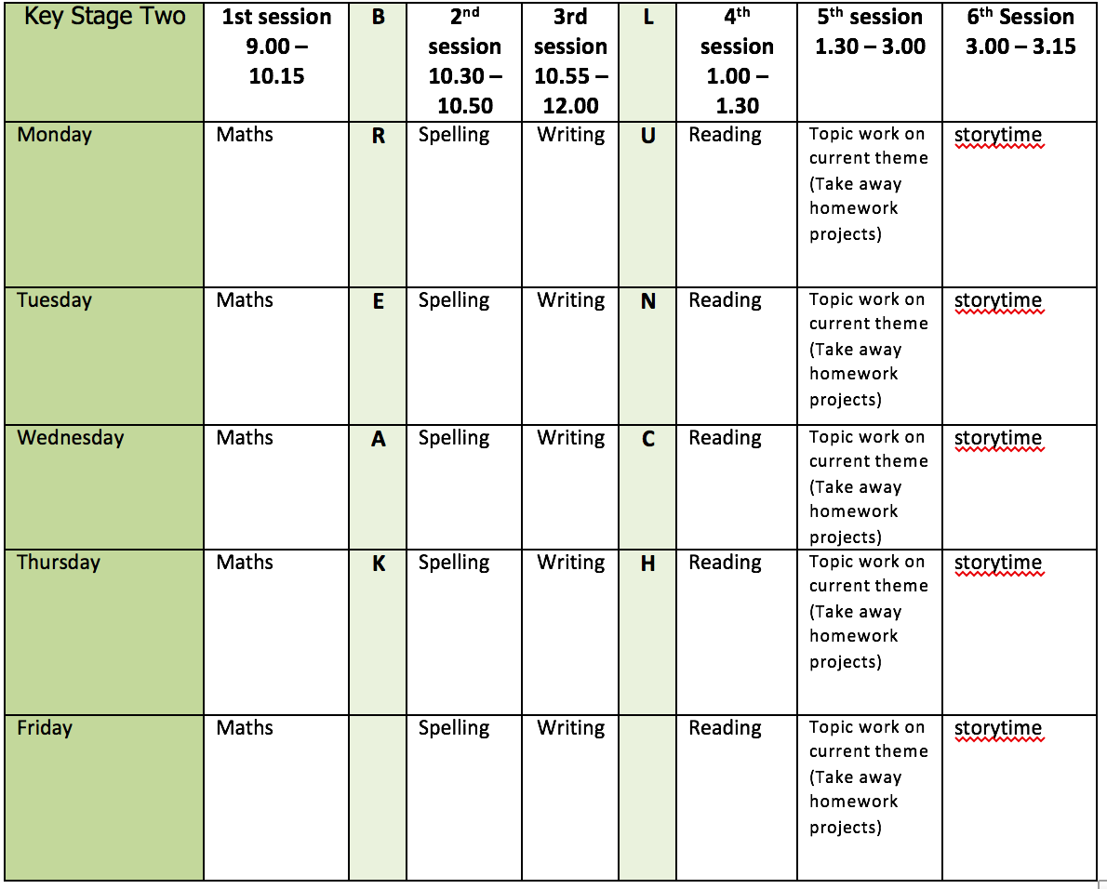
Mental health and well being
Do two acts of kindness per day – one for someone else and one for yourself. Keep track of your acts, for example you could make yourself a calendar like this one:
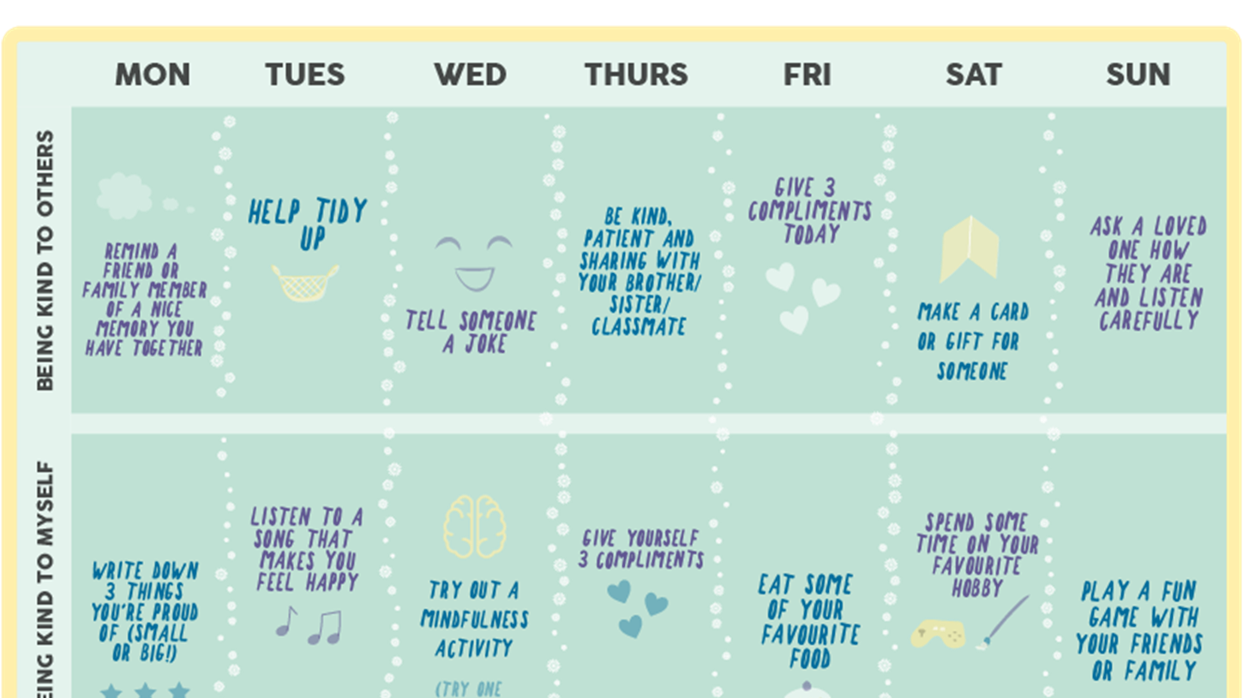

English writing activities for the week: Short narrative (story) based on https://www.youtube.com/watch?v=xFPoIU5iiYQ
Some of you might have already written a diary entry based on this video but this time we are going to change the genre and write a story.
Monday - Watch the video through twice. Create a storyboard or a story map of what happens.
Tuesday – We are going to write our story in the 1st person. Decide whether you want your story to be written from the point of view of the child or the whale. Write some thought bubbles for the characters – draw them too if you would like to!
Wednesday - Plan your story. You could use another storyboard for this or a story mountain like we do in class. Make sure you have the plot planned out into paragraphs.
Thursday - Add some vocabulary to your plan. Don’t forget your story will need some description – can you include a simile? Think about how to describe the setting, characters and the action.
Friday - Write your story. Keep your plan in front of you to help and don’t forget to send me the finished stories – I would love to see them.

Reading:
3 days playscript, 2 days reading for pleasure.
Playscript activities:
- Read the playscript through – involve your family if you can and don’t forget to think about your expression!
- Identify the features that make it different from other genres of writing – what can you see that means you know it is a playscript? Create a playscript toolkit.
- Use the structure of The Three Little Pigs playscript to write your own for another fairy tale.

Spelling:
Suffix ‘ly’ e.g. happily, sleepily, greedily, easily, angrily, simply, gently, dramatically, frantically, basically (3 days)
Continue practise of words from Y3/4 list (2 days)
Use the spelling strategies document to help you.

Maths activities for the week:
All worksheets, answers and video links attached.
Monday - Write decimals
Tuesday - Compare decimals
Wednesday - Order decimals
Thursday - Round decimals
Friday - Revision of anything tricky from week/Mathletics/Times Tables Rock Stars/Purple Mash maths games

Topic work French (Worksheets attached)
Monday - Greetings
Tuesday - Numbers & age
Wednesday - Months, days and birthdays
Thursday - Colours & shapes
Friday - Face & body parts
https://www.bbc.co.uk/teach/class-clips-video/french-ks2-virtually-there-france/zjby8xs
Some of these videos will help with pronunciation. It would be great to create your own French dictionary to remind you of the key vocabulary and its English translation.

PE
This week’s challenge – design your own daily workout. You could include sit ups, press ups, skipping, high knees, spotty dogs, planks and don’t forget your stretches!

