Year 3
W/C 08.06.2020

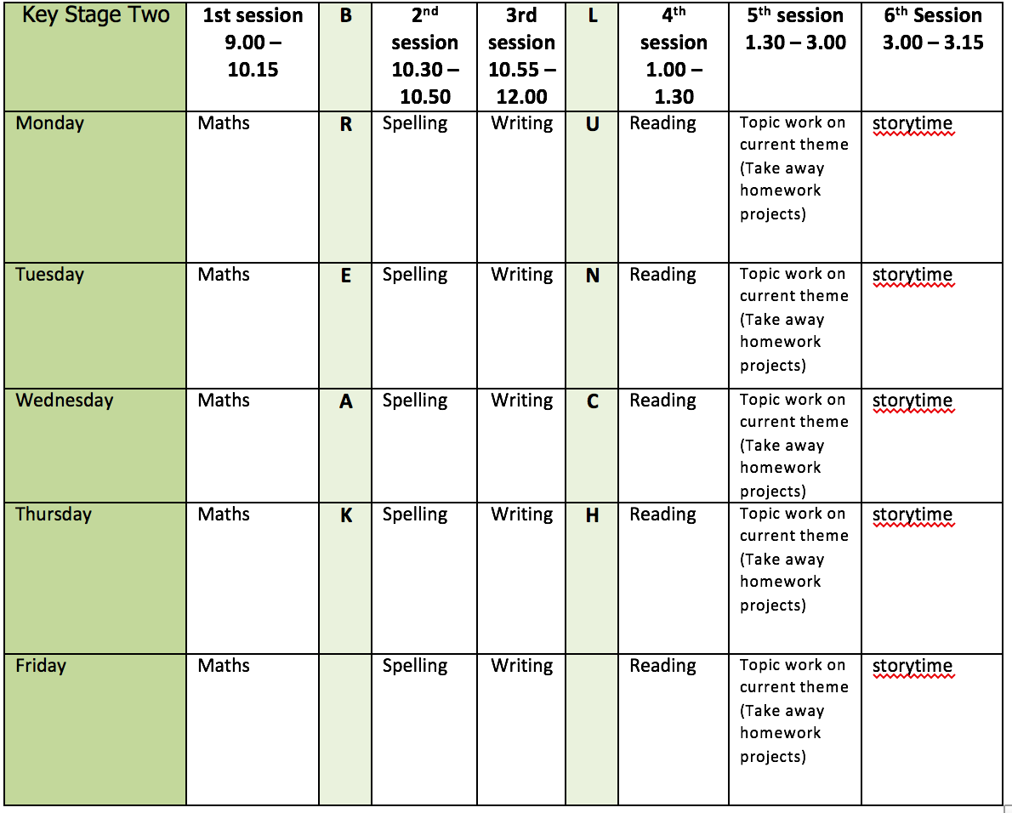
Mental health and well being
Days 8 – 12 of the Wildlife trusts 30 days wild (resources included)

English writing activities for the week: Complete the explanation text - ‘How fruit is formed’
Monday: Using your storyboard for support, plan, write and create a beautiful illustration to accompany the fourth Point which will be Fertilisation. Try to use a fronted adverbial phrase to begin your paragraph. Remember time adverbials help you to sequence your writing which is important when wring an explanation: e.g. Once pollination has taken place, When the bee has visited the flower, (Don’t forget to proof-read and make any corrections).
Tuesday: Using your storyboard for support, plan, write and create a beautiful illustration to accompany the fourth Point which will be Fruit Formation (you could use this as your subheading!). Remember to use a fronted adverbial phrase to begin your paragraph. Time adverbials help you to sequence your writing which is important when wring an explanation: e.g. After fertilisation has taken place, During the fruit formation stage, (Don’t forget to proof-read and make any corrections).
Wednesday: Using your storyboard for support, plan, write and create a beautiful illustration to accompany the fourth Point which will be Mature Fruit. Remember to use a fronted adverbial phrase to begin your paragraph. Remember, time adverbials help you to sequence your writing which is important when wring an explanation: e.g. Now that the fruit is mature, Once the fruit is ripe, (Don’t forget to proof-read and make any corrections).
Thursday: Can you find out what happens to the fruit once it is ripe and ready to eat? Does it all get eaten? How are the seeds dispersed? What happens to any fruit that falls to the floor? This link is a great place to start https://www.dkfindout.com/uk/animals-and-nature/plants/how-seeds-are-spread/ read all about seed dispersal and take the quiz!
5. Friday: Using your research from yesterday, can you independently write add a final paragraph explaining how the seeds inside a piece of fruit are dispersed. Remember the features of an explanation text such as subheadings, fronted adverbials of time, technical vocabulary, diagrams and illustrations.

Reading:

Alongside the release of ‘The Ickabog’, JK Rowling’s publishers have started a competition for children to illustrate the book! Each week I am going to set you a new illustration to complete. If you would like to enter any of your illustration ask an adult to find out a little bit more about it for you https://www.theickabog.com/competition/

Monday: The author helps to us learn all about ‘King Fred’ through clever vocabulary choices and humour. Find examples from chapter one of the text which tell us about King Fred and explain what they tell you by completing the table provided.
Tuesday: Discuss the following questions based on the first chapter:
1. Why do you think ‘Fearless’ is in inverted commas?
2. What is the name of the kingdom that King Fred rules over?
3. The author tells us that King Fred managed to catch and kill a wasp ‘all by himself…’ Why do you think the author tells us this?
4. Can you find a word in the text which means the same as ‘shared’?
5. Imagine you lived in Cornucopia. Would you like King Fred to be your king? Try and discuss you answer using evidence from the text.
Wednesday: Based on what you have read so far, can you design a Flag for Cornucopia?
Thursday: Read the first 4 paragraphs of the second chapter of ‘The Ickabog’ https://www.theickabog.com/the-ickabog/ . Then, with an adult discuss and answer the following questions
- What does ‘word of mouth’ mean?
- What types of stories were originally passed on by word of mouth? How many do you know?
- What is a Legend?
- Can you think of any other legendary/mythical creatures? Can you compile an A-Z of creatures?
Friday: Re-read the first 4 paragraphs of the second chapter https://www.theickabog.com/the-ickabog/ Close your eyes and create a mental picture of what ‘The Ickabog’ might look like based on what you have read. Now, very carefully illustrate your own version of the Ickabog!

Spelling:
Revise previously taught suffixes (-ed, -ing, -s, -es, -ness, -ful, -less and -ly).
First, share your understanding of what a suffix is. Then practice handwriting the suffixes in your neatest cursive handwriting.
Try adding them to a range of words. Are there any that are trickier than others?

Remember:
- A short vowel means you must double the consonant
- If the root word ends in ‘-e’, this is dropped when adding a suffix beginning with a vowel letter (apart from the word ‘being’)
Continue practise of words from Y3/4 list (3 days) using the strategies provided.

Maths activities for the week:
All worksheets and video links available on White Rose maths tab
Monday: Equivalent Fractions 1
Tuesday: Equivalent Fractions 2
Wednesday: Equivalent Fractions 3
Thursday: Compare Fractions
Friday: Revision of anything tricky from week/Mathletics/Times Tables Rock Stars/Purple Mash maths games

Topic work
Monday: Watch the following video and learn a little about surrealism https://www.tate.org.uk/kids/explore/what-is/surrealism
Now, have a go yourself. Inspired by Leonora Carrington, draw your own surreal character. The more surreal the better – I cannot wait to see what you come up with! Follow the link to access the task or download it from this weeks files. https://www.tate.org.uk/kids/make/paint-draw/draw-surreal-creature
Tuesday: Using recycled materials, can you design and build your own bug house? There are some ideas about how to get started provided, but why not do some research of your own and get create.
Wednesday: Have a good read of the posters provided. Then, think about/talk to an adult about all the plastic items we use and throw away e.g. toothbrushes, plastic straws, cartons, plastic bags, earbuds, shampoo bottles, milk bottles, juice cartons, yoghurt pots etc. Find as many of items as you can and use them to make a display about the harmful effects of plastic on our oceans. Your display could contain different facts and figures, as well as ways we can all help to take action.
Thursday: Make a Lovely Lava Lamp using a recycled plastic container https://www.stem.org.uk/resources/elibrary/resource/33256/lava-lamp, (you can share your finished work on Mrs Badgers challenge section on padlet), or have a go at any of the other Starter for STEM activities in the document provided.
Friday: Create a mind map of what you know about the different countries of the British Isles and which you have visited. Have a look at the resources provided, choose a country, and make a poster about its wildlife using the information provided on the resource sheet and your own research. Include details like habitat and diet – you could add symbols and icons of your chosen country to your poster.

PE
- Use the links and resources from Mr Dooley already available on the class home learning webpage – he has added some new activities this week.
- Cosmic Kids Yoga - https://www.youtube.com/user/CosmicKidsYoga

