Recycled bug house

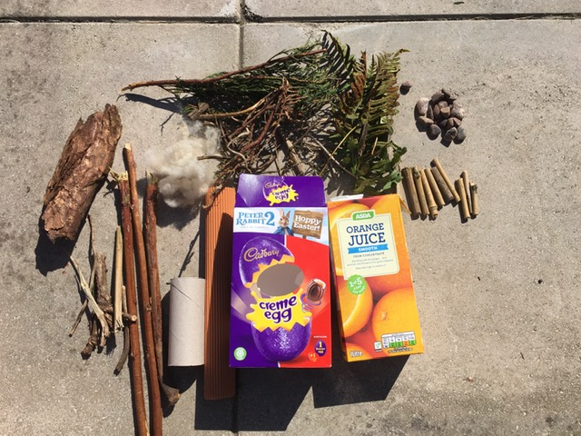

You will need:
Recycled: cardboard boxes, juice cartons, cardboard tube
Different objects from your garden such as leaves, twigs, moss, grass cuttings, bark.

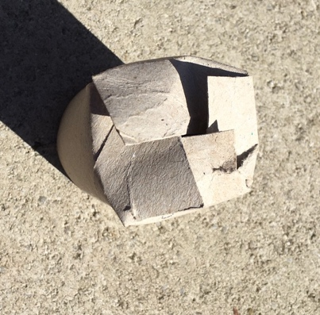
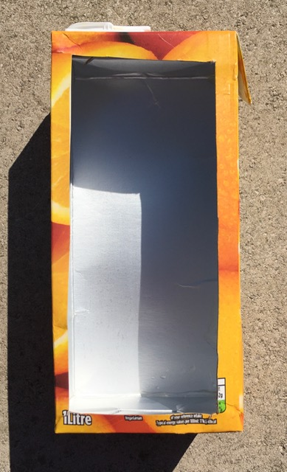

With help from an adult cut a rectangle from the fount of you carton or box, leaving a 1cm edge around the side this will help hold your bug box in place.

Cut 4 small slits in the top of your cardboard tube then fold in to make a base, place tube into one of the corners of your bug house.
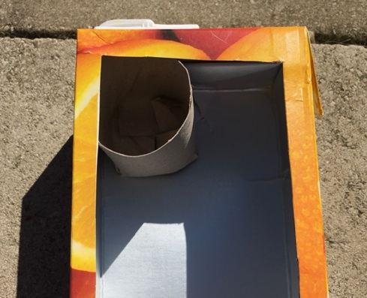

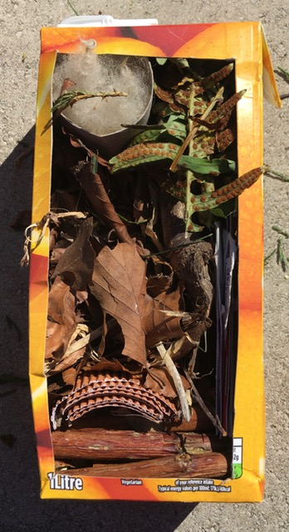
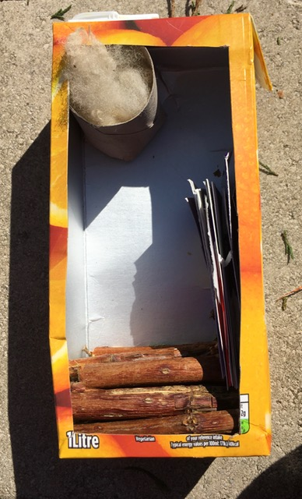
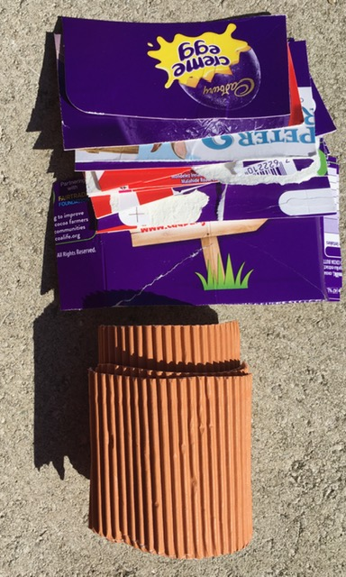

Cut cardboard in to strips and place inside the bug house, start adding sticks to hold cardboard in place. Next you need to add your leaves these will also help hold everything in place.
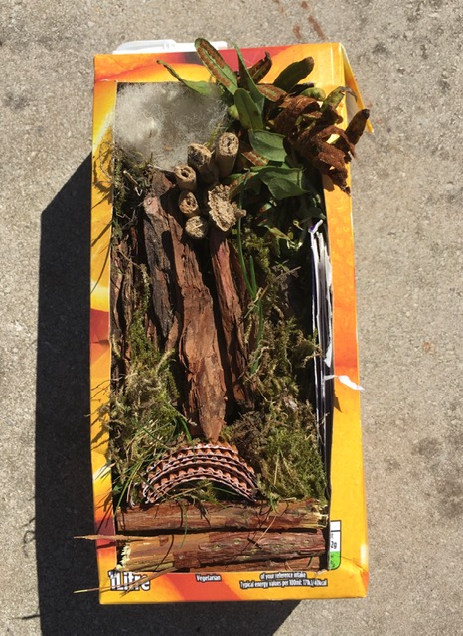
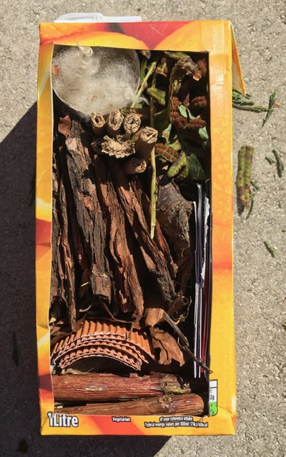

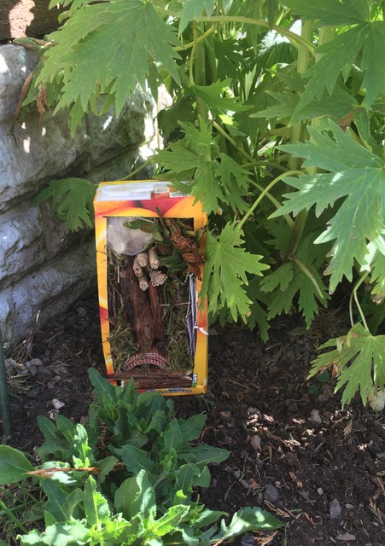
Add more twig, bark and any other bits you have on top of the leaves when you are happy with how it looks, stuff bits of moss into any small gaps to help hold everything in place.

When you are happy with how your bug house looks place it in a shaded corner of your garden amongst some plants for your garden bugs to enjoy.

