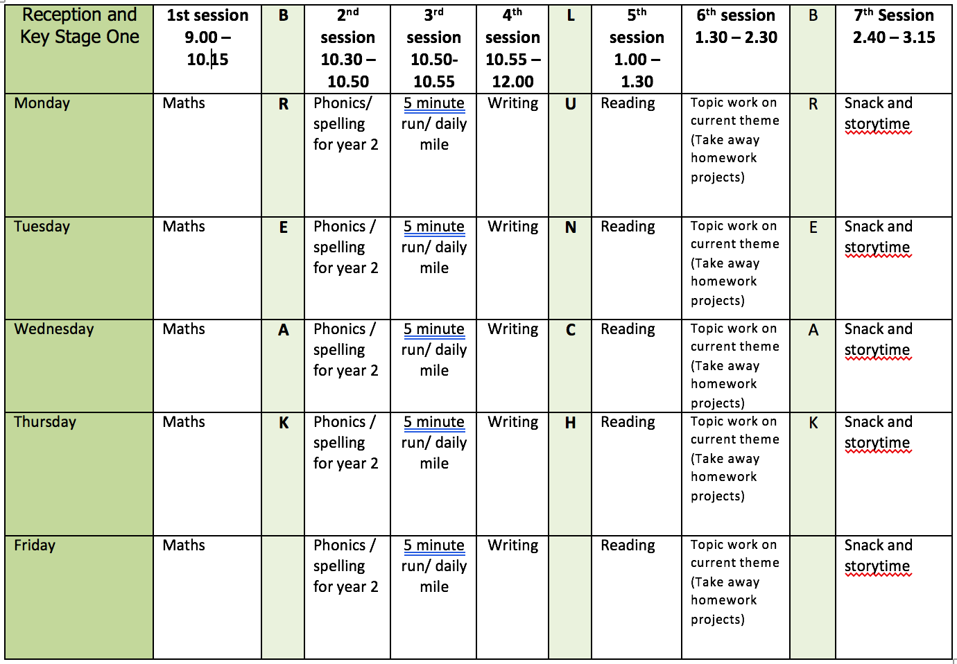

ENGLISH WRITING: Non-Chronological Reports
In the weekly writing activities I am trying to cover all the genres of writing that children are taught in Y2 at Bunbury. Before the March closure we worked on Non – Chronological Reports and had been writing about plants. We use the word point to help structure our work, a point is like a paragraph. In each point I would expect Y2 to write at least 3 sentences joining some of them with conjunctions using co-ordination (or, and, but) or subordination (when, if, that, because). At school we also call conjunctions sentence links. Every sentence needs to have the correct punctuation.

Resources:
Use the pages from What a Waste - Earth’s Resources, Earth’s Atmosphere. If you want to use any of your own information books or resources please do so.

Monday
- Introduction point. Write a general opening point about Earth. Remember to use a title.
Tuesday
- Point 1 – Write a specific paragraph about one of the Earth’s resources. Remember to use a title.
Wednesday
- Point 2 – Write a specific paragraph about one of the Earth’s resources. Remember to use a title.
Thursday
- Ending - Write a point about how we can look after the Earth’s resources and why we need to. If you want you can include make a poster for this part too.
Friday
- Editing your work. Look at all your work from this week. Check your punctuation is correct? Does your work make sense when you read it out loud? Check the spellings of common expectation words using the Y1 and Y2 Word List. Have you used interesting language in your work?
- Redraft any parts you think you can improve.

Further resources to support using conjunctions:
- BBC Bitesize Using conjunctions to join sentences
https://www.bbc.co.uk/bitesize/articles/z6rvbdm
- BBC Bitesize Using coordinating conjunctions https://www.bbc.co.uk/bitesize/articles/zjdxhbk

READING
Monday
- Fluency Expression - reading out loud to develop reading fluency and expression. Continue this daily throughout the week. Own choice of book or you could read Outdoor Art from Oxford Owl as this links to one of the afternoon activities.
Tuesday
- Comprehension Focus– use the list of questions ‘Supporting Reading At Home’ or the questions on the Reading Bookmark or use the online activity below.
- Online Activity - Daisy & The Trouble With Life by Kes Grey. The activities linked to this may take a couple of days to complete. One could be done each day after reading the extracts. https://www.bbc.co.uk/bitesize/articles/zmp2mfr
Wednesday
- As Wednesday. If you haven’t finished the online comprehension work and want to do that for the rest of the week that is ok.
Thursday
- Make a list of 10 nouns in a text you have read this week.
Friday
- Draw a picture of your favourite part of a story you have read and describe what you have drawn.

SPELLING
When practising spelling use the ideas in the school booklet ‘Help You Child with Spelling’.
With the dictation passage parent/carer to dictate sentences one at a time. Check spelling and punctuation in these sentences.
I have made a spelling quiz for each week’s spelling in the Purple Mash 2Dos section.
Monday
- Spelling EE words – feet, see, meet, tree, free, green, keep, sleep, sweet, three
- Dictation - The fat man sucks lots of free green sweets. He feels sick. His dog just sleeps.
Tuesday
- Spelling EA words – eat, meat, peas, beans, cream, tea, sea, seat, beach, dream
- Dictation - Sam sat on the beach to eat six cream buns. Jim had a cup of tea and ran into the sea.
Wednesday
- Spelling Y as e sound - windy, misty, frosty, crusty, plenty, milky, grumpy, twenty
- Dictation – It is November and Sam is grumpy. It is frosty and misty. He has a hot milky drink and plenty of crusty jam tarts.

Thursday
- /r/ sound spelt wr the beginning of words
- Word list – write, written, wrote, wrong, wrap, wrist, wriggle, wren, wreck
- Spelling Fact – this spelling also reflects old pronunciation such as k/g at the beginning of words.
Friday
- Use the words lists (common exception words) on the webpage. Look for any of this week’s sound/spelling focus on these lists and practice spelling them.
- If there aren’t any choose a selection of words to learn and write in a sentence.

Further resources to support Phonics and Spelling:
- Word Lists – Y1, Y2, Y3/4
- Help Your Child With Spelling Document
- Read Write Inc. – daily phonics/spelling lesson starting at 9.30 and then available for 24 hours after that https://www.youtube.com/channel/UCo7fbLgY2oA_cFCIg9GdxtQ

MATHEMATICS (WHITE ROSE)
All these resources are on the webpage with the exception of Friday.
Monday
- Lesson 1 – Unit Fractions
Tuesday
- Lesson 2 – Non-Unit Fractions
Wednesday
- Lesson 3 – Find a Half
Thursday
- Lesson 4 – Find a Quarter
Friday
- Friday Maths Challenge - White Rose in partnership with BBC Bitesize https://www.bbc.co.uk/bitesize/tags/z7s22sg/year-2-and-p3-lessons/1

Further resources to support mathematics:
- Times Table Rockstars https://ttrockstars.com
- Purple Mash https://www.purplemash.com/sch/bunburyaldersey
- Mathletics https://login.mathletics.com

TOPIC/WELL BEING
Monday
- Natural and Made Materials – sort the pictures into those materials, which can be found naturally, or those that need to be made.
- Look around your home and garden. Identify natural and made materials. Draw and label the things found.
- BBC Bitesize Which Material do we use? https://www.bbc.co.uk/bitesize/topics/zrssgk7/articles/z9pgcdm

Tuesday
- Natural Materials – choose a natural material that can be made into something else. E.g. wool, wood. Can you find out and describe what it can be made into? You could show the sequence by making a simple zigzag book.
Wednesday
- Challenge - Imagine you are an inventor and have designed a new material. What would it be called? What properties would it have? What would you use it for?
Thursday
- Outdoor Art – Have a look at the book ‘Outdoor Art’ on Oxford Owl. The pictures are also in the resource PowerPoint/pdf file. Have a go at creating your own outdoor art or story art using a material from your garden.
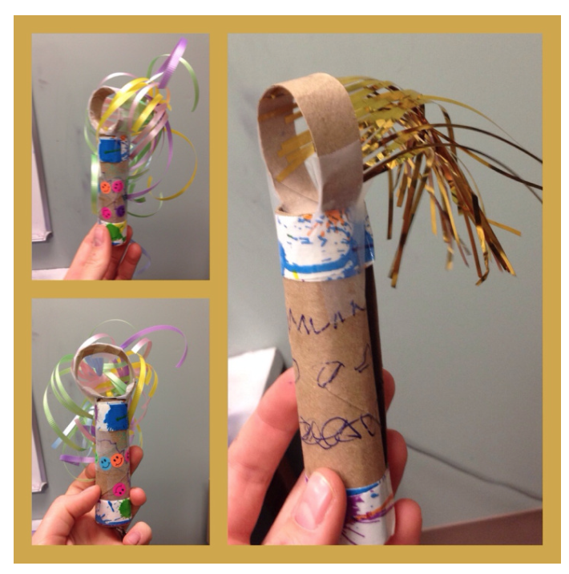
Friday
- Well Being Activity 2 - Breathing Wand
- YOU WILL NEED: a toilet paper or paper towel roll, markers or other decorative things, streamers or thin ribbon that is light enough to be moved easily by their breath.
- Take a toilet paper or paper towel roll and cut off the top (about an inch thick) and set aside.
- Cut a straight line all the way up the remainder of the roll.
- Use this cut to tighten the roll to roll it thinner and tape on top and bottom to hold it in place.
- Decorate the roll with paint, markers, stickers, etc.
- Tape strands of thin light decorative ribbon or streamers along the inside of the small ring you cut off earlier. Thin strips of paper might work too.
- Tape the ring on top of the thinner roll to make the wand.
- BREATHE and notice what you notice.

Other BBC Bitesize Materials Links
- Introduction To Materials https://www.bbc.co.uk/bitesize/articles/z6kdwty

PHYSICAL EDUCATION
- Use the links and resources from Mr Dooley already available on the class home learning webpage. Mr Dooley has sent more resources for this term which are on a separate page.
- PE with Joe https://www.youtube.com/channel/UCAxW1XT0iEJo0TYlRfn6rYQ
- Go Noodle Activities https://family.gonoodle.com

