Week beginning: 8.6.20

Year 6

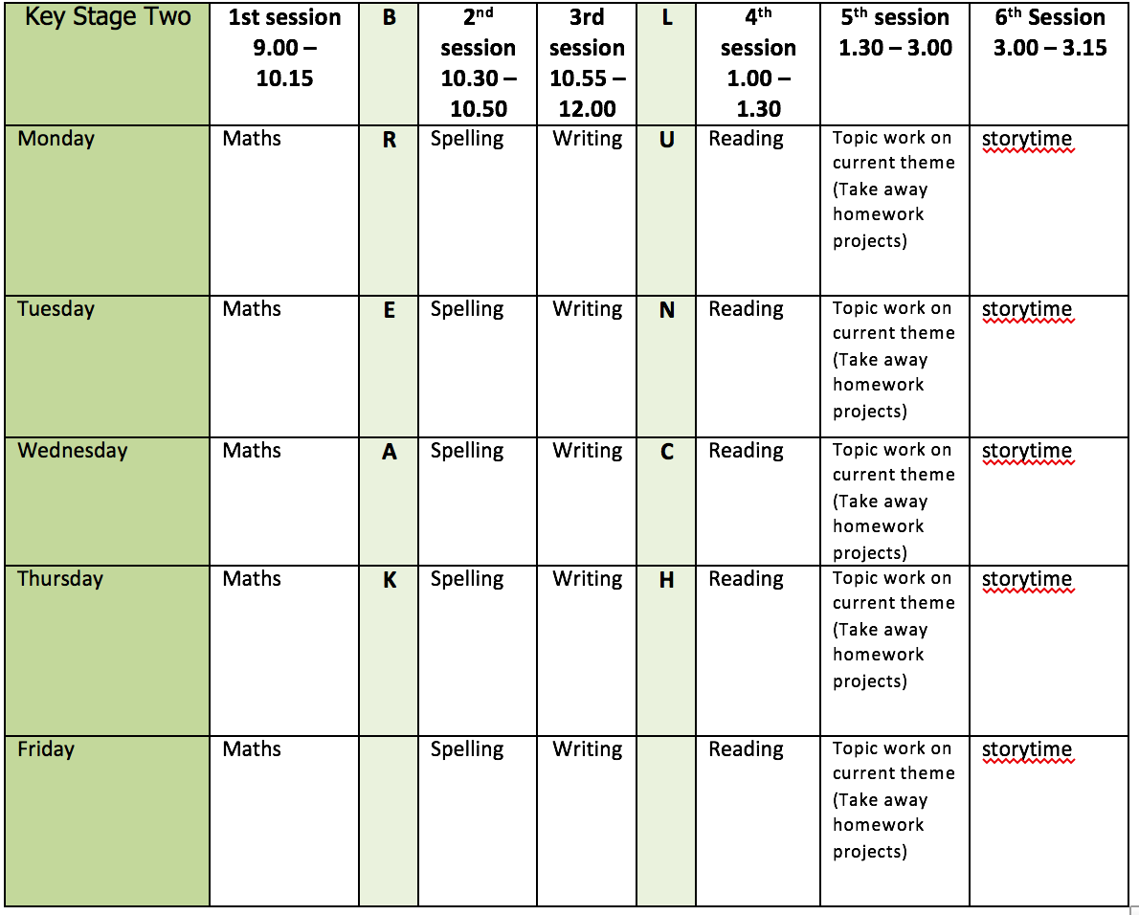

**Mental health and well being**

Choose an activity from the list below as and when you need it:

1. Colouring sheets.

2. Crosswords

3. Sudoku

4. Doodling/drawing

5. Reading

6. Listen to relaxing music <https://www.youtube.com/watch?v=qFZKK7K52uQ>

7. Yoga - <https://www.youtube.com/watch?v=Td6zFtZPkJ4>

**Maths activities for the week**: (7)

1. Monday Lesson 1 - Find a rule

2. Tuesday Lesson 2 - Forming expressions

3. Wednesday Lesson 3 - Substitution

4. Thursday Lesson 4 - Solve simple one-step equations

5. Friday Lesson 5 - Practise your timestables (on TT rock stars if you wish) and then complete the appropriate timestable sheet (5 minute timer). Complete the Friday Maths Challenge <https://whiterosemaths.com/homelearning/year-6/>

**Spelling:**

The spelling pattern focus for this week is: cious/tious/xious

Teach tips: when the root word ends in ce, the suffix is usually cious (vice/vicious, grace/gracious, space, spacious, malice/malicious)

Tious – ambition, nutrition, caution, fiction, infection. If the word ends tion it becomes tious.

cious/tious means ‘full of’ e.g. gracious – full of grace

Anxious is the exception – Angst (full of angst)

1. Monday Create a table with different cious/tious/xious words in. Highlight the endings and think about why it has that particular ending.

2. Tuesday Find related words: for example, nutrition, nutritious, nutritional, and nutrient.

3. Wednesday Look up the definition in a dictionary of any word meanings not known. Create 5 sentences using any of the words.

4. Thursday Learn the cious/tious/xious words. (Use different colours, write mnemonics to remember the letter order, draw around the shape of the word, play hangman, test yourself)

5. Friday Complete the wordsearch.

**English writing activities for the week: Poetry writing**

1. Monday Watch the 1998 Guinness surfer advert: <https://www.youtube.com/watch?v=OIh-0AsRKqk> why has the film maker chosen to use horses for the waves? What effect does this have? Can the sea really feel emotions? What do we call it when we give human characteristics to non-living things? (Personification). Read the poem ‘The Sea’ by James Reeves. Highlight the personification in the poem.

2. Tuesday Look at 2 pictures of the sea. 1 when the sea is calm and 1 when the sea is stormy. Make a list of actions and descriptive vocabulary to describe the sea. Create short phrases, for example: destructive waves enveloping the beach. Collect ideas about human or animal actions that might link to the features or actions of the sea to create personification. For example: the sea’s fists punch the air or white horses of the ocean gallop.

3. Wednesday You are going to write a poem of an ocean voyage. See the map of Charles Darwin’s journey on The Beagle which you will remember from the autumn term:



Think about 4 different events on that journey and make notes on what the sea was like. For example: Events: Setting sail – calm seas – waves of hope. Crossing the ocean – heavy rain – waves of anger. Sky grew dark – storm – waves of fear. Reached the land – calm seas – waves of wonder

4. Thursday Plan your poem of at least 4 stanzas. Include personification.

5. Friday Write your poem. Can you perform it after? Think about your intonation.

**Reading:**

1. Monday - 30 mins of independent reading

2. Tuesday - Comprehension (complete the words in context and the retrieval questions - this week’s is extract 2: Aberrations – The Beast Awakens by Joseph Delaney)

3. Wednesday - 30 mins of independent reading

4. Thursday –Comprehension (complete the inference, choice and challenge questions on Aberrations – The Beast Awakens by Joseph Delaney)

5. Friday – 30 mins of independent reading

**Topic work**:

1. Monday Science - Draw 3 of your own electrical circuits accurately and using the correct symbols.

2. Tuesday Art – cardboard prints. Use leftover cardboard boxes to create prints.

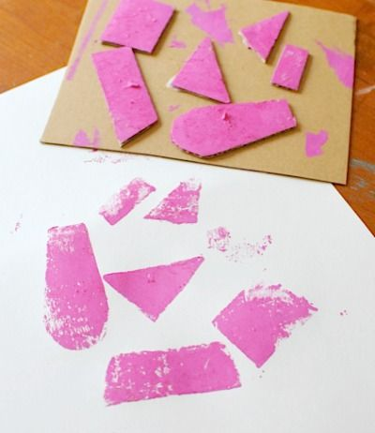 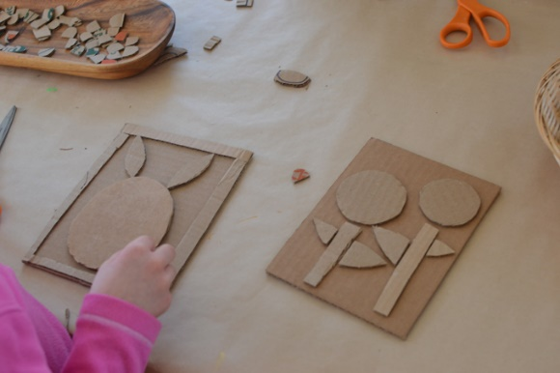

Can you create different patterns? Can you create a picture? Can you build up layers using different colours of paint?

3. Wednesday DT – Create a 5 minute pitch for the ocean friendly product which you designed last week. Remember to cover the following points: What is your product? Why is it not normally ocean friendly? What is your new design? Why is it ocean friendly?

4. Thursday Geography – Finish your PowerPoint on the Great Barrier Reef. Can you include some slide transitions? Can you include a link to a video to show the Great Barrier Reef?

5. Friday Free choice from takeaway homework list or a mental health and well-being activity.

**PE:**

Please find ideas for daily PE activities on the PE documents on the webpage and via the link below

<https://homelearning.primarypepassport.co.uk/#/>

This week’s daily challenge: how many sit ups can you do in 2 minutes? Can you improve your score each day?