Year 4
WB 8.6.2020

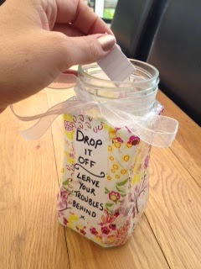
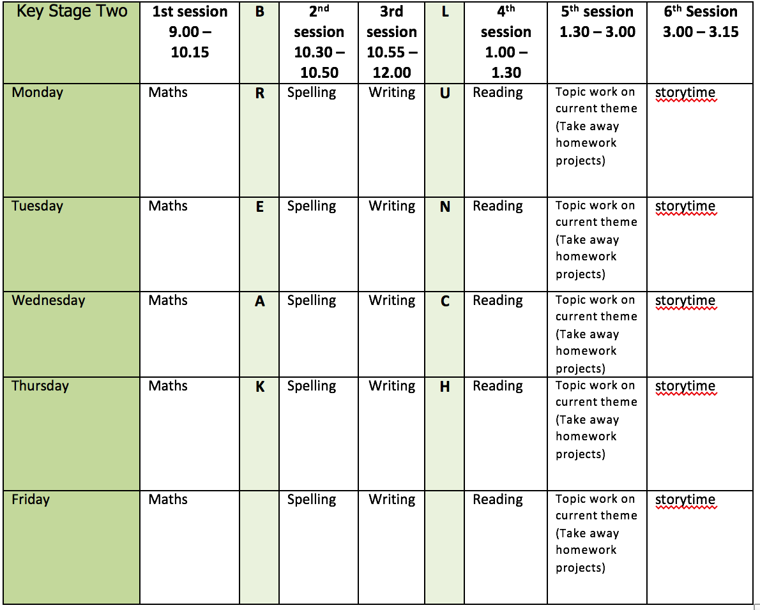
Mental health and well being
Find something you can recycle into a ‘worry jar’. Decorate the outside and get some strips of paper ready to write your worries on. When you feel a worry, write it down and pop it in the jar.

English writing activities for the week: Explanation text on ‘The Water Cycle’
Monday - Plan and write the second Point which will be about condensation. Don’t forget to proof-read and make any corrections.
Tuesday - Plan and write the third Point which will be about precipitation. Don’t forget to proof-read and make any corrections.
Wednesday - Plan and write your Ending which should mention that the water cycle is a continuous process – it just keeps going!
Thursday - Write up your full explanation text and add a diagram.
Friday - Your turn to be the teacher! Mark your work. Do you have technical vocabulary, conjunctions, interesting sentence openers? Do you need to fix any spellings or punctuation? What would you say your next step is?

Reading:
2 days on Opening Night comprehension (attached)
3 days reading for pleasure. Can you read in an exciting place e.g. up a tree, build a den, upside down?!
Spelling:
Prefixes: ‘un-’, ‘dis-’, ‘in-’, ‘re-’, ‘sub-’, ‘inter-’, ‘super-’, ‘anti-’, ‘auto-’ (3 days)
Continue practise of words from Y3/4 list (2 days)
Use the spelling strategies document to help you.

Maths activities for the week:
All worksheets, answers and video links attached.
Monday - Tenths as decimals
Tuesday - Divide 2-digits by 10
Wednesday - Hundredths as decimals
Thursday - Divide 1 or 2-digits by 100
Friday - Revision of anything tricky from week/Mathletics/Times Tables Rock Stars/Purple Mash maths games

Topic work
Monday - Research the creatures in the ocean. How many can you find that are affected by plastic waste invading their habitats? Note down any facts you find interesting.
Tuesday - Gather some pictures of the creatures you researched yesterday and practise sketching them. Remember to use light strokes and look closely at the details.
Wednesday - Gather any newspapers, magazines, scrap paper and other collage materials you can find that can be recycled. Cut them up into small pieces that can be used to collage with. Sketch just the outline of 5 different creatures onto a large piece of paper/card that can be the ocean.
Thursday/Friday - Use your small pieces to collage the sea creatures and the background. Don’t worry if everything isn’t the correct colour!
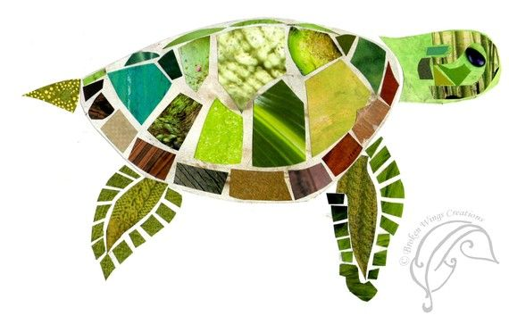

PE
This week’s challenge – try a different form of exercise each day e.g. walking, running, skipping, cycling, football.

