Year 3
W/C 01.06.2020

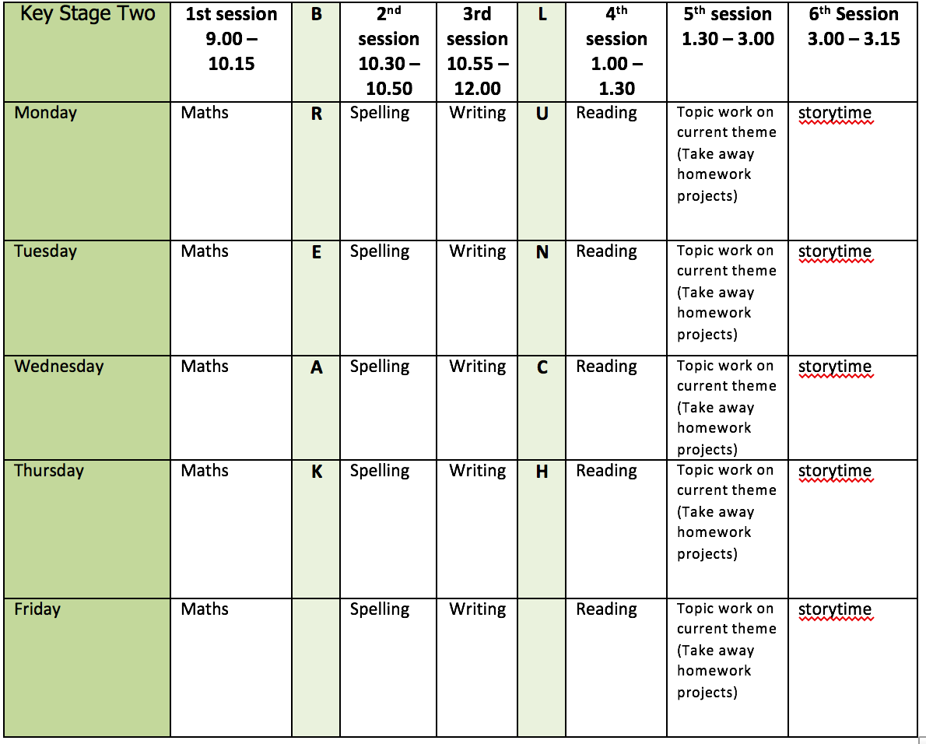
Mental health and well being
Days 1 -5 of the Wildlife trusts 30 days wild (resources included)

English writing activities for the week: Explanation text - ‘How fruit is formed’

Monday: Create a mind map of everything you already know about flowers e.g. have petals, different types. Then, read all about flowers and test your knowledge by taking the quiz https://www.dkfindout.com/uk/animals-and-nature/plants/
Tuesday: Discover the role that insects play in pollination
https://www.bbc.co.uk/bitesize/clips/zfx76sg then complete the sequencing task to check that you have understood. Watch the following clip that shows what happens to a runner bean once it is pollinated http://www.bbc.co.uk/education/clips/zvypyrd and view the PowerPoint presentation ‘From fruit to Flower’. Create a storyboard for the process (resource and support provided). Remember, at this point you just need to use rough sketches to help you remember. Focus on using the correct vocabulary provided.
Wednesday: Make a zig zag book (instructions provided) for your explanation text. Next, choose from one of the plant images provided to be the focus of your explanation text. Illustrate your front cover and give your text the Title ‘From Flower to Fruit’ (see PowerPoint provided for support).
5. Thursday: Plan and write the Introduction paragraph to your explanation text how fruit is formed. Remember, this needs to introduce the topic and give a brief overview but NOT explain anything yet! You could use a question to hook the reader or an interesting fact. Don’t forget to proof-read and make any corrections.
5. Friday: Using your storyboard for support, plan and write the first Point which will be about pollination. Don’t forget to proof-read and make any corrections.

Reading:
Chapter by chapter, JK Rowling has recently begun to publish her new book ‘The Ickabog’ online. It is suitable for 7-9-year olds to read independently (we are really enjoying it).
Monday: With an adult, read the first 3 paragraphs of chapter one of ‘The Ickabog’ - King Fred the fearless https://www.theickabog.com/king-fred-the-fearless/ Are there any tricky words that you don’t know? Can you use your skills to read around the word to try and work out what they mean? Can you use a dictionary to help? Could you ask an adult?
Tuesday – Reread the first three paragraphs. Close your eyes and picture Fred the Fearless. What does he look like? Now very carefully and neatly illustrate King Fred.
Alongside the book release, JK Rowling’s publishers have started a competition for children to illustrate the book! Each week I am going to set you a new illustration to complete. If you would like to enter your illustration as an adult to find out a little bit more about it for you https://www.theickabog.com/competition/
Wednesday – Reading for pleasure. Can you find somewhere interesting to read? The bath? Under a table? In the garden?
Thursday – Finish reading the first chapter of The Ickabog.
Friday – Reading for pleasure. Can you read aloud to someone?

Spelling:
Revise Homophones. How many homophones can you come up during the week? E.g. blue, blew. Spend 5 minutes each day adding to the list. Then, in your neatest handwriting, put them into sentences.
Continue practise of words from Y3/4 list (3 days)

Maths activities for the week:
All worksheets and video links available on White Rose maths tab
Monday: Tenths as decimals
Tuesday: Fractions on a number line
Wednesday: Fractions of a set of objects 1
Thursday: Fractions of a set of objects 2
Friday: Revision of anything tricky from week/Mathletics/Times Tables Rock Stars/Purple Mash maths games

Topic work
Monday: Read about Georgia O’Keefe https://www.tate.org.uk/kids/explore/who-is/who-georgia-okeeffe and create your own illustration of a Lilly in the style of Georgia O’Keefe using the image provided. Remember, botanical illustrators spend a lot of time looking before they draw and paint. Look particularly at the structure of your flower - the arrangement of petals and the inner structures. Mix colours to match the shades you see and build up layers of colour from light to dark. When you have finished, use the following link to help you label the parts of the flower https://www.dkfindout.com/uk/animals-and-nature/plants/parts-flower/

Tuesday: Plan a nature wall around your local area. Draw a beautiful map and mark your route. You could use OS website for support. Simply type the starting postcode of your walk into the search box and it will provide you with a map of the area https://osmaps.ordnancesurvey.co.uk/

Wednesday: With an adult go out on your nature walk. Take your map, a pencil and a spare piece of paper with you. What human features can you spot e.g. church, school. What physical features can you spot e.g. hill, woodland. Can you spot any wildflowers, animals or insects? Number each feature as you find it, label the map in the exact spot you find the feature and write a numbered list of the things you find to create the key to the map.

Thursday: Create a fact file about one of the features you found on your walk. You could use the internet to do some additional research.

Friday: Natural colour collection task. Collect as wide a range of natural colours as you can find in a given area (ask an adult to tell you where you can collect your materials from) sticking tiny bits of each colour to a small piece of white card using double sided tape or cello tape.
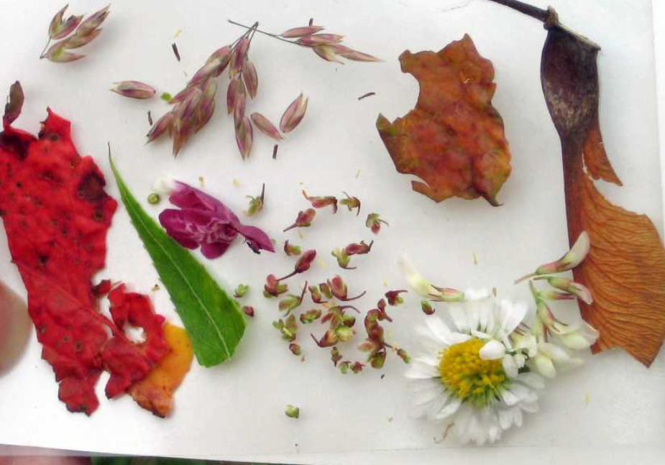
Limit damage to plants by collecting only tiny bits. Now, read the ‘Heathland Palette’ poem (provided). Pick one eye-catching colour from your palette and write a short colour phrase describing it using adjectives, similes and metaphors. There are some excellent examples on the Eden project website https://www.edenproject.com/learn/schools/lesson-plans/colour-palettes under the subheading collaborative poems.

PE
Cosmic Kids Yoga – there are some new ones on their YouTube that we haven’t tried in school:
https://www.youtube.com/user/CosmicKidsYoga/videos

