Bunbury Aldersey CE Primary School
Homework – Summer
Table 2 – White Group
Suggested  w/c 15.4. | Suggested  w/c 22.4 | Suggested  w/c 29.4 | Suggested  w/c 6.5 | Suggested  w/c 13.5 | Suggested  w/c 20.5
material medicine mention minute natural | naughty notice occasion(ally) often opposite | ordinary particular peculiar perhaps popular | position possess(ion) possible potatoes  pressure | probably promise purpose quarter question | recent regular  reign remember sentence

Table 2 – Blue Group: National Curriculum Statutory Spelling List
White Group please ignore. Dates are suggestions only.
w/c 15.4 | w/c 22.4 | w/c 29.4 | w/c 6.5 | w/c 13.5 | w/c 20.5
kind  last  love  many  money | move  Mr  Mrs  Now  old | once  one  only  our  parents | pass  path people plant  poor | pretty prove  pull  push  said | says  school  she  should  some

Times tables / Division to learn
Year 2: 1s, 2s, 5s, 10s
Year 3: 3s, 4s, 8s
Year 4: 6s, 7s, 9s, 11s, 12s
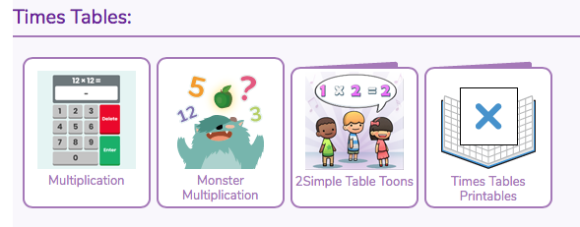

Recommended reading linked to our topic

Fiction Books
"Naughty Bus" by Jan Oke
Join the mischievous adventures of a toy double-decker bus as it travels around the city when no one is looking. This charming story provides a playful look at different modes of transportation.
"The Adventures of Captain Underpants" by Dav Pilkey
This humorous book follows the escapades of two schoolboys who turn their headteacher into a superhero who fights crime using various modes of transport. A fun and engaging read for young readers.
"Mr. Gumpy's Outing" by John Burningham
Follow Mr. Gumpy and his passengers as they set off on a boat ride that turns into a chaotic journey full of different forms of transport. This classic tale explores the concept of shared transport.
Kensuke's Kingdom" by Michael Morpurgo
This gripping novel follows the story of a young boy named Michael who becomes stranded on a deserted island and forms a bond with an old man named Kensuke. Together, they embark on a journey of survival, friendship, and discovery.
"The Lion, the Witch and the Wardrobe" by C.S. Lewis
Join the Pevensie siblings as they step through a magical wardrobe into the enchanting land of Narnia. This classic tale explores the thrilling adventures and unexpected journeys that await beyond the wardrobe's doors.
"The Unforgotten Coat" by Frank Cottrell Boyce
Set in Liverpool, this poignant story follows Julie and her friend Chingis, a new student from Mongolia. Through their friendship, readers embark on a journey of cultural differences, acceptance, and the power of memory.

Non-Fiction Books
"See How They Go: Spaceship" by DK
Delve into the world of space travel with this interactive book that introduces children to different types of spaceships and how they work. Perfect for young readers curious about futuristic forms of transport.

"Planes Fly!" by George Ella Lyon
Learn about various aircraft and how they work in this beautifully illustrated book. From jets to helicopters, this book provides fascinating facts about different flying machines.

"Trains: A Pop-Up Railroad Book" by Robert Crowther
Explore the world of trains through intricate pop-up illustrations that showcase different types of trains and how they operate. This tactile book brings the magic of railways to life for young readers.

- "Explorers: Amazing Tales of the World's Greatest Adventures" by Nellie Huang
Dive into the real-life journeys of famous explorers such as Marco Polo, Amelia Earhart, and Ibn Battuta. Filled with fascinating facts and illustrations, this book inspires young readers to explore the world around them.

- "Maps" by Aleksandra Mizielinska and Daniel Mizielinski
This beautifully illustrated book takes readers on a visual journey around the world through detailed maps. From continents to countries, children will learn about different landscapes, cultures, and landmarks, igniting their sense of curiosity and adventure.

- "A Street Through Time" by Anne Millard
Step back in time and follow the evolution of a street from prehistoric times to the present day. This informative book uses detailed illustrations to showcase how communities, transportation, and daily life have changed over different historical periods, making it a fascinating exploration of the concept of journeys through time.

