Bunbury Aldersey CE Primary School
Homework – Summer A
Y1 Common Exception Words
Week 1 | Week 2 | Week 3 | Week 4 | Week 5 | Week 6
the  a  do  to  today  of | said  says  are  were  was  is | his  has  I  you  your  they | be  he  me  she  we  no | go  so  by  my  here  there | where  love  come  some  one  once

Y2 Common Exception Words
Week 1 | Week 2 | Week 3 | Week 4 | Week 5 | Week 6
door  floor  poor  because  find  kind  mind  behind | child  children  wild  climb  most  only  both  old | cold  gold  hold  told  every  great  break  steak | pretty  beautiful  after  fast  last  past  father  class | grass  pass  plant  path  bath  hour  move  prove | improve  sure  sugar  eye  could  should  would  who

Times tables / Division to learn
Please see TT Rockstars to see the times table you need to learn.
Our focus during the whole year is x2 x5 x10 and related division facts. Start with x10 and then move on to x2 and x5. If your child is on ‘gold’ in the challenge then x4s are introduced. You can practise online at TT Rockstars (login details in reading record book) and download worksheets at Times Table Worksheet. There are lots of activities on Purple Mash too.
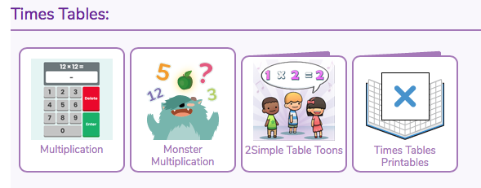

Recommended reading linked to our topic
Our class text for this half term is The Last Wolf by Mini Grey.
Other books you might enjoy:

