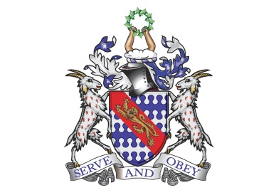
Bunbury Aldersey CE Primary School
My homework tasks for this half term – Summer A
High frequency word spellings to learn
Week 1 | Week 2 | Week 3 | Week 4 | Week 5 | Week 6
available  average  awkward  bargain  bruise  category  cemetery  committee | communicate  community  competition  conscience  conscious  controversy  convenience  correspond | criticise  curiosity  definite  desperate  determined  develop  dictionary  disastrous | embarrass  environment  equipment  especially  exaggerate  excellent  existence  explanation | familiar  foreign  forty  frequently  government  guarantee  harass  hindrance | identity  immediate(ly)  individual  interfere  interrupt  language  leisure  lightning

Times tables / division to learn
Please learn all times tables up to 12 and the related division facts.

Recommended reading linked to our topic
Smart About Sharks by Owen Davey
Atlas of Ocean Adventures by Emily Hawkins & Lucy Letherland
Interview with a Shark by Andy Seed & Nick East
This Morning I Met a Whale by Michael Morpurgo & Christian Birmingham
Shark Lady by Jess Keating & Marta Alvarez Miguens
Curious Creatures Glowing in the Dark by Zoe Armstrong & Anja Susan
The Lost Whale by Hannah Gold & Levi Pinfold
Malamander by Thomas Taylor
Ariki and the Giant Shark by Nicola Davies & Nicola Kinnear
Song of the Dolphin Boy by Elizabeth Laird & Peter Bailey
The Girl Who Thought Her Mother Was a Mermaid by Tania Unsworth
The Aquanaut by Dan Sentat
The Brilliant Deep: Rebuilding the World’s Coral Reefs by Kate Messner & Matthew Forsythe
Oceanarium by Loveday Trinick & Teagan White
Earth’s Incredible Oceans by Jess French & Claire McElfatrick
Blue Planet II by Leisa Stewart-Sharpe & Emily Dove

