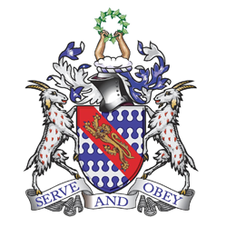
Rural Church Schools Academy Trust
Gross Motor Skills Progression
 | 2 years old | 3 years old | Reception
Locomotor | Walk with one foot in front of the other  Run  Stop safely  Jump on two legs on the spot | Tip-toe,  Climb well  Try to stand on one foot,  Gallop  Jump confidently  Kick a ball (to anywhere)  Try to skip  Pedal a trike | Leap  Hop  Skip  Run  Walk backwards  Move around targets and objects with ease  Ride a scooter and bike
Manipulative | Bounce (their hands on their knee, hands on their head)  Lift items up and lower them down  Push wheeled toys  Throw a ball (anywhere, not a target) | Kick a ball to a target  Catch a large ball  Pulling a wheeled toy  Throwing whilst aiming for a target  Skittles | Dribble with a ball  Strike  Catch arrange of objects eg tennis balls, foam balls, beanbags,  Throw overhead  Kick a ball around a target  Play garden games – hoopla, giant jenga etc
Stability | Stand still/freeze when on two legs  Ride on toys with 4 wheels – balance and begin to move self along with legs. | Jumping from one foot to another  Bend to touch toes without falling over  Twist midsection to left and right Balance on a three wheeled toy | Dodging when running  Landing a jump with bent knees  Forward roll  Ride a scooter or balance bike with confidence and safety.

