Week beginning: 1.3.21
Year 6
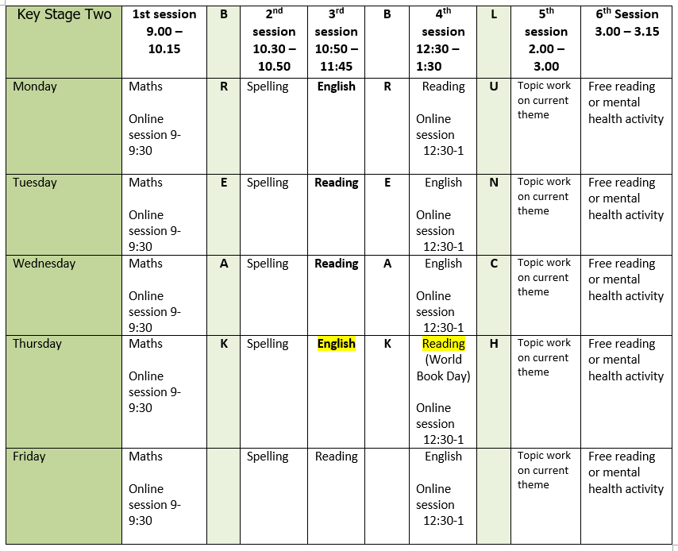
Mental health and wellbeing – All on the level 2 closure tab
Choose an activity from the list below as and when you need it:
1. Colouring sheets.
2. Crosswords
3. Sudoku
4. Doodling/drawing
5. Reading
6. Listen to relaxing music https://www.youtube.com/watch?v=qFZKK7K52uQ
7. Yoga - https://www.youtube.com/watch?v=Td6zFtZPkJ4

Maths activities for the week – All on the level 2 closure tab
1. Monday – 1 Percentage of an amount 2
2. Tuesday – 2 Percentages, missing values
3. Wednesday – 3 Measurement: metric measures
4. Thursday – 4 Convert metric measures
5. Friday – 5 Calculate with metric measures
I have also uploaded the fluency grids we use in class (you can choose a number to put in the star) and the timestables test (5 minute timer).

Spelling: All on the level 2 closure tab
The spelling pattern focus for this week is: ant/ancy/ance

Teach tips: if words end in ‘ant’ then related words will be spelt ance/ancy/ation e.g.
Observant (a person who observes), Observance (the practise of observing), Observation (the action or process of observing).
An ‘ant’ ending is often when there is an ‘ay’ sound in ‘ation’ endings e.g. toleration.
Some examples: expectant, hesitant, tolerant, dominant.

1. Monday Complete a ‘Modification of words’ table for:
appear | assist | attend | expect | instant
Extend your vocabulary by making variations of the above words e.g. appears, appearance, disappear, disappearance, appearing, reappear, reappearance. You can use prefixes too.
2. Tuesday Look up the definition in a dictionary of any word meanings not known and create 5 sentences using any of the words.
3. Wednesday Create word webs. Start with unobservant. How many words can be made using the patterns? For example, a dictionary could be used to look up serve to see how many words there are related to serve. Choose a different ant/ance/ancy word to create a word web for.
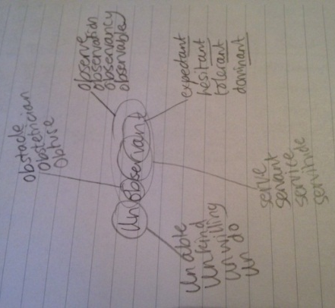
4. Thursday Learn the ant/ancy/ance words. (Use different colours, write mnemonics to remember the letter order, draw around the shape of the word, play hangman, test yourself)
5. Friday Complete the wordsearch.

English writing activities for the week: All on google classrooms
1. Monday – Finish and/or edit your writing (independent work)
2. Tuesday – Toolkit, PAT and ideas
3. Wednesday – Plan
4. Thursday – Write
5. Friday – Edit

Reading – All on google classrooms
1. Monday - Guided Reading session live at 12:30 then follow up work on google classrooms.
2. Tuesday – Independent questions to answer on google classrooms. There is also an optional challenge to complete.
3. Wednesday – Lightning Mary comprehension
4. Thursday – The Rise of Wolves (World Book Day)
5. Friday – Free reading

Topic work: All on google classrooms
1. Monday – Spanish
2. Tuesday – History
3. Wednesday – DT/History
4. Thursday – World Book Day
5. Friday – PE

PE:
Please find ideas for PE activities on google classroom or on the closure tab. This week’s daily challenge: how long can you hold the plank position for? Can you improve your time each day?

