Year 4
WB 1.3.2021
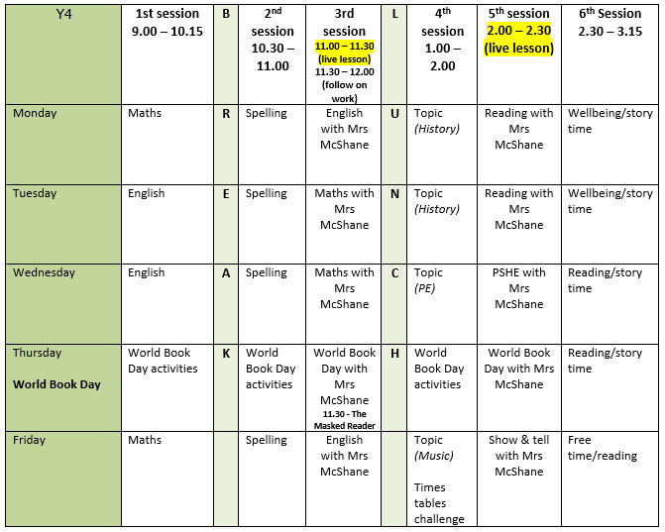

Mental health and well being
Getting outside in nature is brilliant for our wellbeing so this week I’d like you to choose an activity from here to complete:
Activities for Kids & Families | Educational DIY Projects -The RSPB
I am going to try ‘Sounds of Spring’!

English writing activities for the week:
Monday – (live lesson with Mrs McShane) Present tense
Tuesday – Plan your setting description. Choose which of the images you are going to focus on and brainstorm as much language as you can that will help you to write your description tomorrow. Remember to think of adjectives, adverbs, similes and using your different senses.
Wednesday – Independent write – setting description
Thursday – World Book Day activities
Friday – (live lesson with Mrs McShane) Evaluating and editing our descriptions

Reading:
Monday – Live guided reading lesson with Mrs McShane. If possible, print out the page on Google Classrooms ready for this lesson.
Tuesday – Live guided reading lesson with Mrs McShane
Wednesday – Follow on task on Google Classroom
Thursday – World Book Day activities
Friday – Reading for pleasure

Spelling: (complete in yellow homework book)
Monday – Spend today’s spelling lesson selecting the next words from your word list that you need to learn. Choose 8 to focus on this week. They could be the next 8 from the list or 8 that we have covered already but you know you still find tricky.
Tuesday – Use any of your favourite spelling strategies to practise your 8 chosen words e.g. pyramid words, rainbow write, look-say-cover-write-check, mnemonics.
Wednesday – Hide some of the words you are currently practising in your own wordsearch. Let someone in your household try to find them and time how quickly they can do it!
Thursday – World Book Day activities
Friday – Ask somebody at home to test you on the 8 words you have learnt this week – practise any you get incorrect.

Maths activities for the week: Fractions
Worksheets, answers and video link on COVID level 2 tab
Monday – Subtract fractions
Tuesday – (live lesson with Mrs McShane) Subtract 2 fractions
Wednesday – (live lesson with Mrs McShane) Subtract from whole amounts
Thursday – World Book Day activities
Friday – Fractions of a set of objects

Topic work
Monday – History – research and find out about as many different Roman Gods and Goddesses as you can. You can use the internet and the pages from the book I have uploaded on Google Classroom. Choose your 6 favourites and bullet point some facts about each of them. Keep these facts safe for tomorrow’s activity.
Tuesday – History – Follow the instructions on Google Classroom to make a zigzag book. On each page, draw a Roman God/Goddess and write some facts about them. Try to present your book as beautifully as you can.
Wednesday – PE – try Mr Friel’s challenge for this week.
Thursday – World Book Day activities
Friday – Music – watch Mr Birch’s video lesson.

PE
Try some of Mr Friel’s activities on Google Classroom.

